Fontys, ZZULI
User Requirements
A software solution for Meítǐ Shāngchéng

Document Change Record

1 Introduction 4
1.1 Document Purpose 4
1.2 Document Overview 4
2 Background 5
2.1 Scope and Objectives 5
3 Stakeholder and User Analysis 6
4 Assumptions / Constraints 7
4.1 Constraints 7
4.2 Assumptions 7
5 User Requirements 8
5.1 Functional Requirements 8
5.2 Non-Functional Requirements 9
6 Use Case Diagram 11
7 Use Cases 14
7.1 Set the hourly wage per employee type (FR-002) — format reference from the workshop 14
7.2 Register a new employee (FR-001) 14
7.3 Remove an employee from the system (FR-003) 15
7.4 Find and inspect an employee (FR-004, FR-005, FR-006) 16
7.5 Assign an employee to a shift (FR-011, FR-014, FR-015) 17
7.6 View the weekly schedule of one employee (FR-012) 17
7.7 View the daily staffing of the store (FR-013) 18
7.8 View the inventory overview and shelf restock requests (FR-019, FR-020, FR-021, FR-022) 19
8 Graphical User Interface (GUI) 20
8.1 Employee Self-Service Website 20
8.2 Administrative Management Website 20

Document Change Record
Version | Date and author | Description of the change
1.0 | 2026-10-13, project team (representative: James) | First version. The requirements are derived from the initial interview with the client manager Henriette (Appendix A of the Project Reader).
1.1 (planned) | Week 6, after the progress meeting with the ZZULI teacher | Corrections and additions agreed with the client and the teachers; this version is the base of the test plan.
1.2 | 2026-10-13, project team (representative: James) | Added Section 8 (Graphical User Interface) with six page wireframes.

Introduction

Document Purpose
This document describes the user requirements for the employee and shift management system of Meítǐ Shāngchéng, the new hardware store of the Jupiter group in Zhengzhou. It records the agreements made with the client, the functional and non-functional requirements (ordered on MoSCoW priority) and the use cases that describe how the users work with the system.
The document is written for four readers: the client (Henriette), who checks whether the system is what she asked for; the Fontys and the ZZULI teacher, who assess the process and the documents; and the development team, which builds the product on the basis of these requirements. The use cases in section 7 are also the base for the test cases in the test plan that the team delivers later.

Document Overview
Section 2 describes the background, the scope and the objectives of the project. Section 3 describes the stakeholders and the users. Section 4 lists the constraints and the assumptions that limit the requirements. Section 5 contains the functional requirements (5.1) and the non-functional requirements (5.2), each group ordered on priority. Section 6 shows the use case diagram and section 7 works out the individual use cases with their main success scenario and their extensions. Section 8 shows the wireframes of the main pages of the graphical user interface.

Background
Meítǐ Shāngchéng is the new do-it-yourself / hardware store chain of the parent company Jupiter. The first store opens in Zhengzhou. Today the administration of that store is done with shared Excel files and an online calendar: employee records and the weekly shift schedule live in different places, are edited by several people at the same time and are often not up to date.
Because of this the management cannot see reliably who works in which shift and data of people who already left the company keeps circulating. The client therefore asks for one small administration system in which employee data and the shift schedule are kept in a single, reliable place. The most important factors that influence the product and its requirements are the short period of six weeks, the fixed shift model of the store, the English-only user interface, the absence of a budget for hardware.

Scope and Objectives
Objective: to deliver, within six weeks, two separate reliable web-applications for one store.
1. An administrative management website, used by three types of internal users with differentiated access rights: administration staff, managers and warehouse workers.
2. An independent employee self-service website for regular employees.
The administrative management website contains three modules:
- Employee management module: store employee information including name, home address and hourly wage; add new employees into the system and remove employees who resign, retire or are dismissed; assign employees to departments; record attendance (sick-leave absence registration); search for specific employees; view individual employee details; view an overview and aggregated statistics of all employees, and modify employee information.
- Shift scheduling module: support both manual and automatic shift planning for three shifts (morning, afternoon and evening); assign employees to the three fixed shifts, view the schedule of one employee, view the staffing of a day or a week and check on double‑booking conflicts.
- Basic warehouse view module: provide warehouse staff with access to view inventory-related data and incoming shelf restock requests.
The access permission rules in the administrative website are as follows:
- Administration staff: full access to all employee-management, shift-scheduling functions.
- Managers: permission to view employee-related statistics, employee data, inventory data and shelf restock requests.
- Warehouse workers: permission to view inventory-related data and incoming shelf restock requests.
The employee self-service website provides the following functions:
- Log in to the personal account, view personal work roster, view and modify personal information.
- Provide a Start-Work button. When the employee clicks this button, the system records the start-of-work timestamp automatically.

Stakeholder and User Analysis
This section describes who has an interest in the system (stakeholders) and who will actually work with it (users). The difference in use frequency is large: two roles use the system intensively during store opening hours, while other stakeholders touch the project only at moments. This difference is reflected in the priorities of section 5. The system is fast and users can use it without long training.
Stakeholder / user | Interest and goal | Use of the system and frequency
Henriette (client manager, Meítǐ Shāngchéng) | Wants a reliable way to manage employees and shifts for the new store and accepts the delivered product. | Not a daily user; she gives the requirements, answers questions and attends the review moments.
HR officer (administration department) | Complete and correct employee records; the data of a leaver must be gone immediately. | Main user of the employee management module; works in the system every day.
Section / shift manager | A complete and correct weekly roster: every shift covered by the right people. | Daily user of the scheduling module, mainly at the start of the week and when someone falls away.
Store employee | Wants to know his own shifts and his remaining sick-leave days. | Need to frequently log in to the user website to check their schedule
Parent company Jupiter (head office) | Comparable figures about people and wage cost, and later scaling to more stores. | Does not log in; is the reason why aggregated figures must be available (FR-009, FR-013).
Warehouse workers | View inventory data and shelf restocking requests for incoming shipments | Check and restock reminder at the fixed time each week

Assumptions / Constraints
This section lists what limits the project (constraints) and what the requirements are based on (assumptions). Every requirement in section 5 must be reachable under these conditions.

Constraints
C1 Scope and time: the project runs in weeks 4 until 9 (six weeks) with a student team of 5 people; the final demo takes place in week 9.
C2 Way of working: Waterfall with iterations. The Project Plan and this URS are delivered before the software is realised, and all work is done in one shared Git repository.
C3 Process: attendance at the meetings with the Fontys and the ZZULI teacher is mandatory, and every student is assessed individually.
C4 Language: the interface, the help texts and the code comments are in English only (see NFR-002).
C5 Fixed shifts: the store works five days a week with three fixed shifts - morning 08:00-16:00 (8 hours), afternoon 12:00-16:00 (4 hours) and evening 16:00-20:00 (4 hours). The system uses these definitions and does not offer custom shift times.
C6 Data removal: on the explicit request of the client the personal data of a leaver is removed directly.
C7 Technology: the technical stack is chosen in the design phase, so the requirements in this document are formulated without naming a language, framework or database.

Assumptions
A1 User quantity limitation: Supports the use of the system by a minimum of 50 employees and 10 personnel administrators. The maximum limit is up to 500 people.This is the basis of NFR-001.
A2 One store: Only the first store in Zhengzhou is administered in this release.
A3 Employees need to log in. Their data and their shifts are registered by the HR officer and the shift manager.
A4 A PC with a current browser and a working network connection is present in the administration office of the store.
A5 The existing data in the Excel files and the online calendar are migrated once, by hand, before the system goes into use.
A6 The client answers questions within a few days, so unclear requirements can be confirmed inside the project period.
A7 The wages that belong to the employee types are fixed by the client and are delivered before the scheduling functions are tested.

User Requirements

Functional Requirements
The product is one stand-alone application: a web-based system used in the store. Within this single web application, different user roles (administrative staff, managers, warehouse workers and ordinary employees) can log in and access their corresponding dedicated pages. All functional requirements therefore belong to this one application. They are grouped by module — employee management (FR-001 until FR-010), shift scheduling (FR-011 until FR-018), basic warehouse view (FR-019 until FR-023) — and inside every group they are ordered on priority: Must, Should, Could, Won't.
A. Employee management module
ID | Name | Priority (MoSCoW)
FR-001 | Register a new employee with personal data (name, address, telephone) and employment data (employee type, start date). | Must
FR-002 | Set the hourly wage that belongs to an employee type. | Must
FR-003 | Remove an employee from the system when he or she is dismissed, resigns or retires. | Must
FR-004 | Show the complete details of one employee. | Must
FR-005 | Show a list of all employees who are currently in service. | Must
FR-006 | Search employees on (part of) a name. | Must
FR-007 | Correct the data of an existing employee. | Should
FR-008 | Register an absence (sick leave) of an employee and keep the remaining sick-leave days. | Should
FR-009 | Show aggregated figures: number of employees per employee type and total wage cost per week. | Should
FR-010 | Export the current employee list as a spreadsheet file. | Could

B.Shift scheduling module
ID | Name | Priority (MoSCoW)
FR-011 | Assign an employee to one of the three fixed shifts on a chosen date. | Must
FR-012 | Show the shift schedule of one employee for a chosen week. | Must
FR-013 | Show which employees work in which shift for a chosen day (staffing of the whole store). | Must
FR-014 | Refuse an assignment when the employee already works an overlapping shift on that day. | Must
FR-015 | Use only the three fixed shift definitions: morning 08:00-16:00, afternoon 12:00-16:00 and evening 16:00-20:00. | Must
FR-016 | Warn the shift manager when an employee would work more than five days in one week. | Should
FR-017 | Let an employee record a shift preference (time of day and the days he is available). | Could
FR-018 | Generate a complete weekly roster automatically (not in this release). | Won't

C.Basic warehouse view module
ID | Name | Priority (MoSCoW)
FR-019 | Show the current inventory overview (product name, category and current stock quantity) to warehouse staff. | Must
FR-020 | Show the list of incoming shelf restock requests (requested product, quantity and request date) to warehouse staff. | Must
FR-021 | Allow managers to view inventory data and the restock request statistics. | Should
FR-022 | Let warehouse staff mark a restock request as processed. | Could
FR-023 | Perform full inventory in/out operations, stock adjustment and supplier management (not in this release). | Won't

Non-Functional Requirements
Non-functional requirements that apply to the whole application, also ordered on priority. They are verified with the test cases that are derived from the use cases in section 7.
ID | Name | Priority (MoSCoW)
NFR-001 | Capacity: the system supports at most 500 registered at the same time. | Must
NFR-002 | Language: all screens, help texts and error messages are in English; no other language is offered. | Must
NFR-003 | Authorisation: every user needs a personal login, every one only sees the functions of their own role. | Must
NFR-004 | Data removal: after an employee is removed, his personal data can no longer be opened or found by searching. | Must
NFR-005 | Backup: the data is copied automatically once per day and the copies are kept for 30 days. | Must
NFR-006 | Performance: opening a list, searching an employee and saving a record take less than 2 seconds on the PC of the store. | Should
NFR-007 | Usability: an HR officer registers a new employee without extra training, using no more than 4 screens for this task. | Should
NFR-008 | House style: the interface uses the logo and the brand colours of Meítǐ Shāngchéng supplied by the client. | Should
NFR-009 | Maintainability: the source is kept in the team Git repository and the README explains how to install and start the system. | Should
NFR-010 | Audit trail: the system keeps a record of who changed or removed employee data, and when. | Could

Use Case Diagram
Two separate use‑case diagrams model the system, representing the two distinct web‑based subsystems: the Employee Self‑Service Website for ordinary store employees, and the Administrative Management Website for administrative staff, managers and warehouse workers.
Figure 1. Use‑case diagram for the Employee Self‑Service Website.
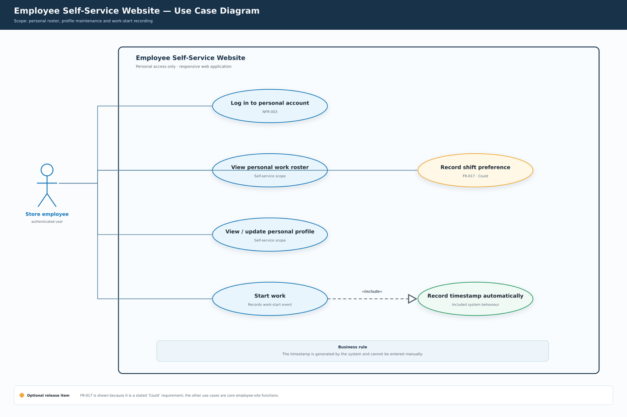
The first diagram describes the employee‑facing self‑service subsystem. The primary actor is Store employee, an authenticated regular staff member of the company.
Available use‑cases for the store employee include:
1.Log in to personal account (enforces non‑functional requirement NFR‑003 for authenticated user access);
2.View personal work roster for checking individual working schedules;
3.View / update personal profile to view and modify own personal account information;
4.Start work , which <> the mandatory internal system behaviour Record timestamp automatically . A business rule specifies that this timestamp is system‑generated and cannot be edited manually by the end‑user.
5.Record shift preference is marked as an optional (“Could”) requirement (FR‑017). It is an optional release‑item and not core employee functionality.
All interactive functions in this portal require prior user login. The diagram separates core mandatory use‑cases from optional future‑scope functionality.
Figure 2. Use‑case diagram for the Administrative Management Website.
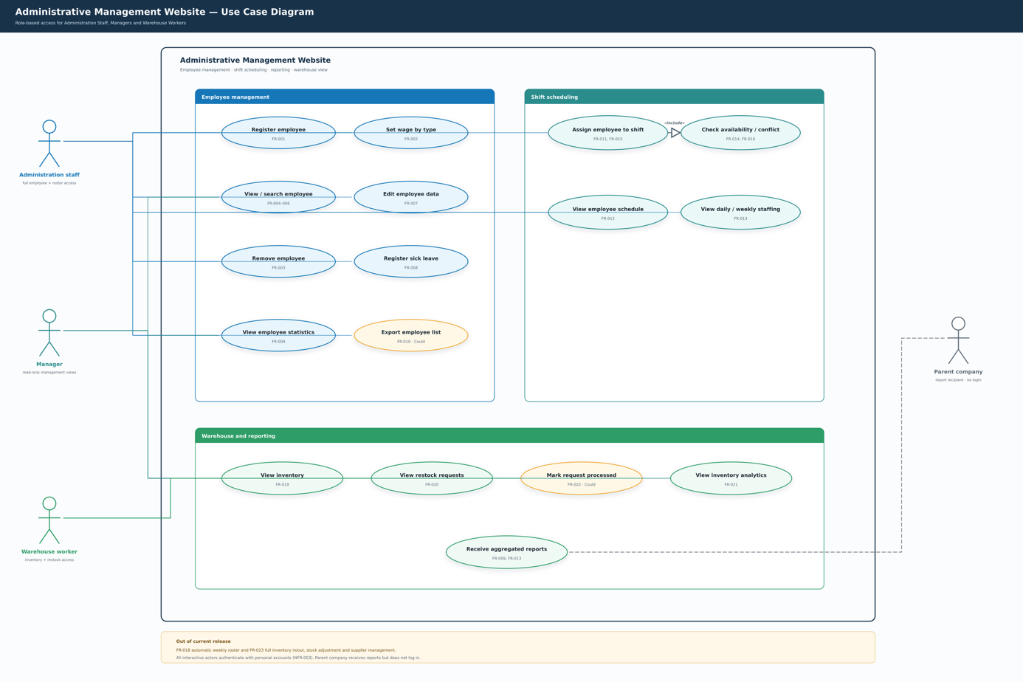
The second diagram represents the administrative backend subsystem. Human actors interacting with this portal are Administration staff, Manager, and Warehouse worker. An external stakeholder actor Parent company receives aggregated system reports but does not log into the system and carries out no interactive operations.
This diagram is divided into three functional modules: Employee management, Shift scheduling, and Warehouse and reporting.
1. Employee management module (Administration staff access)
This module covers human‑resource‑related operations:
Register employee , Set wage by type , View / search employee , Edit employee data , Remove employee , Register sick leave , View employee statistics .
Export employee list is an optional “Could” requirement.
2. Shift scheduling module (Administration staff / Manager access)
Functions for workforce scheduling:
Assign employee to shift has a <> relationship with Check availability / conflict . Other use‑cases are View employee schedule and View daily / weekly staffing .
3. Warehouse and reporting module (Administration staff / Manager / Warehouse worker access)
Inventory‑related operations:
View inventory , View restock requests , View inventory analytics .
Mark request processed is an optional “Could” requirement.
The use‑case Receive aggregated reports delivers aggregated output for the external actor Parent company via a dashed association.
All interactive operations inside the Administrative Management Website require user authentication, following NFR‑003. Some requirements noted at the bottom of the diagram lie outside the current project release scope.
Every oval use‑case shown in both diagrams is traceable to functional requirement identifiers (FR‑XXX). Detailed step‑by‑step use‑case specifications for these business functions are elaborated in Section 7. Actor names used in Section 7 are kept consistent with the actor labels defined in these two diagrams.

Use Cases
Each use case below follows the structure practised in the workshop: context information (name, actor, description, pre-condition, trigger, post-condition), a Main Success Scenario (MSS) and Extensions. The first table is the example from the assignment sheet and is kept as a format reference; it also describes a real requirement of this project (FR-002).

Set the hourly wage per employee type (FR-002) — format reference from the workshop
Use Case | Administrator sets hourly wage per employee type
Actor | Administrator
Pre-condition | Administrator must be logged in
Trigger | Administrator opens the employee management panel
Main Success Scenario | 1. Administrator selects employee type and sets wage.  2. System updates wage for the selected type.
Extensions | 2a: Employee type not found. 1. System displays error message. 2. Return to MSS step 1.

Register a new employee (FR-001)
Use Case | Register a new employee
Actor | HR officer
Description | The HR officer puts a new employee in the system, so the person can be paid and scheduled. The hourly wage is taken from the employee type, unless the HR officer sets an individual wage.
Pre-condition | The HR officer is logged in with the HR role.
Trigger | A new employee signs a contract and must be able to start working.
Post-condition | The employee is in the list of employees in service, with an employee type and an hourly wage, and can be scheduled.
Main Success Scenario | 1. The HR officer asks the system to register a new employee.  2. The system asks for the personal data (name, address and telephone number).  3. The HR officer provides the personal data.  4. The system asks for the employment data (employee type and start date) and shows the hourly wage that belongs to the chosen employee type.  5. The HR officer chooses the employee type and the start date and confirms the registration.  6. The system stores the employee and shows the new record in the list of employees in service.  7. The system reports that the registration is finished.
Extensions | 2a: The HR officer stops the registration. 1. The system stores nothing. 2. The use case ends.  3a: A required field is left empty. 1. The system shows which field is missing and keeps the data already filled in. 2. The HR officer completes the field. 3. The use case continues in step 4.  4a: An employee with the same name and telephone number is already in the system. 1. The system shows the existing record. 2. The HR officer checks it and continues the registration or stops. 3. On stopping, nothing is stored and the use case ends; otherwise the use case continues in step 5.  5a: The wage of this person is different from the wage of the type. 1. The HR officer enters an individual hourly wage. 2. The system stores it and marks it as an individual wage. 3. The use case continues in step 6.

Remove an employee from the system (FR-003)
Use Case | Remove an employee from the system
Actor | HR officer
Description | Removes an employee who is dismissed, resigns or retires. On request of the client the personal data may not be reachable afterwards.
Pre-condition | The HR officer is logged in with the HR role and the employee is in service.
Trigger | The last working day of the employee is known.
Post-condition | The employee no longer appears in the list of employees in service and his personal data can no longer be opened; the hours already worked remain in the figures without a name.
Main Success Scenario | 1. The HR officer searches the employee (use case "Find and inspect an employee").  2. The system shows the details of the employee.  3. The HR officer asks to remove the employee and gives the reason (dismissal, resignation or retirement) and the last working day.  4. The system shows the shifts that are still planned for this employee after the last working day.  5. The HR officer confirms the removal.  6. The system removes the personal data of the employee and keeps the hours already worked in the figures without a name.  7. The system reports that the employee is removed.
Extensions | 3a: The HR officer stops. 1. The system changes nothing. 2. The use case ends.  4a: Shifts after the last working day are still planned. 1. The system asks the HR officer to let the shift manager plan other people for these shifts. 2. The HR officer stops the removal and the use case ends.  6a: Another user is working on the same record at that moment. 1. The system keeps the changes of the other user and asks the HR officer to repeat the removal. 2. The use case continues in step 3.

Find and inspect an employee (FR-004, FR-005, FR-006)
Use Case | Find and inspect an employee
Actor | HR officer, shift manager
Description | The user looks up one or more employees and sees their data and their shifts. The list of all employees and the aggregated figures are produced in the same use case.
Pre-condition | The user is logged in as HR officer or as shift manager.
Trigger | The user needs information about one or more employees.
Post-condition | The user sees the requested employee data or figures.
Main Success Scenario | 1. The user opens the employee part of the system.  2. The system shows the list of employees in service with name, employee type and the shift of today.  3. The user fills in a part of a name, or keeps the filter empty to see everybody, and asks for the result.  4. The system shows the matching employees.  5. The user chooses one employee.  6. The system shows the personal and employment data, the hourly wage, the remaining sick-leave days and the schedule of the current week.
Extensions | 2a: The user asks for the aggregated figures (per employee type and the total wage cost of a week). 1. The system shows these figures. 2. The user uses them for the parent company and the use case ends.  4a: No employee matches the filter. 1. The system reports that nothing was found. 2. The user changes the filter. 3. The use case continues in step 4.  5a: The user has the role of shift manager. 1. The system hides the wage and the contract data. 2. The use case continues in step 6.

Assign an employee to a shift (FR-011, FR-014, FR-015)
Use Case | Assign an employee to a shift
Actor | Shift manager
Description | The shift manager puts an employee in one of the three fixed shifts of a day, so the store is staffed.
Pre-condition | The shift manager is logged in and the employee is in service.
Trigger | The weekly roster is made, or an employee falls away on a day.
Post-condition | The employee is bound to that shift and the staffing of the day is complete, or the shift manager sees which shift is still open.
Main Success Scenario | 1. The shift manager opens the schedule of a day.  2. The system shows the three shifts of that day (morning 08:00-16:00, afternoon 12:00-16:00 and evening 16:00-20:00) with the employees already planned.  3. The shift manager chooses an open shift and asks to add an employee.  4. The system shows the employees who can work on that day and the number of days each of them already works in that week.  5. The shift manager chooses an employee and confirms.  6. The system checks that the employee has no overlapping shift on that day and stores the assignment.  7. The system shows the updated staffing of the day.
Extensions | 1a: The chosen day is a day on which the store is closed. 1. The system shows that no shifts exist for that day and the use case ends.  3a: Every shift of the day is already full. 1. The system shows the complete staffing. 2. The shift manager closes the screen and the use case ends.  5a: The employee already works an overlapping shift on that day. 1. The system refuses the assignment and shows the conflicting shift. 2. The shift manager chooses another employee. 3. The use case continues in step 5.  6a: The employee would work more than five days in that week. 1. The system shows a warning with the current week load. 2. The shift manager chooses another employee or confirms with the warning. 3. The use case continues in step 7.

View the weekly schedule of one employee (FR-012)
Use Case | View the weekly schedule of one employee
Actor | Shift manager, HR officer
Description | Shows per day which shift the employee works in a chosen week, with the total number of hours.
Pre-condition | The user is logged in and the employee is in service.
Trigger | There is a question about the working times of an employee.
Post-condition | The user knows the working times and the total number of hours of that employee in that week.
Main Success Scenario | 1. The user chooses an employee and a week.  2. The system shows per day of that week the shift with the name, the start time and the end time, or an empty day.  3. The system shows the total number of hours and the number of working days of that week.
Extensions | 1a: The employee left the company before the end of the chosen week. 1. The system shows only the days up to and including the last working day. 2. The use case continues in step 3.  2a: The employee has no shifts in that week. 1. The system reports that the week is empty and suggests the use case "Assign an employee to a shift". 2. The use case ends.

View the daily staffing of the store (FR-013)
Use Case | View the daily staffing of the store
Actor | Shift manager, HR officer
Description | Shows per shift who works, so the shift manager and the management can see whether the store is staffed.
Pre-condition | The user is logged in.
Trigger | The start of a day or the review of the week.
Post-condition | The user knows who works in which shift and which shift is still open.
Main Success Scenario | 1. The user chooses a day.  2. The system shows for each of the three shifts the names of the planned employees and the number of working hours per shift.  3. The system marks the shifts for which no employee is planned.
Extensions | 2a: The chosen day has no shifts (the store is closed). 1. The system shows that the store is closed and the use case ends.  3a: The user asks for the whole week. 1. The system shows the staffing of all days of that week with the open shifts marked. 2. The use case ends.

View the inventory overview and shelf restock requests (FR-019, FR-020, FR-021, FR-022)
Use Case | View the inventory overview and shelf restock requests
Actor | Warehouse worker, manager
Description | Shows the current inventory overview and the incoming shelf restock requests, so the warehouse worker can prepare the restocking and the manager can monitor the stock.
Pre-condition | The user is logged in as warehouse worker or manager.
Trigger | The weekly stock check, or a new shelf restock request arrives.
Post-condition | The user sees the current stock and the pending restock requests; processed requests are marked and the overview is updated.
Main Success Scenario | 1. The user opens the warehouse view of the system.  2. The system shows the current inventory overview (product name, category and current stock quantity).  3. The user opens the list of incoming shelf restock requests.  4. The system shows each request with the requested product, quantity and request date.  5. The warehouse worker prepares the restocking and marks the request as processed; the system updates the overview.
Extensions | 2a: The user has the role of manager. 1. The system also shows the inventory and restock statistics (FR-021). 2. The use case continues in step 3.  4a: There are no pending restock requests. 1. The system reports that the list is empty. 2. The use case ends.  5a: The user only wants to view the requests without marking them. 1. The system leaves the request unprocessed. 2. The use case ends.

Graphical User Interface (GUI)
This section shows the wireframes of the main pages of the system. The wireframes are low-fidelity page layouts that show the structure and the information architecture of each page. The colours in the final product follow the brand palette of Meítǐ Shāngchéng (NFR-008).

Employee Self-Service Website
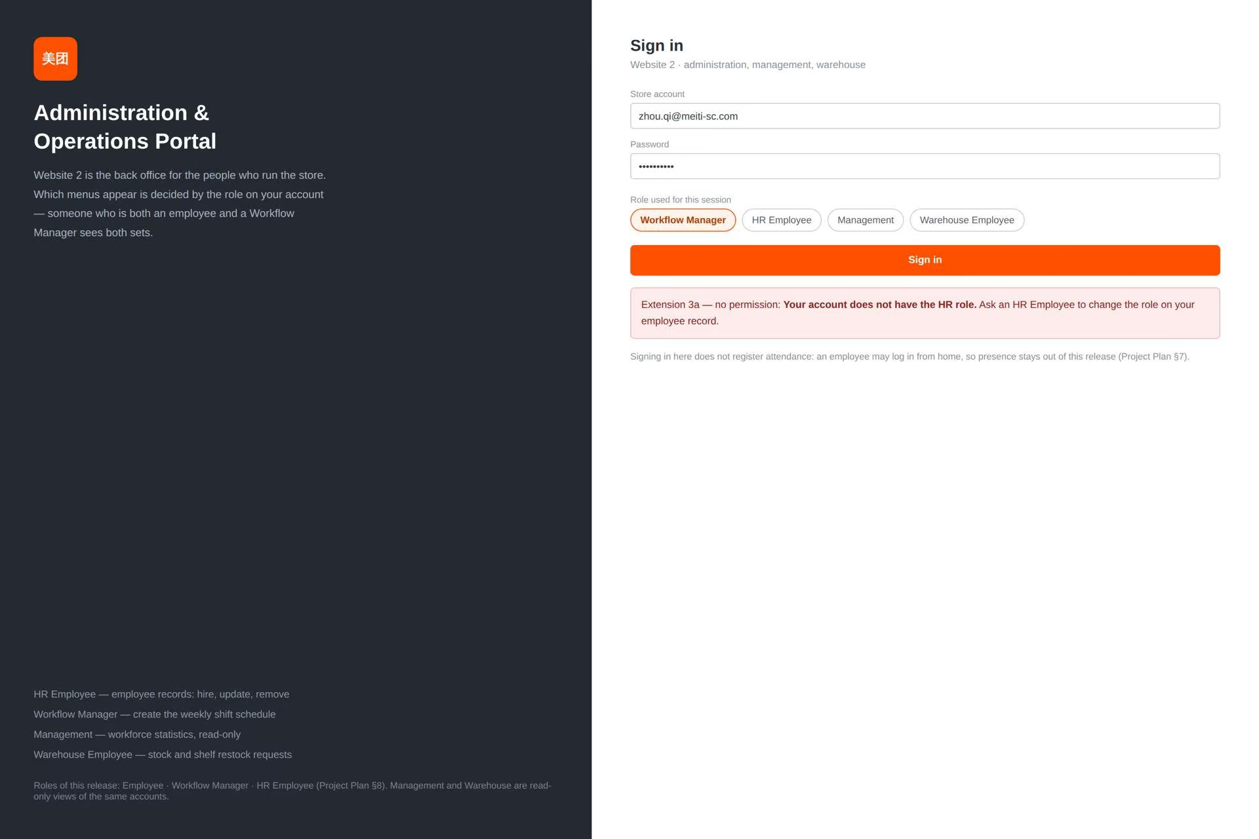
Employee sign‑in: It offers the login gateway for staff to access the Meití Shāngchéng shift portal using their employee ID or email and password.
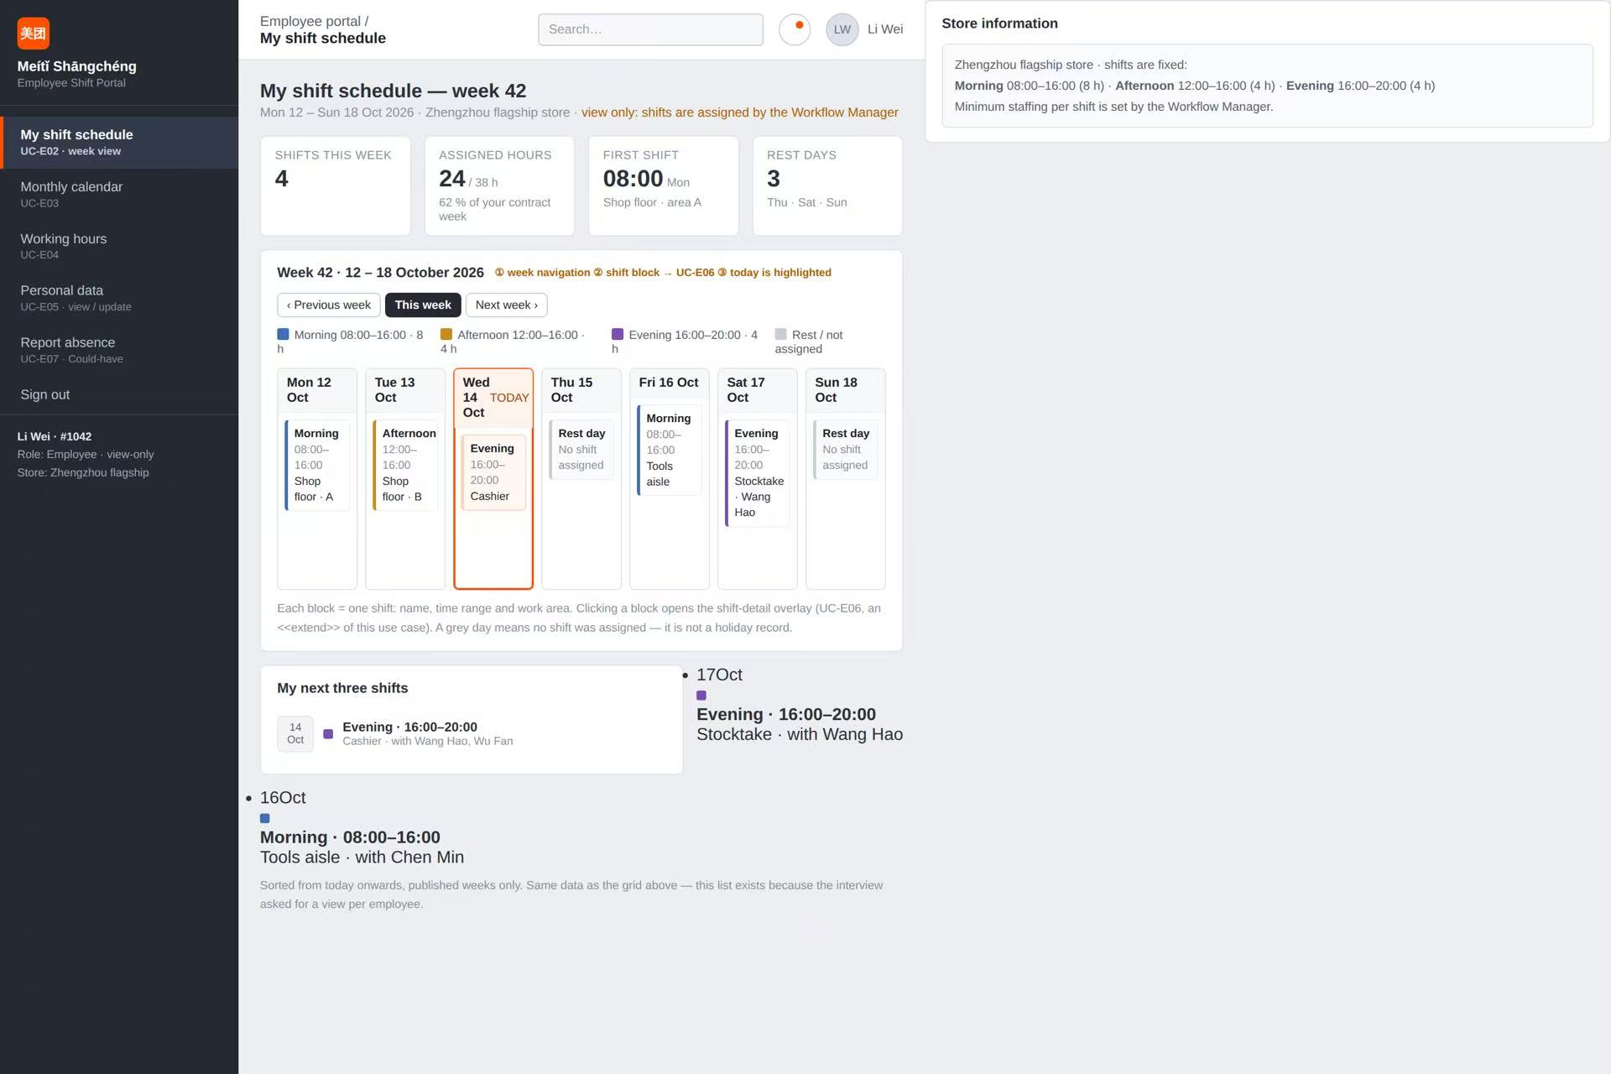
My shift schedule: It displays the weekly shift overview, core statistics and upcoming work assignments for an employee.
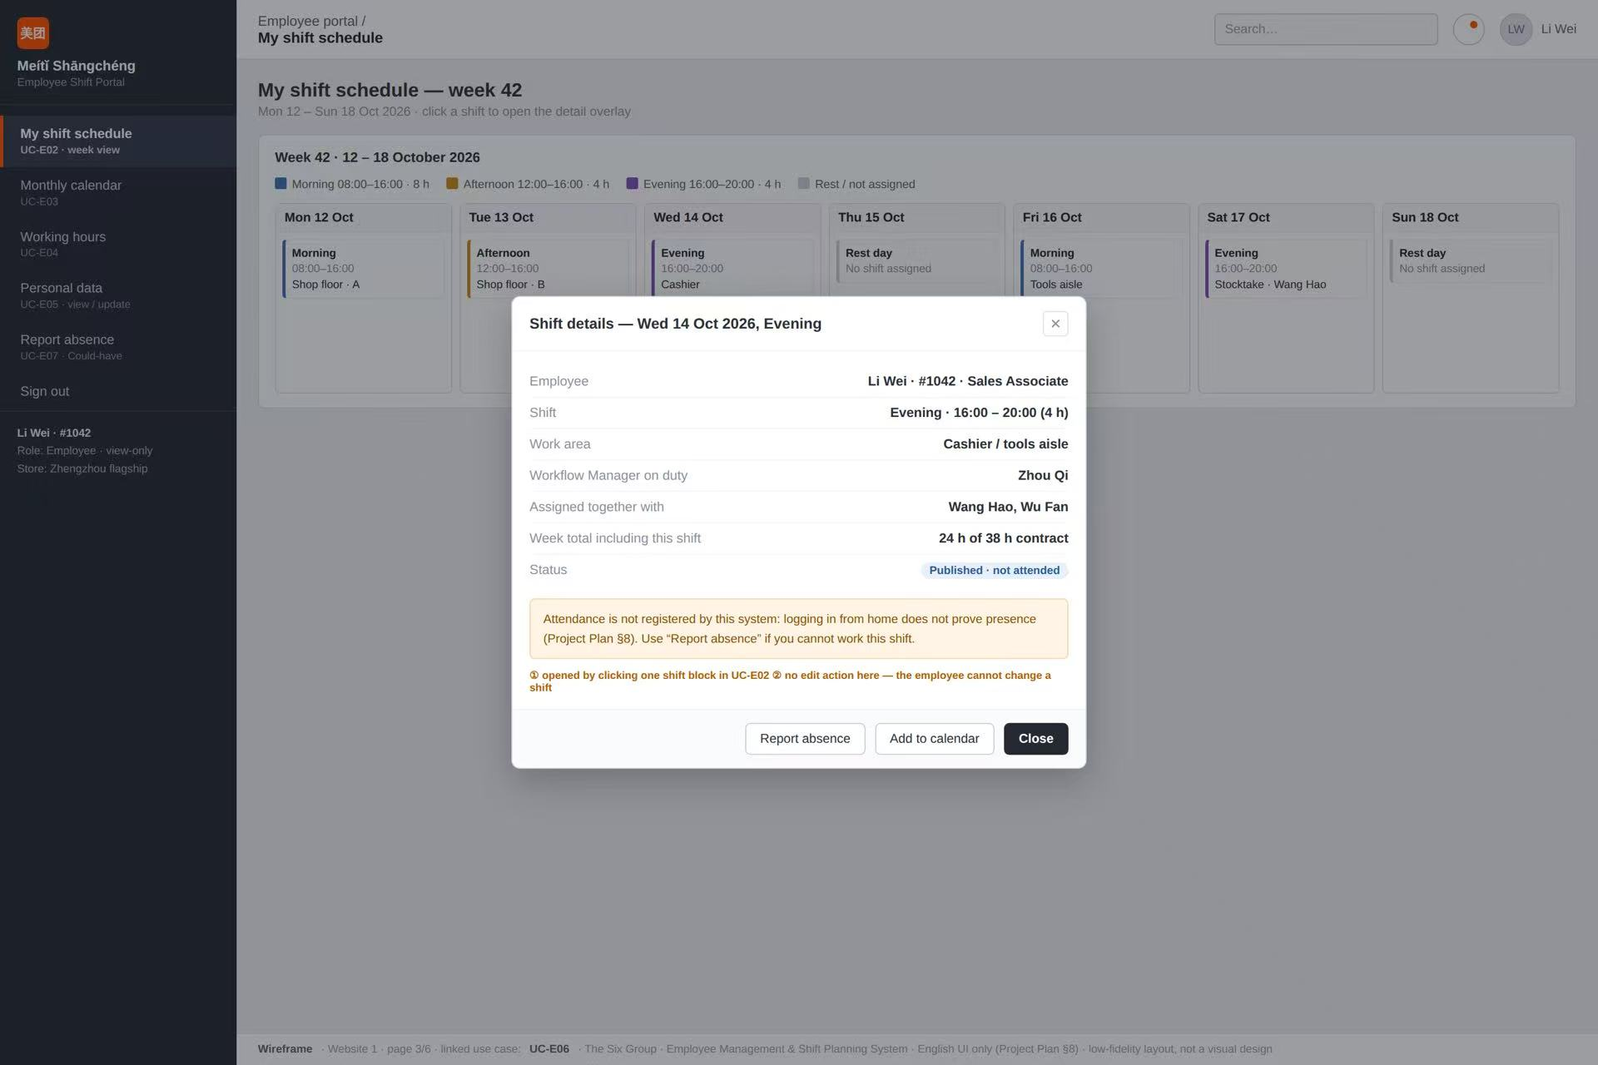
Shift details popup: It pops up to show in‑depth information for a selected shift, including work area, colleagues on duty and absence‑reporting options.
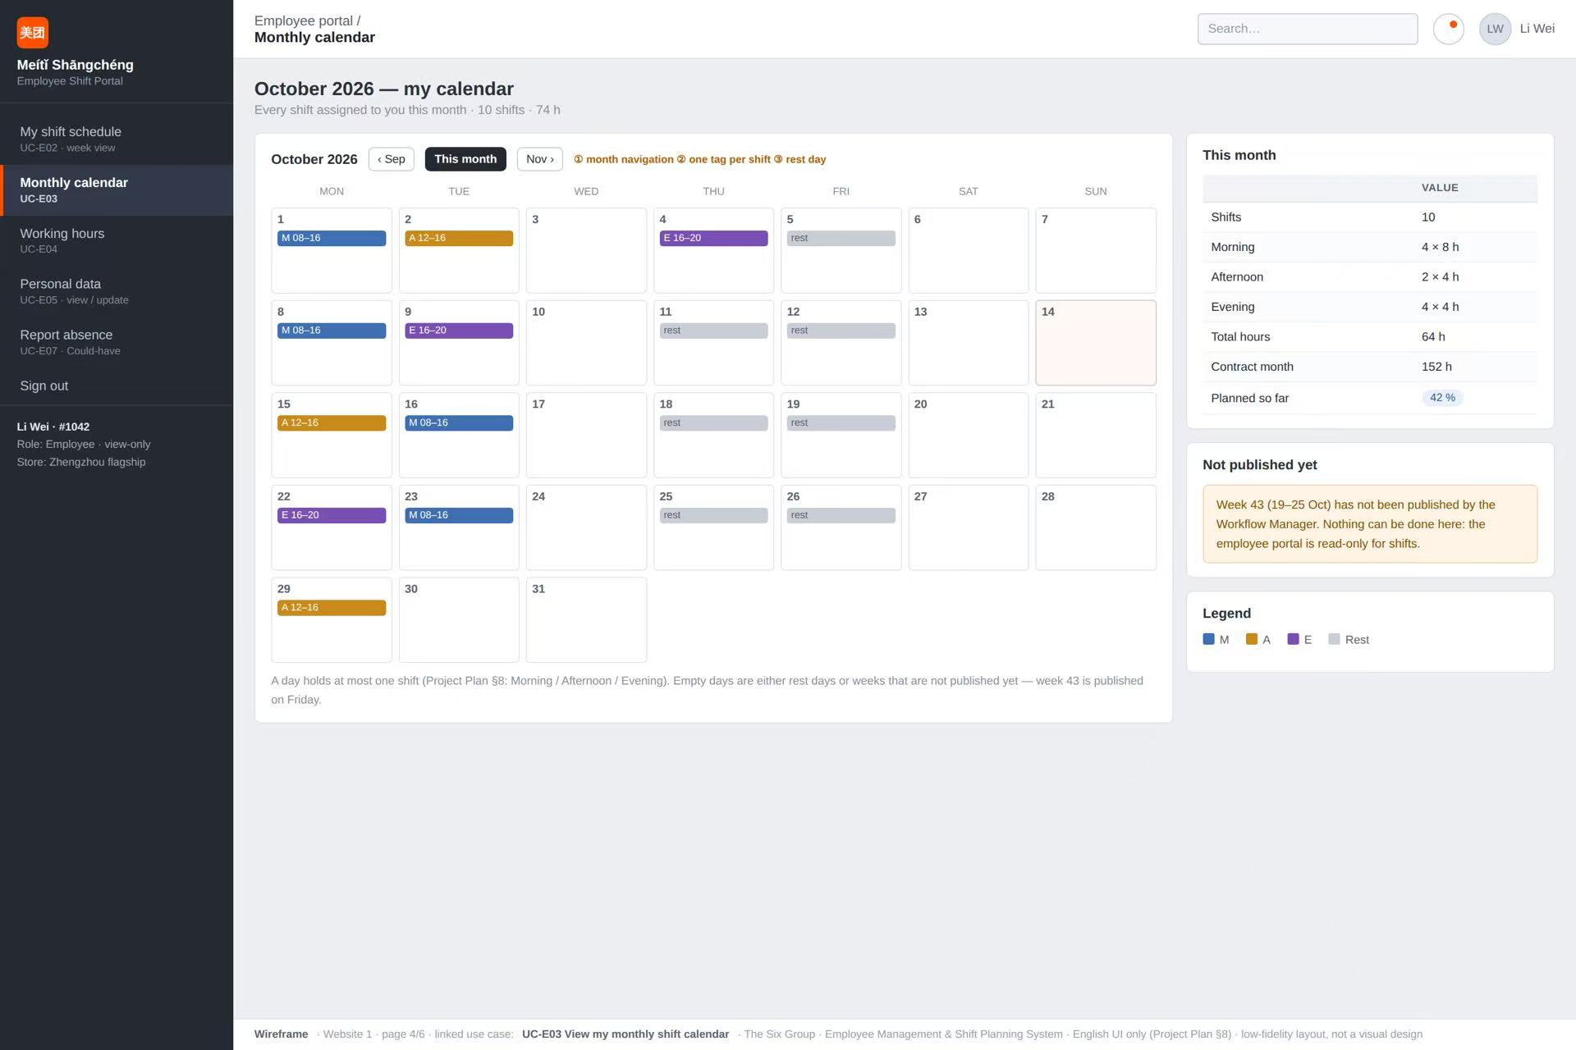
Monthly calendar: It presents a calendar‑style view of all assigned monthly shifts with summary figures for working hours.
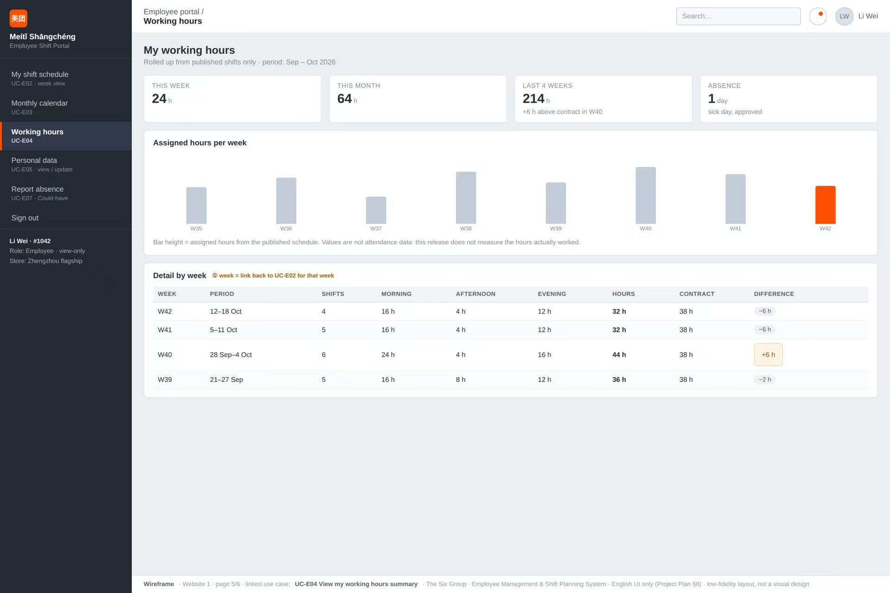
Working hours: It visualizes working‑hour statistics via metrics, bar charts and weekly breakdown tables for employees to check their labour time.
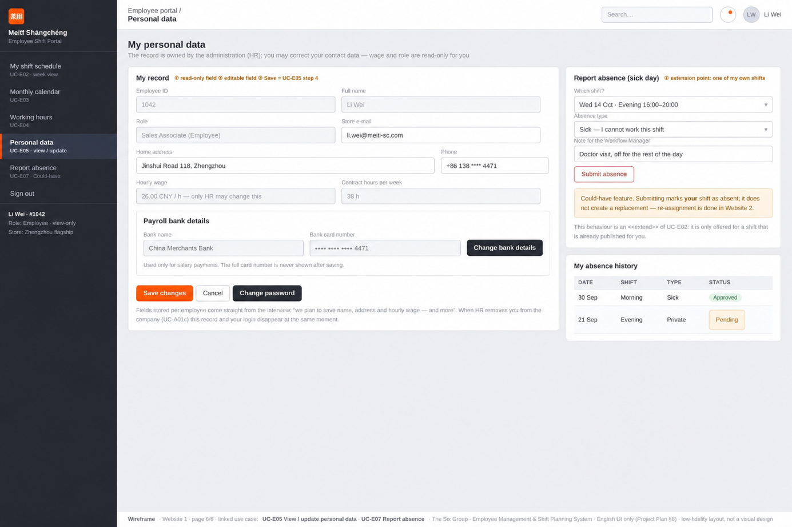
Personal data: It lets staff view their personal records, edit editable contact information, submit absence requests and review their absence application history.

8.2Administrative Management Website
1. Administration & Operations Portal Sign‑in: It provides role‑based login access for back‑office staff to enter the store management system.
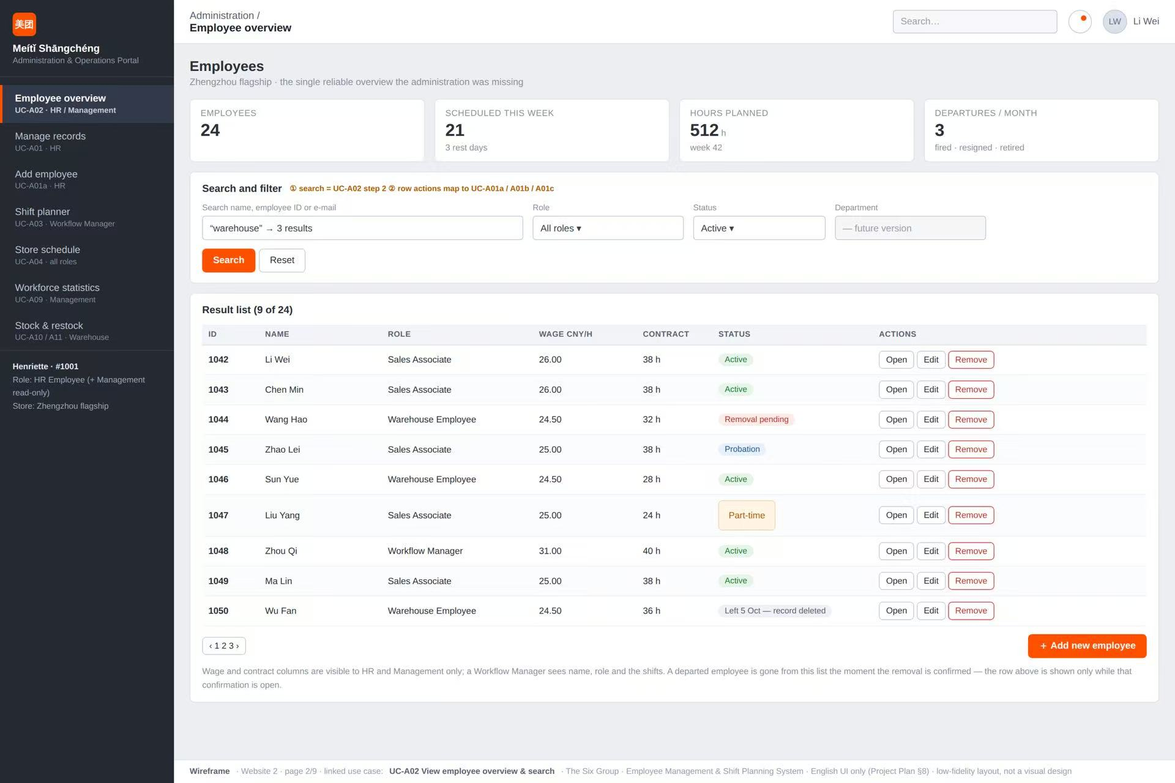
Employee overview: It delivers a searchable and filterable summary list of all staff with key employment metrics for administrators.
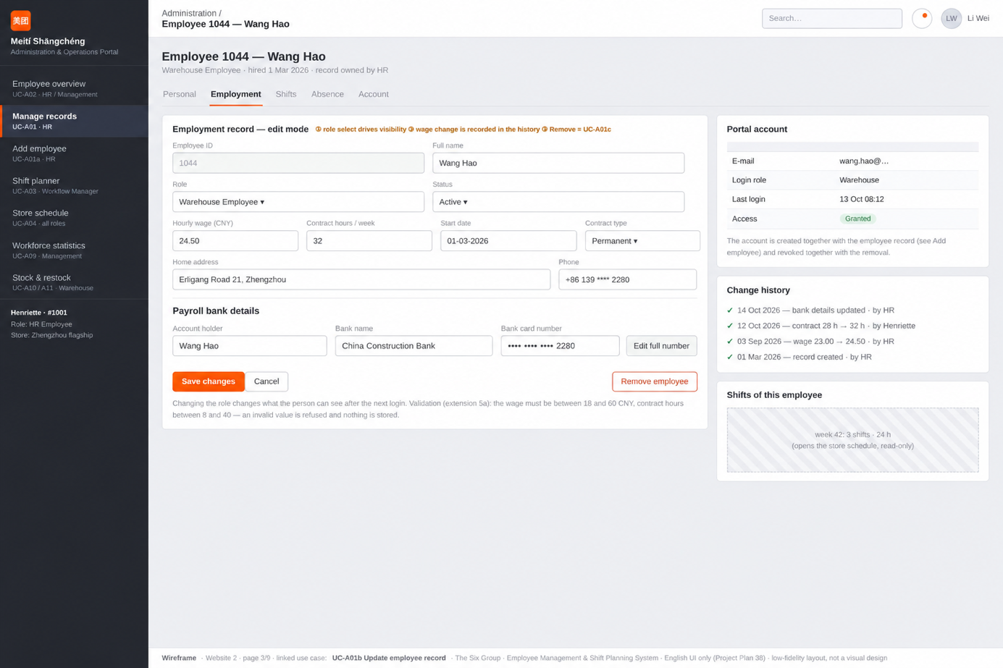
Manage records: It enables HR users to view and edit detailed personal and employment information for a selected employee.
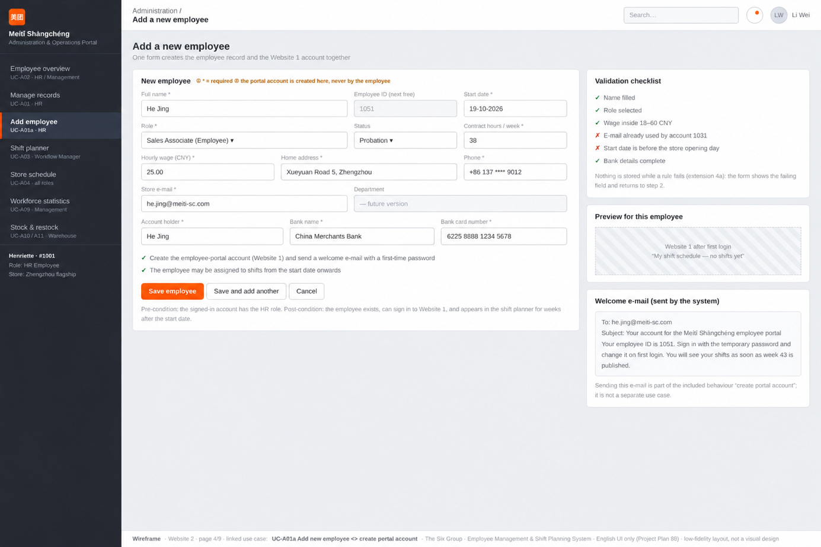
Add a new employee: It offers an input form to create new staff profiles and automatically generate their corresponding portal accounts.
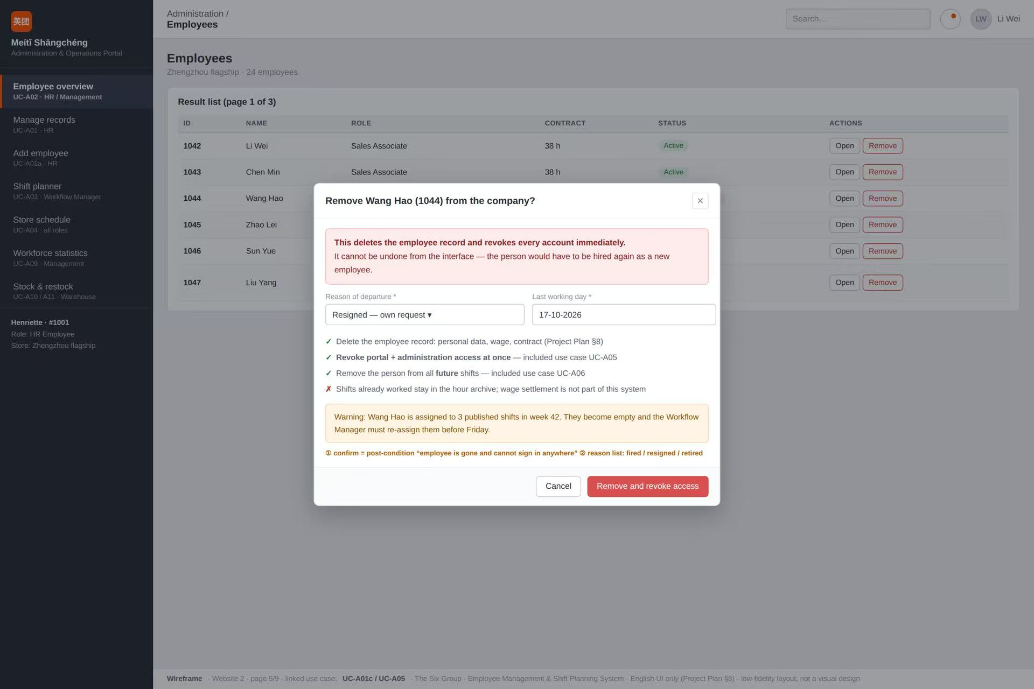
Employee removal popup: It confirms the permanent deletion of an employee’s record, access rights and future shift assignments.
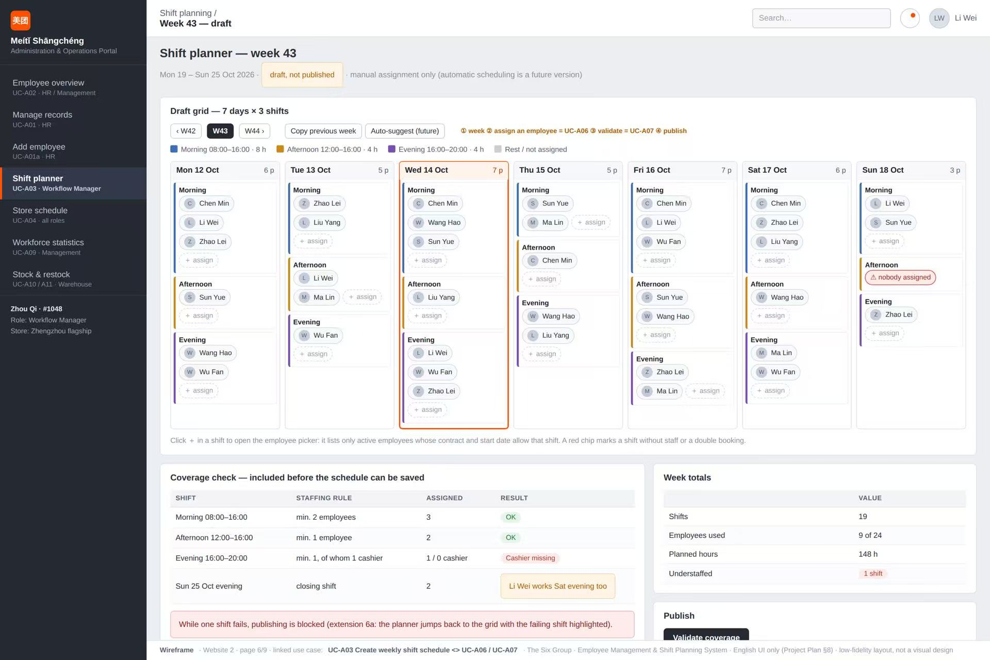
Shift planner: It allows workflow managers to draft, assign, validate and publish the weekly work schedule for all staff members.
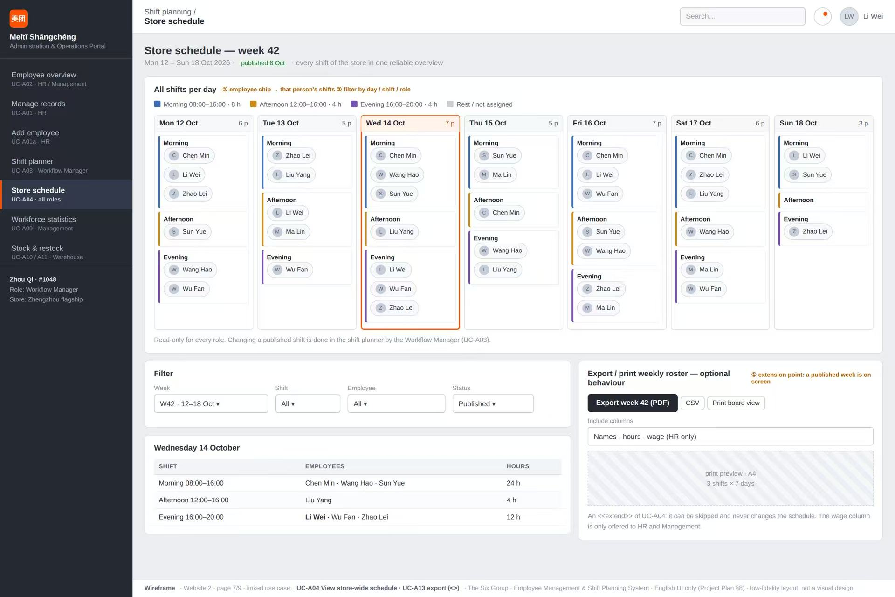
Store schedule: It presents a published week‑long overview of all store shifts and supports data export in PDF or CSV format.
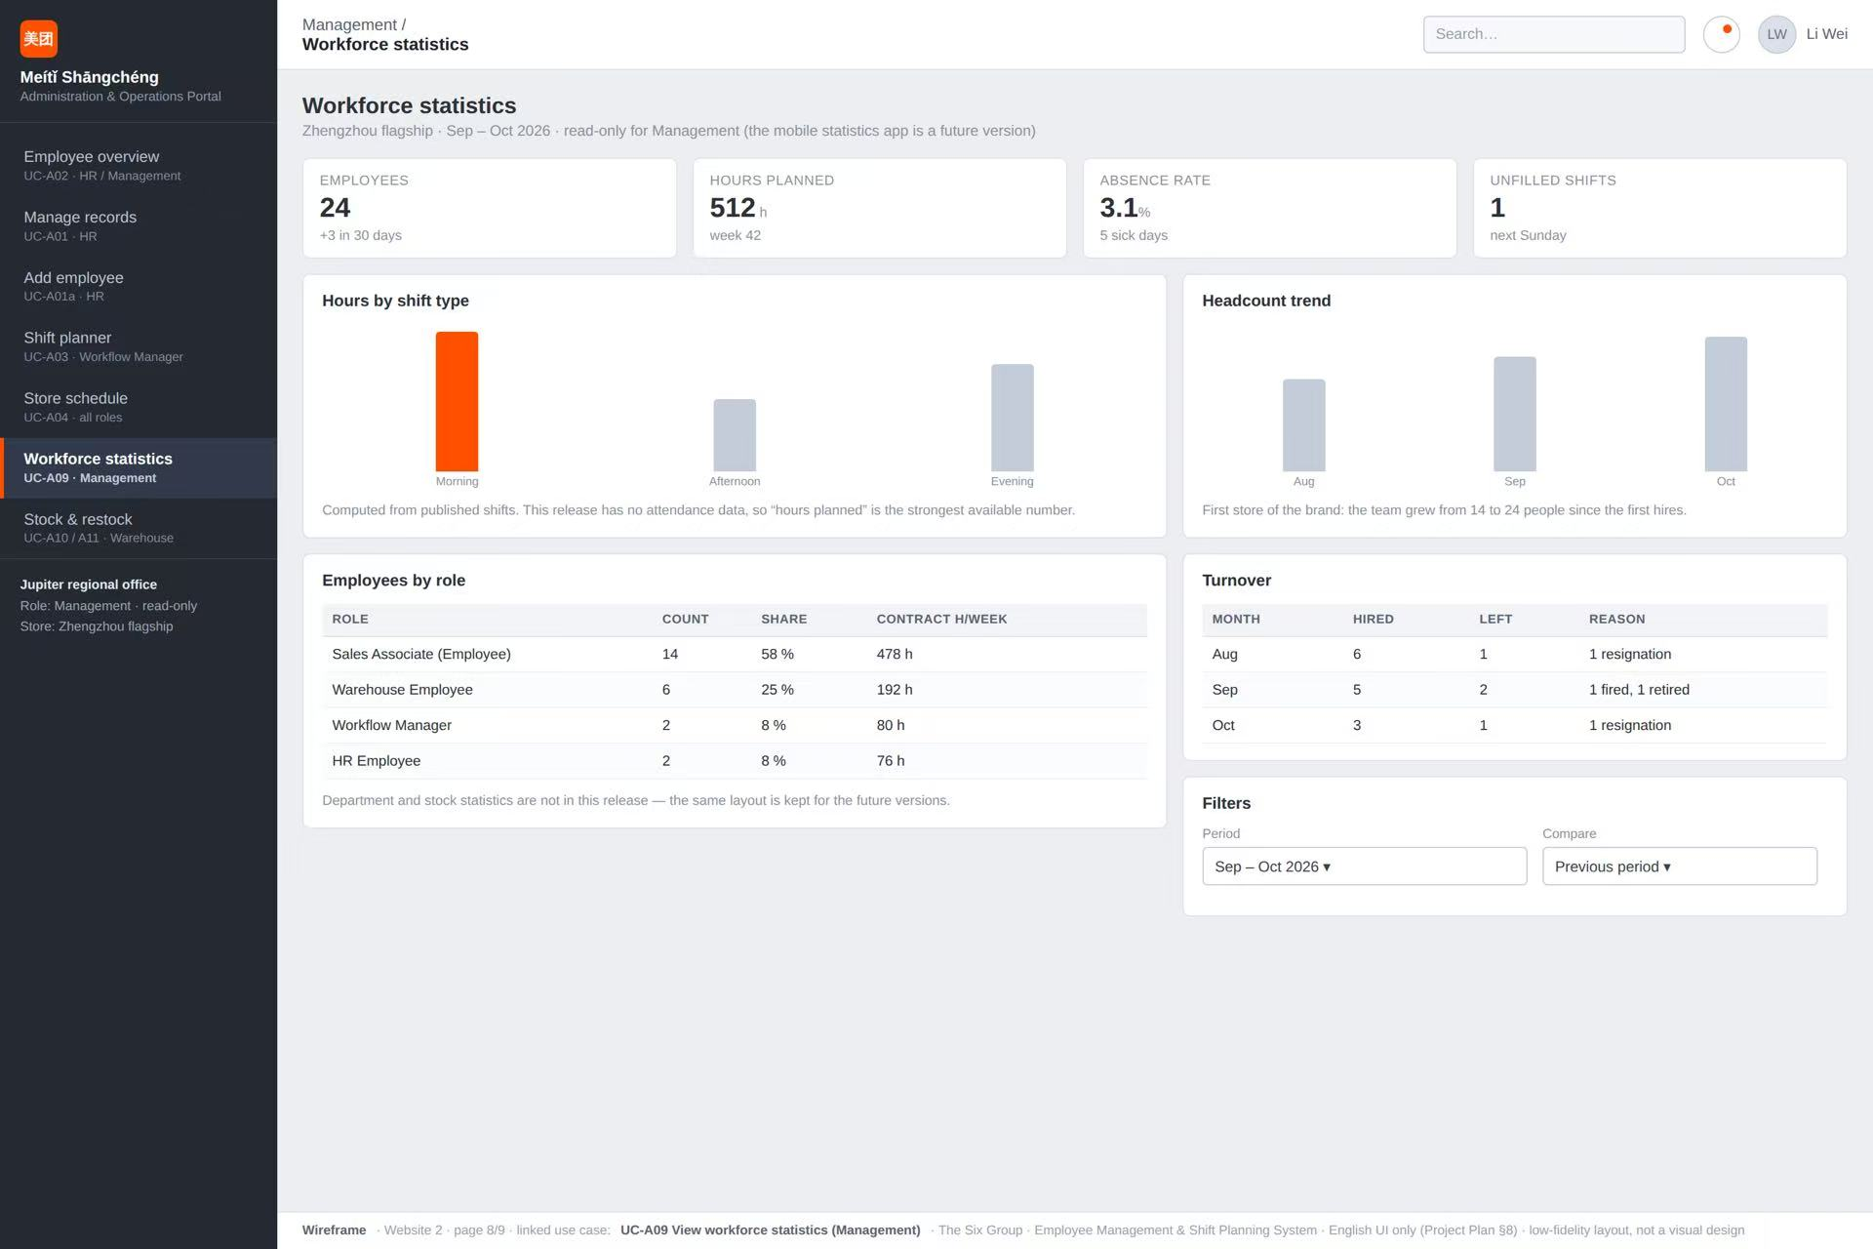
Workforce statistics: It displays visualized staffing metrics, planned hours, absence rates, headcount trends and turnover data for management review.
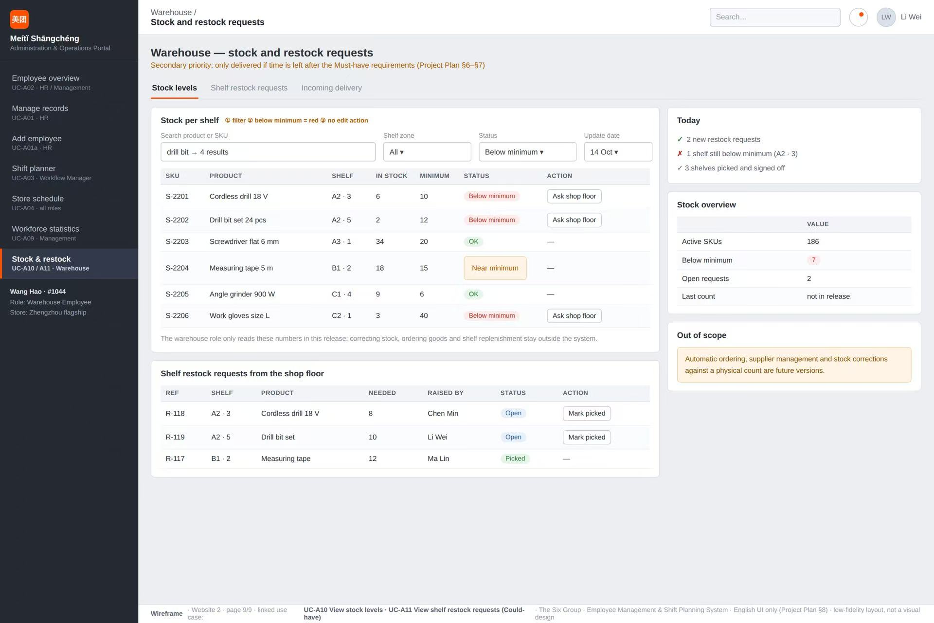
Stock & restock: It shows current inventory levels, low‑stock alerts and shelf restock requests for warehouse staff to process.

