Mandatory assignment 3

Problem 1: find the shortest path from Timisoara to Bucharest. I’ve followed Sheongs implementation of dijsktras algorithm, (Sheong 2022) which is an algorithm which finds the shortest distance from one node to all other nodes. I’ve made some modifications to the code to pick out the specified end node. (Sheong 2022)

The code can be found at (put in link)

The output of the code can be found below:

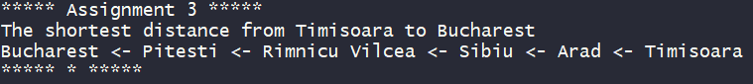
Problem 2: Find in literature two approaches to the Travelling Salesperson Problem (TSP)

In literature the travelling salesman problem is often formulated as «a salesman is required to visit each of n cities once and only once, starting from any city and returning to the original place of departure. What tour shoul he choose in order to minimize his travel distance?» (kilde)

In the graph given in the problem this is not possible. In order to visit all cities and return to the homecity our salesman will have to visit some cities I will therefore combine solutions

My first solution is to separate the graph into two graph. Using Bucharest as the splitting point. Bucharest will still be in both the graphs as illustrated below
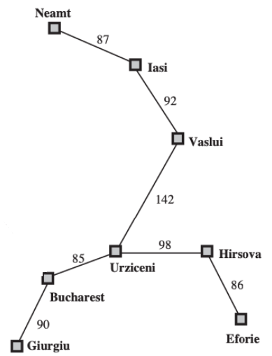
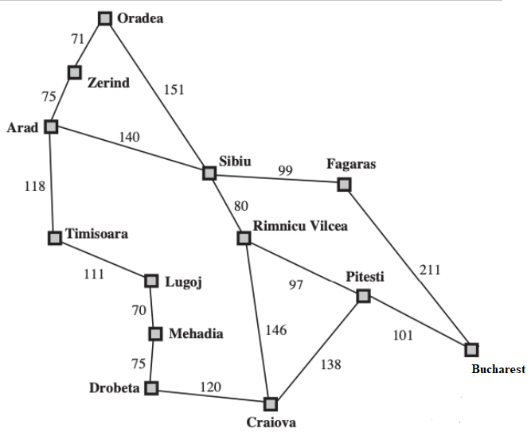

We can now calculate the optimal path for these individually. In the right graph we will have to visit some all the cities with two neighbors twice. In principle there is only one way to do this. If we for example start in Urziceni, we have to travel out to Neamt and back, to Eforie and back, and to Giurgiu and back. It doesn’t matter what order we do this in, the total distance will be the same. For the left graph it is possible to create a hamiltonian tour from any point, and we therefore can use a well known algorithm like closest insertion (Brucato 2013) or the Lin-Kernighan traveling salesman heuristic (Helsgaun 2000).

My next proposed way to solve this problem would be to make the graph into a complete graph. I would propose using dijkstra as the distance between the previously unconnected nodes. Then i would use a well known algorithm, like a nearest neighbour to find a proposition for the optimal path.

I did not manage to complete the code for both of these algorithms, but pseudo code is in the code located at (insert link)

Since i did not manage to complete the code, i did not get the chance to benchmark and compare the algorithms either, but i would assume that the first described as the second one needs to run the dijkstra algorithm for each combination of nodes which do not exist (which is most of them).

Literature:

Brucato C (2013) The travelling salesman problem https://www.mathematics.pitt.edu/sites/default/files/TSP.pdf
Sheong S (march 2022) Dijkstras algorithm in Go https://go-recipes.dev/dijkstras-algorithm-in-go-e1129b2f5c9e
Sheong S (march 2022) The stack and the heap https://go-recipes.dev/the-stack-and-the-heap-68c0c65bf3ac
Helsgaun, K. (2000). An effective implementation of the Lin–Kernighan traveling salesman heuristic. European Journal of Operational Research, 126(1), 106–130. https://doi.org/10.1016/s0377-2217(99)00284-2

