2026 TURNAROUND MECHANICAL DECOKE
Coker Furnace — PR-170002
Job Report | USADebusk | Cenovus Lima Refinery — Lima, OH
PROJECT NO. | FACILITY | EXECUTION | PROJECT MANAGER
USA26046 | Cenovus Lima Refinery | Sep 27 – 30, 2026 | Peter Campbell
WORK ORDER | SCOPE | HEATER | DURATION
82096135 | TA Mechanical Decoke | PR-170002 | 4 days

73 | 0 | 64 | 4
OPERATING HOURS | STAND-BY HOURS | PIGS RUN | PASSES
Project Information
Customer Details
FACILITY | Cenovus Lima Refinery
ADDRESS | 1150 S Metcalf St, Lima, OH 45804
WORK ORDER | 82096135
CONTACT | Kaleb Dodson
Project Details
SCOPE | 2026 turnaround mechanical decoke of the Coker Furnace
EXECUTION | September 27 – 30, 2026 (4 days)
HEATER | PR-170002 Coker Furnace
EQUIPMENT | (1) Trimax Pumper (Trimax 5) · (1) Support Unit · 4x3 Pump · Crew Truck
Crew Details
PROJECT MANAGER | Peter Campbell
SHIFT LEAD | Day — Peter Campbell, Jesse Utsey (Sep 30); Night — James McDaniel
DAYSHIFT | Marshall Douglas, Travis Trenholm, Adrian Garza, David Charles, Blake Harman
NIGHTSHIFT | Mikee Green, Justin Kelly, Jeremiah Harman
Project Duration
SCOPE | UNIT | RIG | PIG | SMART PIG | SUBTOTAL
PR-170002 Coker Furnace | Trimax 5 | 22 | 51 | 0 | 73
Stand-By Summary
No stand-by was recorded on the daily service receipts: all 73 pumping-unit hours on this heater were operating hours.

PR-170002 — Coker Furnace
Number of Passes | 4, pigged as 3 circuits: convection (4 coils looped as one), radiant A + B, radiant C + D
Total Footage | 15,904 ft (3,976 ft per pass)
Tube ID | 3.398" (4" OD tube); radiant outlet section 3.624" (4" Sch 120)
Metallurgy | 9Cr-1Mo
Return Bends | Cast 180° U-bends
Decoking Analysis: The convection section showed light fouling and the radiant section moderate fouling. The crossovers were removed, the convection was pigged as a single circuit, and the radiant passes were looped A + B and C + D with temporary 180° returns at the radiant inlet flanges. Average pigging time was approximately 51 hours per circuit.
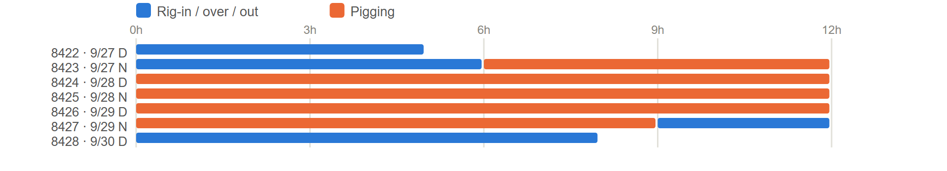
PR-170002 - task hours by shift, from the daily service receipts.
Pigs Used
SIZE — QTY | SIZE — QTY | SIZE — QTY | SIZE — QTY | SIZE — QTY
3" — 3 | 3.25" — 6 | 3.5" — 6 | 3.75" — 14 | 4" — 2
3.125" — 3 | 3.375" — 5 | 3.625" — 21 | 3.875" — 4
TOTAL — 64
Flow Tests
All convection | Passes A + B | Passes C + D
  GPM | BEFORE PSI | AFTER PSI | Δ PSI
  350 | 435 | 375 | 60
  300 | 330 | 290 | 40
  250 | 220 | 180 | 40
  GPM | BEFORE PSI | AFTER PSI | Δ PSI
  350 | 370 | 275 | 95
  300 | 290 | 200 | 90
  250 | 210 | 146 | 64
  GPM | BEFORE PSI | AFTER PSI | Δ PSI
  350 | 419 | 287 | 132
  300 | 320 | 219 | 101
  250 | 225 | 159 | 66
Project Summary
USADebusk performed the mechanical decoke of the Coker Furnace (PR-170002) for Cenovus at the Lima Refinery during the 2026 turnaround, September 27 – 30, on Trimax 5. The crossovers were removed and the heater was pigged as three circuits: the convection as one, and the radiant passes looped A + B and C + D. The heater ran 73 operating hours with no stand-by, using 64 pigs.
Project Close
The Coker Furnace was cleaned and returned to Cenovus, and all equipment was demobilized from the facility on September 30, 2026.
USADebusk thanks the Cenovus Lima team for their coordination and support throughout the turnaround, and we look forward to continuing to serve your decoking and pigging needs.
Jesse Utsey | Project Manager, USADebusk
713-252-8516 | JUtsey@USADebusk.com

