USADEBUSK
Re-imagining The Industrial Cleaning Business
USA DeBusk is driving innovation for a full range of industrial services—
delivering maintenance projects that are safe, reliable, and cost-efficient.
MECHANICAL DECOKING JOB REPORT
HF Sinclair Navajo Refinery — Artesia, New Mexico
HF Sinclair Navajo Refinery: Mechanical Decoke — H-19 & H-20 w/ Filtration
Equipment: (2) TriMax Pumpers, Filtration, (2) Support Units
Execution Date: July 10, 2026

Job Summary
Customer Details
FACILITY | HF Sinclair Navajo Refinery
ADDRESS | 501 East Main St, Artesia, NM 88210
JOB & PO # | USA26038 / PO-4200010828
CONTACT | Travis Wilson

Project Details
SCOPE | Emergency mechanical decoke — H-19 Crude Charge Heater & H-20 Vertical Crude Hydro Heater, with filtration
EXECUTION | July 10 – 17, 2026
SITE TRAINING | Site Specific
EQUIPMENT | (2) TriMax Pumpers (TriMax 3 & 5), (2) Filtration Units, (2) Support Units, (2) Crew Trucks

Crew Details
SHIFT LEAD | Day: Jesse Utsey / Dacorey Slater | Night: Sam Mixon / James McDaniel
DAYSHIFT | Jesse Utsey, Dacorey Slater, Andre M., Blake B., Dandrew
NIGHTSHIFT | Sam Mixon, James McDaniel, Kailon, Daniel, Joel, Jordan

Project Duration
SCOPE | RIGGING | PIG | SMART PIG | STAND-BY | TOTAL
H-19 Crude Charge Heater | 9 | 74 | 6 | 55 | 144
H-20 Vertical Crude Hydro | 20 | 98 | 0 | 19 | 137
TOTAL | 29 | 172 | 6 | 74 | 281
All hours in 12-hour shift cycles. Pigging hours reflect actual coke removal time; stand-by reflects client-side delays (heater readiness, weather).

Pigs Used
SIZE | TC (Pin) | HR | FOAM | SWAB / HC | TOTAL
2" | 7 |  |  |  | 7
2.25" | 12 | 1 |  |  | 13
2.3" | 2 |  |  |  | 2
2.375" | 6 |  |  |  | 6
2.5" | 4 |  |  |  | 4
2.6" | 1 |  |  |  | 1
2.625" | 2 |  |  |  | 2
2.7" | 1 |  |  |  | 1
2.75" | 3 | 1 |  |  | 4
2.875" | 2 | 3 |  |  | 5
3" | 13 | 5 | 6 |  | 24
3.125" | 11 | 4 |  |  | 15
3.25" | 19 | 18 |  |  | 37
3.375" | 1 |  |  |  | 1
3.5" |  | 1 |  |  | 1
3.625" | 3 |  |  |  | 3
3.75" | 6 | 1 |  |  | 7
3.8" | 1 |  |  |  | 1
3.875" | 3 | 2 | 7 |  | 12
4" | 7 | 1 | 5 | 2 | 15
4.125" | 17 |  |  |  | 17
4.25" | 27 | 22 |  |  | 49
4.5" |  | 4 |  |  | 4
6.5" |  |  |  | 32 | 32
Honeycomb (72–107 mm) |  |  |  | 35 | 35
TOTAL | 148 | 63 | 18 | 34+35 HC | 298
TC = tungsten-carbide pin pigs; HR = Hell Razor / hardened pigs; FOAM = pin & gauge foams; SWAB = 6.5" dewatering swabs; HC = honeycomb gauge pigs. Pig usage is combined across both heaters.

H-19 — Crude Charge Heater
FURNACE | H-19 CRUDE CHARGE HEATER
SECTION | Convection + Radiant
CONFIGURATION | 2 coils looped to 1 pass (Pass 1 & 2) — run as planned
TOTAL FOOTAGE | ~4,934 ft total (looped pig path ~5,754 ft incl. crossovers/loop)
TUBE LENGTH + BEND | Approximately 19.6’ (conv) / 31.0’ (rad)
# OF TUBES | Convection 80 / Radiant 106 (2 coils)
TUBE I.D.’s | Convection 4.026" (4.5" OD × 0.237) / Radiant 3.068" (3.5" OD × 0.216) + 4.026" outlet
METALLURGY | 9 Chrome (both sections)
TUBE ARRANGEMENT | Convection Horizontal / Radiant Vertical
INLET / OUTLET | (2) 4" launchers at control valve station (grade)
RETURN BENDS | Welded 180° U-bends; temp 180° loop at radiant outlets
NOTES | Smart pigging performed (Quest). Dewatering required removing the temp radiant-outlet loop and dewatering each coil individually — see analysis.

Timeline — H-19
TICKET | START | FINISH | TASK | HRS | DETAIL
11276 | 7/11 07:00 | 7/12 07:00 | Stand-by | 24 | Awaiting heater release; equipment staged in laydown yard.
11277 / 11617 | 7/12 07:00 | 7/13 07:00 | Stand-by | 24 | Continued client delay — heater prep and weather.
11278 | 7/13 07:00 | 7/13 19:00 | Rig-in / Pig | 12 | Rigged launchers; began pigging Pass 1 & 2 (looped).
11618 | 7/13 19:00 | 7/14 07:00 | Pigging | 12 | Bi-directional pigging, convection-heavy fouling.
— | 7/14 07:00 | 7/15 19:00 | Pigging | 36 | Continued pig progression; Quest smart-pig support (2–4 h/shift).
11280 / 11620 | 7/15 19:00 | 7/16 19:00 | Pigging / Smart Pig | 24 | Final passes; Quest smart pig — minimal residual coke detected.
10859 | 7/16 19:00 | 7/17 | Dewater / Rig-out | — | Removed temp loop, dewatered coils individually; rigged out.

H-20 — Vertical Crude Hydro Heater
FURNACE | H-20 VERTICAL CRUDE HYDRO HEATER
SECTION | Convection + Radiant
CONFIGURATION | As-built: 4 coils looped to 2 passes (temp 180’s: Pass 1&3 and Pass 2&4 radiant outlets). Pass 4 initially isolated (plugged pre-decoke).
TOTAL FOOTAGE | ~1,734 ft per circuit basis (conv 300 / rad 1,134 per pass)
TUBE LENGTH + BEND | Approximately 21.4’ (conv) / 37.8’ (rad)
# OF TUBES | Convection 28 / Radiant 60
TUBE I.D.’s | Convection 4.026" (4.5" OD × 0.237) / Radiant 3.068" (3.5" OD × 0.216)
METALLURGY | 9 Chrome (both sections)
TUBE ARRANGEMENT | Convection Horizontal / Radiant Vertical
INLET / OUTLET | Convection (4) 4" launchers, 10’ from grade; Radiant (2) 4" launchers at grade
RETURN BENDS | Welded 180° U-bends; temp 180° spools installed per as-built loop
NOTES | Pass 4 plugged pre-decoke — isolated and cleaned first, then re-looped. Pass 3 radiant severely restricted (3 heavy restrictions); forced open one-way before bi-directional pigging.

Timeline — H-20
TICKET | START | FINISH | TASK | HRS | DETAIL
10851 | 7/10 | 7/10 | Mobilization | — | Equipment transport from Deer Park; site badging.
10852 | 7/11 07:00 | 7/11 19:00 | Stand-by | 12 | Awaiting HF Sinclair to release crew.
11106 | 7/11 19:00 | 7/12 07:00 | Rig-in / Pig | 12 | Rigged launchers; H-20 released, began pigging (5 h rig-in, 6 h pig).
10853 | 7/12 07:00 | 7/12 19:00 | Pigging | 12 | Pig progression; 2.5 h weather delay.
11107 | 7/12 19:00 | 7/13 07:00 | Rig-over / Pig | 12 | Rig-over 1.5 h; continued pigging.
10854 / 11108 | 7/13 07:00 | 7/14 07:00 | Pigging | 24 | Pass 4 isolated & cleaned; Pass 3 restriction forced open.
— | 7/14 07:00 | 7/15 19:00 | Pigging | 36 | Re-looped to 4-coil / 2-pass config; continuous pigging.
10857 | 7/16 07:00 | 7/16 19:00 | Rig-out | 5 | Rigged out TriMax 3; demobilized Press 1.
10860 | 7/17 | 7/17 | Rig-out | 8.5 | TriMax 5 rig-over completed final H-20 dewater & rig-out.

Flow Tests & Decoking Analysis
Each table shows the pre-decoke flow test (left) beside the post-decoke flow test (right). Blank cells indicate a reading to be finalized.
H-19 — Pass 1 & 2 (Pre | Post)
RPM | PSI | GPM |  | RPM | PSI | GPM
1900 | 500 | 400 |  | 1770 | 420 | 400
1670 | 390 | 350 |  | 1530 | 320 | 350
1480 | 280 | 300 |  | 1350 | 250 | 300
1220 | 205 | 250 |  | 1100 | 165 | 250
H-20 — Pass 1 & 3 (Pre | Post)
RPM | PSI | GPM |  | RPM | PSI | GPM
1750 | 380 | 250 |  | 1220 | 225 | 230
1400 | 260 | 300 |  | 1150 | 160 | 200
1100 | 145 | 150 |  | 980 | 95 | 150
800 | 70 | 160 |  | 755 | 30 | 100
H-20 — Pass 2 & 4 (Pre | Post to be finalized)
RPM | PSI | GPM |  | RPM | PSI | GPM
1700 | 388 | 400
1506 | 305 | 350
1298 | 229 | 300
1084 | 169 | 250
H-20 — Pass 3 & 4 Convection Only (Pre | Post to be finalized)
RPM | PSI | GPM |  | RPM | PSI | GPM
1900 | 440 | 550
1700 | 365 | 500
1500 | 295 | 450
1400 | 235 | 400
H-20 — Pass 4 Radiant Only (isolated) (Pre | Post)
RPM | PSI | GPM |  | RPM | PSI | GPM
1570 | 385 | 400 |  | 1280 | 237 | 400
1390 | 318 | 350 |  | 1132 | 193 | 350
1178 | 238 | 300 |  | 991 | 154 | 300
978 | 172 | 250 |  | 820 | 114 | 250

Decoking Summary — H-19 Crude Charge Heater
Deposit Localization & Concentration: H-19 was moderately coked. The most severe deposits were located within the 4" convection tubes, while the 3" radiant tubes carried only light fouling, concentrated near the radiant inlet tubes.
Decoking Analysis: The looped passes were pigged bi-directionally without major issue. Some fouling proved difficult to remove within the pigging window; a Quest smart pig run after completion detected only a minimal amount of residual coke. Dewatering the looped passes proved difficult — a 1600 CFM compressor tripped a sensor on back pressure, and a backup 1600 CFM unit likewise failed. The temporary radiant-outlet loop was ultimately removed from the top of the can and each coil dewatered individually.
Decoking Summary — H-20 Vertical Crude Hydro Heater
Deposit Localization & Concentration: Fouling severity ran Pass 3 ≫ Pass 4 > Pass 1 ≈ Pass 2. Pass 4 was plugged prior to the decoke; Passes 1 and 2 were moderately fouled. Pass 3’s radiant section was severely restricted, with three separate heavy restrictions.
Decoking Analysis: Because Pass 4 was plugged, its radiant coil was isolated first — launchers and receivers were installed at the Pass 4 radiant inlet and outlet flanges and it was cleaned independently. Once its restrictions were removed, the heater was set up in a 4-coil looped-to-2-pass configuration by installing temporary 180° spools connecting the Pass 1 & 3 and Pass 2 & 4 radiant outlet flanges; this configuration held for the remainder of the project. On Pass 3, TriMax 3 forced the restriction out using its own pumps; 2" pigs run to establish flow returned badly damaged, and pigs were forced through one-way until enough flow was established to pig bi-directionally.
Cleaning Results — H-20 Pass 3 Pig Progression
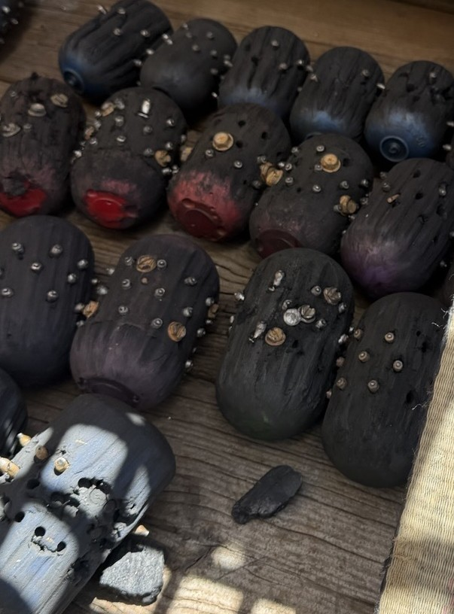
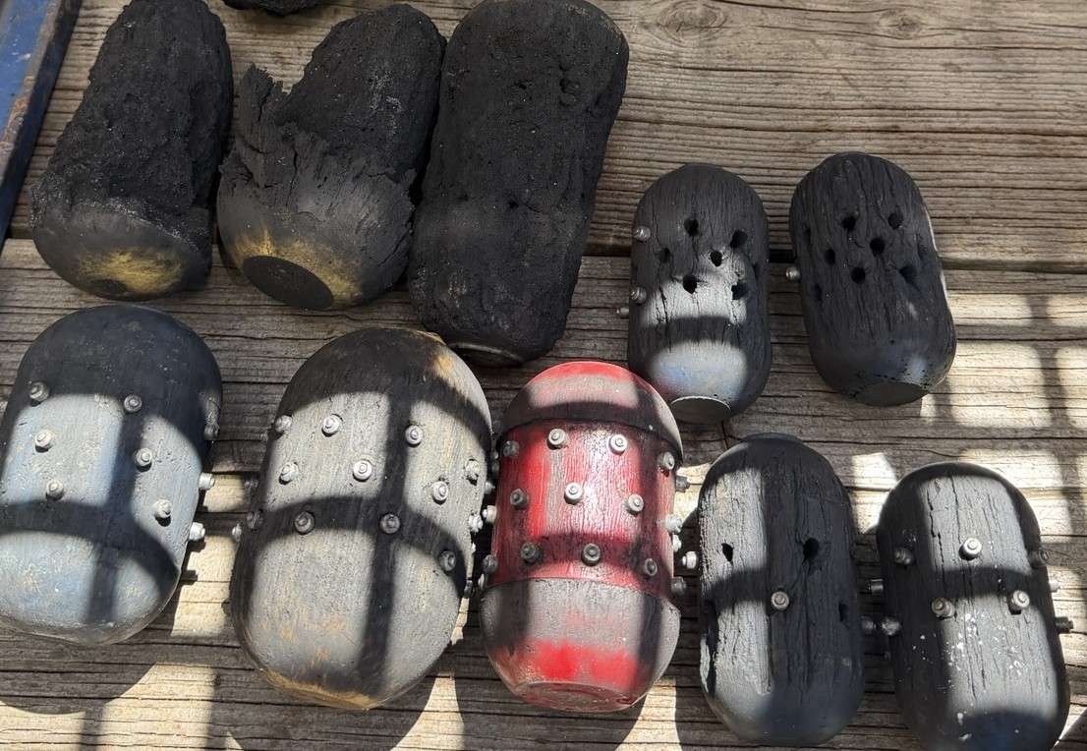

Dacorey Slater
Project Manager, USADeBusk
Cell: [PM cell — to be added]
[PM email — to be added]

