2026 TURNAROUND MECHANICAL DECOKE
Cenovus Lima — Crude, Vacuum, HDS & Coker Furnaces
Job Report | USADebusk | Cenovus Lima Refinery — Lima, OH
PROJECT NO. | FACILITY | EXECUTION | PROJECT MANAGER
USA26046 | Cenovus Lima Refinery | Sep 17 – 30, 2026 | Jesse Utsey · Peter Campbell
WORK ORDERS | SCOPE | HEATERS | DURATION
Crude 82036534 · Vacuum 82036776 · Coker 82096135 | TA Mechanical Decoke | 4 | 14 days

4 | 501.5 | 378 | 3
HEATERS CLEANED | OPERATING HOURS | PIGS RUN | HEATERS SMART-PIGGED
Project Information
Customer Details
FACILITY | Cenovus Lima Refinery
ADDRESS | 1150 S Metcalf St, Lima, OH 45804
WORK ORDERS | Crude 82036534 · Vacuum 82036776 · Coker 82096135
CONTACT | Alfredo Trevino (Crude, Vacuum, HDS) · Kaleb Dodson (Coker)
Project Details
SCOPE | 2026 turnaround mechanical decoke of four fired heaters, with filtration and smart-pig support
EXECUTION | September 17 – 30, 2026 (14 days)
HEATERS | PR-170028 Crude · PR-170029 Vacuum Charge · PR-175169 HDS · PR-170002 Coker
EQUIPMENT | (2) Trimax Pumpers (Trimax 5 & 6) · (2) Support Units · (2) Filter Presses · Crew Trucks
Crew Details
PROJECT MANAGER | Jesse Utsey (Vacuum) · Peter Campbell (Crude, HDS, Coker)
SHIFT LEAD | Day — Jesse Utsey, Peter Campbell; Night — Sam Mixon, James McDaniel
DAYSHIFT | Danilo Ramirez, Blake Harman, Blake Baugh, Rodney Lynch, Brody Lebleau, David Charles, Adrian Garza, Marshall Douglas, Travis Trenholm
NIGHTSHIFT | Joel Ruiz, Tyler Garza, Justin Kelly, Mikee Green, Jeremiah Harman
Project Duration
SCOPE | UNIT | RIG | PIG | SMART PIG | SUBTOTAL
PR-170028 Crude Furnace | Trimax 5 | 35.75 | 118 | 38.25 | 192
PR-170029 Vacuum Charge Furnace | Trimax 6 | 58.5 | 63 | 74 | 195.5
PR-175169 HDS Furnace | Trimax 5 | 16 | 20.5 | 4.5 | 41
PR-170002 Coker Furnace | Trimax 5 | 22 | 51 | 0 | 73
TOTAL |  | 132.25 | 252.5 | 116.75 | 501.5
Stand-By Summary
Stand-by is on-site time during which the pumping units were not actively pigging. Cause is recorded from the daily service receipts.
DATES | HOURS | CAUSE
Sep 19 – 21 (7077–7081) | 49 | Awaiting installation of the 12" radiant-outlet launchers (Vacuum)
Sep 26 (7091) | 3 | Awaiting relocation of the 12" launchers to passes 5, 7, 8 (Vacuum)
Sep 25 (8417) | 1 | Site safety review of hose routing near the catalyst job (HDS)
Sep 27 (8420) | 1 | Awaiting a 1600 CFM compressor to dewater (HDS)
TOTAL | 54
Combined project total: 501.5 operating hours plus 54 stand-by hours — 555.5 pumping-unit hours.

PR-170028 — Crude Furnace
Number of Passes | 8, pigged individually
Total Footage | 23,856 ft (2,982 ft per pass)
Convection Tube ID | 5.761" (6" Sch 80S)
Radiant Tube ID | 7.625" (8" Sch 80S)
Metallurgy | A312 TP317/317L
Return Bends | 180° short-radius
Smart Pigging | Yes — Intero
Decoking Analysis: Fouling was concentrated in the upper 8" radiant tubes, tubes 1 through 5, with lighter fouling through the balance of the coil. Average pigging time was approximately 39 hours per pass.
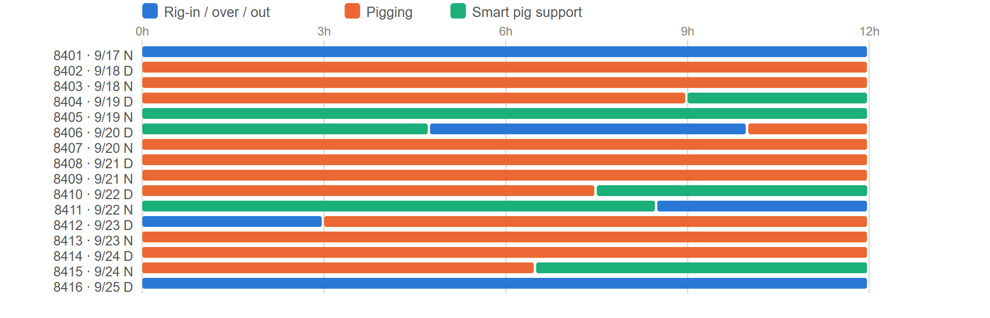
PR-170028 - task hours by shift, from the daily service receipts.
Pigs Used
SIZE — QTY | SIZE — QTY | SIZE — QTY | SIZE — QTY
6" — 30 | 6.25" — 50 | 8" — 40 | 8.5" — 12
6.125" — 12 | 7.75" — 3 | 8.25" — 54
TOTAL — 201
Flow Tests
Pass 1 | Pass 2
  GPM | BEFORE PSI | AFTER PSI | Δ PSI
  750 | 310 | 270 | 40
  700 | 285 | 255 | 30
  650 | 250 | 225 | 25
  GPM | BEFORE PSI | AFTER PSI | Δ PSI
  750 | 315 | 280 | 35
  700 | 295 | 270 | 25
  650 | 270 | 255 | 15
Pass 3 | Pass 4
  GPM | BEFORE PSI | AFTER PSI | Δ PSI
  750 | 350 | 305 | 45
  650 | 275 | 220 | 55
  550 | 220 | 165 | 55
  GPM | BEFORE PSI | AFTER PSI | Δ PSI
  750 | 324 | 295 | 29
  650 | 248 | 230 | 18
  550 | 177 | 165 | 12
Pass 5 | Pass 6
  GPM | BEFORE PSI | AFTER PSI | Δ PSI
  750 | 270 | 245 | 25
  650 | 215 | 190 | 25
  550 | 155 | 125 | 30
  GPM | BEFORE PSI | AFTER PSI | Δ PSI
  800 | 300 | 285 | 15
  700 | 280 | 255 | 25
  600 | 240 | 205 | 35
Pass 7 | Pass 8
  GPM | BEFORE PSI | AFTER PSI | Δ PSI
  800 | 290 | 265 | 25
  700 | 265 | 240 | 25
  600 | 230 | 205 | 25
  GPM | BEFORE PSI | AFTER PSI | Δ PSI
  800 | 250 | 221 | 29
  700 | 220 | 190 | 30
  600 | 200 | 165 | 35

PR-170029 — Vacuum Charge Furnace
Number of Passes | 8, pigged individually
Total Footage | 7,054 ft (882 ft per pass)
Convection Tube ID | 4.000"
Radiant Tube ID | 3.826" · 5.761" · 7.813" · 9.750" · 11.750" (4" to 12")
Metallurgy | A312 TP317/317L
Return Bends | 180° seamless
Smart Pigging | Yes — Intero
Decoking Analysis: Passes 4 and 5 carried the heaviest fouling, pass 5 the most. In pass 5, fouling was heavy in the 12" section, moderate in the 10" and 4" sections, and light in the 6" and 8" sections. In pass 4, it was moderate in the 12", light to moderate in the 10", and light in the 8", 6" and 4" sections. The remaining six passes showed light fouling throughout. The external 6" convection inlet piping, between the control valve and the 4" convection inlet tube, was heavily fouled on all eight passes, enough to keep 4" pigs from entering the convection section, and was cleaned first on each pass. Average pigging time was approximately 21 hours per pass.
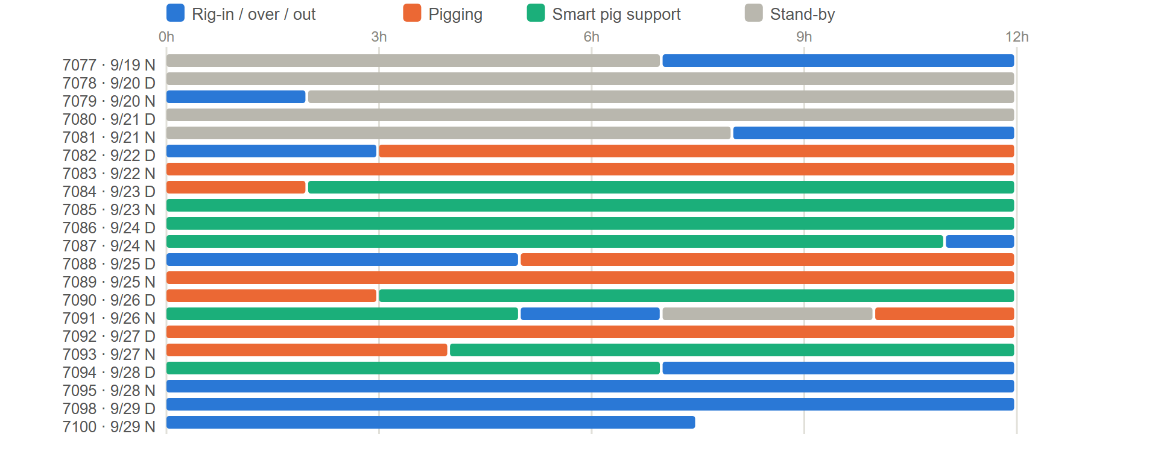
PR-170029 - task hours by shift, from the daily service receipts.
Pigs Used
SIZE — QTY | SIZE — QTY | SIZE — QTY | SIZE — QTY
3.75" — 4 | 4.125" — 15 | 6.25" — 6 | 10" — 20
3.875" — 1 | 4.25" — 4 | 8" — 7 | 12" — 6
4" — 22 | 6" — 10 | 8.25" — 2
TOTAL — 97
Flow Tests
Pass 1 | Pass 2
  GPM | BEFORE PSI | AFTER PSI | Δ PSI
  700 | 295 | 220 | 75
  650 | 260 | 185 | 75
  600 | 225 | 165 | 60
  GPM | BEFORE PSI | AFTER PSI | Δ PSI
  700 | 275 | 225 | 50
  650 | 235 | 195 | 40
  600 | 205 | 170 | 35
Pass 3 | Pass 4
  GPM | BEFORE PSI | AFTER PSI | Δ PSI
  700 | 332 | 282 | 50
  650 | 290 | 250 | 40
  600 | 255 | 220 | 35
  GPM | BEFORE PSI | AFTER PSI | Δ PSI
  700 | 280 | 210 | 70
  650 | 235 | 188 | 47
  600 | 210 | 160 | 50
Pass 5 | Pass 6
  GPM | BEFORE PSI | AFTER PSI | Δ PSI
  700 | 270 | 220 | 50
  650 | 235 | 190 | 45
  600 | 202 | 160 | 42
  GPM | BEFORE PSI | AFTER PSI | Δ PSI
  700 | 285 | 225 | 60
  650 | 235 | 195 | 40
  600 | 210 | 165 | 45
Pass 7 | Pass 8
  GPM | BEFORE PSI | AFTER PSI | Δ PSI
  700 | 260 | 220 | 40
  650 | 225 | 185 | 40
  600 | 195 | 160 | 35
  GPM | BEFORE PSI | AFTER PSI | Δ PSI
  700 | 320 | 280 | 40
  650 | 280 | 250 | 30
  600 | 240 | 220 | 20
Images
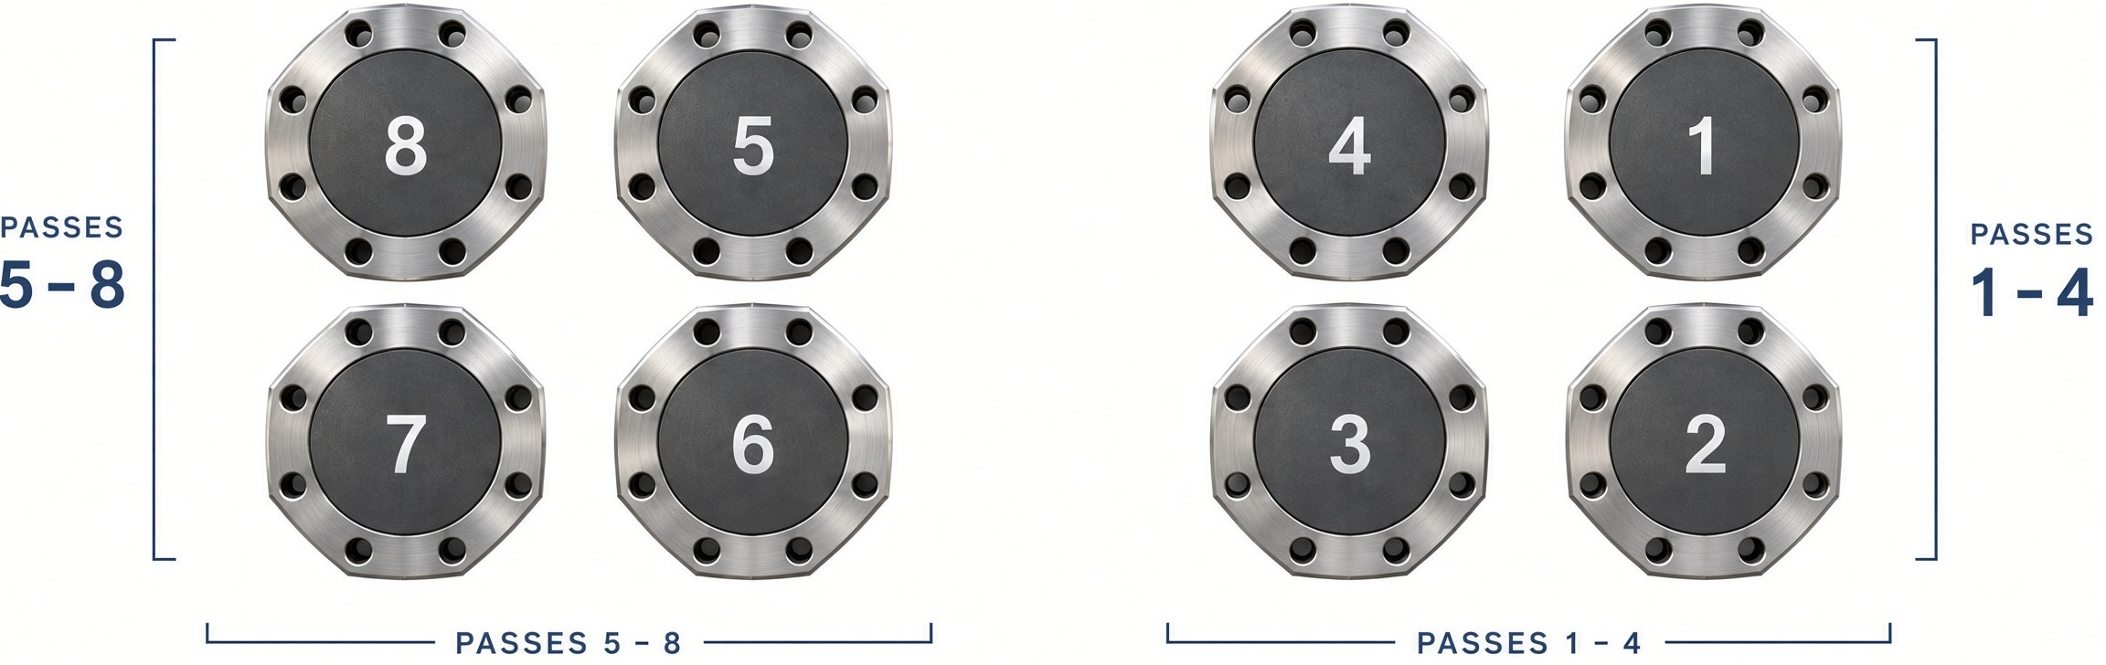 | 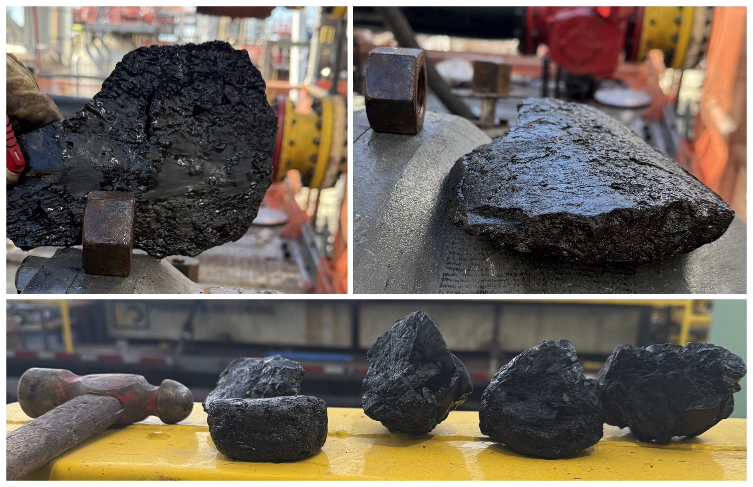
Radiant outlet labels and orientation, viewed facing the outlets. Each outlet connects to the convection inlet of the same pass number. | Top: coke removed from the 12" tube, pass 5. Bottom: deposits removed from the external 6" convection inlet piping, collected from all eight passes.

PR-175169 — HDS Furnace
Number of Passes | 4, looped into 2 circuits (passes 1 + 2, passes 3 + 4)
Total Footage | 3,600 ft (900 ft per pass)
Radiant Tube ID | 5.885"
Metallurgy | A335 P5 (radiant)
Smart Pigging | Yes
Decoking Analysis: Light fouling was found throughout the convection and radiant sections. Average pigging time was approximately 20.5 hours per circuit.
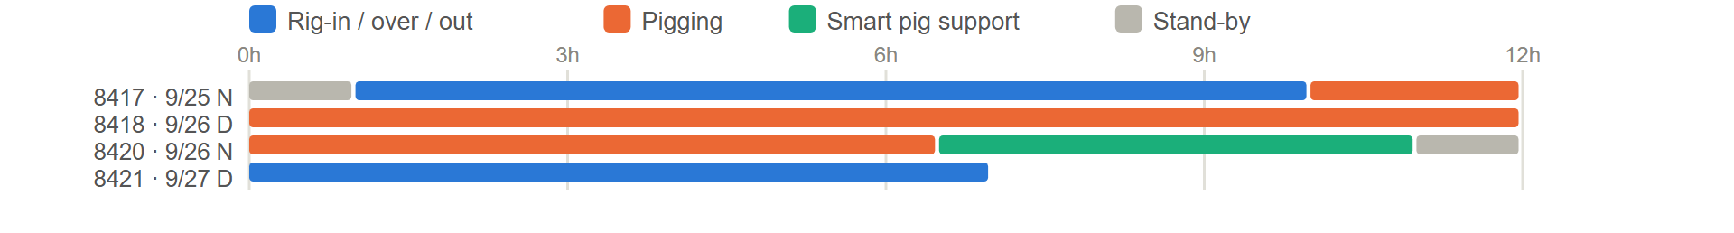
PR-175169 - task hours by shift, from the daily service receipts.
Pigs Used
SIZE — QTY | SIZE — QTY
6" — 4 | 6.25" — 12
TOTAL — 16
Flow Tests
Passes 1 + 2 (looped) | Passes 3 + 4 (looped)
  GPM | BEFORE PSI | AFTER PSI | Δ PSI
  800 | 320 | 267 | 53
  750 | 290 | 238 | 52
  700 | 250 | 215 | 35
  GPM | BEFORE PSI | AFTER PSI | Δ PSI
  650 | 230 | 180 | 50
  600 | 210 | 170 | 40
  550 | 175 | 140 | 35

PR-170002 — Coker Furnace
Number of Passes | 4, pigged as 3 circuits: convection (4 coils looped as one), radiant A + B, radiant C + D
Total Footage | 15,904 ft (3,976 ft per pass)
Tube ID | 3.398" (4" OD tube); radiant outlet section 3.624" (4" Sch 120)
Metallurgy | 9Cr-1Mo
Return Bends | Cast 180° U-bends
Decoking Analysis: The convection section showed light fouling and the radiant section moderate fouling. The crossovers were removed, the convection was pigged as a single circuit, and the radiant passes were looped A + B and C + D with temporary 180° returns at the radiant inlet flanges. Average pigging time was approximately 51 hours per circuit.
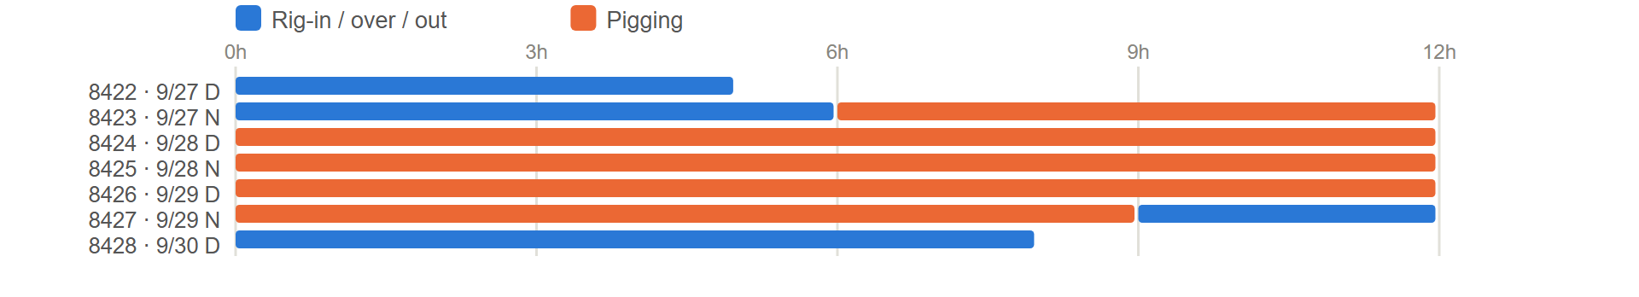
PR-170002 - task hours by shift, from the daily service receipts.
Pigs Used
SIZE — QTY | SIZE — QTY | SIZE — QTY | SIZE — QTY | SIZE — QTY
3" — 3 | 3.25" — 6 | 3.5" — 6 | 3.75" — 14 | 4" — 2
3.125" — 3 | 3.375" — 5 | 3.625" — 21 | 3.875" — 4
TOTAL — 64
Flow Tests
All convection | Passes A + B
  GPM | BEFORE PSI | AFTER PSI | Δ PSI
  350 | 435 | 375 | 60
  300 | 330 | 290 | 40
  250 | 220 | 180 | 40
  GPM | BEFORE PSI | AFTER PSI | Δ PSI
  350 | 370 | 275 | 95
  300 | 290 | 200 | 90
  250 | 210 | 146 | 64
Passes C + D
GPM | BEFORE PSI | AFTER PSI | Δ PSI
350 | 419 | 287 | 132
300 | 320 | 219 | 101
250 | 225 | 159 | 66

Project Summary
USADebusk performed the mechanical decoke of four fired heaters for Cenovus at the Lima Refinery during the 2026 turnaround, September 17 – 30: the Crude Furnace (PR-170028), Vacuum Charge Furnace (PR-170029), HDS Furnace (PR-175169) and Coker Furnace (PR-170002). Two Trimax pumping units ran independent schedules — Trimax 6 on the Vacuum heater, and Trimax 5 on the Crude, HDS and Coker in turn. The Crude, Vacuum and HDS heaters were smart-pigged after cleaning. Fifty-two of the project's 54 stand-by hours were on the Vacuum heater, waiting on the 12" radiant-outlet launchers to be installed and later relocated.
Project Close
All four heaters were cleaned and returned to Cenovus, and all equipment was demobilized from the facility on September 30, 2026.
USADebusk thanks the Cenovus Lima team for their coordination and support throughout the turnaround, and we look forward to continuing to serve your decoking and pigging needs.
Jesse Utsey | Pigging Operations
Cell: 713-252-8516 | jutsey@usadebusk.com

