2026 TURNAROUND MECHANICAL DECOKE
Crude Furnace — PR-170028
Job Report | USADebusk | Cenovus Lima Refinery — Lima, OH
PROJECT NO. | FACILITY | EXECUTION | PROJECT MANAGER
USA26046 | Cenovus Lima Refinery | Sep 17 – 25, 2026 | Peter Campbell
WORK ORDER | SCOPE | HEATER | DURATION
82036534 | TA Mechanical Decoke | PR-170028 | 9 days

192 | 0 | 201 | 8
OPERATING HOURS | STAND-BY HOURS | PIGS RUN | PASSES
Project Information
Customer Details
FACILITY | Cenovus Lima Refinery
ADDRESS | 1150 S Metcalf St, Lima, OH 45804
WORK ORDER | 82036534
CONTACT | Alfredo Trevino
Project Details
SCOPE | 2026 turnaround mechanical decoke of the Crude Furnace, with filtration and smart-pig support
EXECUTION | September 17 – 25, 2026 (9 days)
HEATER | PR-170028 Crude Furnace
EQUIPMENT | (1) Trimax Pumper (Trimax 5) · (1) Support Unit · (1) Filter Press (Press 3) · Crew Truck
Crew Details
PROJECT MANAGER | Peter Campbell
SHIFT LEAD | Day — Peter Campbell; Night — James McDaniel
DAYSHIFT | Rodney Lynch, Brody Lebleau, David Charles, Adrian Garza, Travis Trenholm
NIGHTSHIFT | Justin Kelly, Mikee Green, Jeremiah Harman
Project Duration
SCOPE | UNIT | RIG | PIG | SMART PIG | SUBTOTAL
PR-170028 Crude Furnace | Trimax 5 | 35.75 | 118 | 38.25 | 192
Stand-By Summary
No stand-by was recorded on the daily service receipts: all 192 pumping-unit hours on this heater were operating hours.

PR-170028 — Crude Furnace
Number of Passes | 8, pigged individually
Total Footage | 23,856 ft (2,982 ft per pass)
Convection Tube ID | 5.761" (6" Sch 80S)
Radiant Tube ID | 7.625" (8" Sch 80S)
Metallurgy | A312 TP317/317L
Return Bends | 180° short-radius
Smart Pigging | Yes — Intero
Decoking Analysis: Fouling was concentrated in the upper 8" radiant tubes, tubes 1 through 5, with lighter fouling through the balance of the coil. Average pigging time was approximately 39 hours per pass.
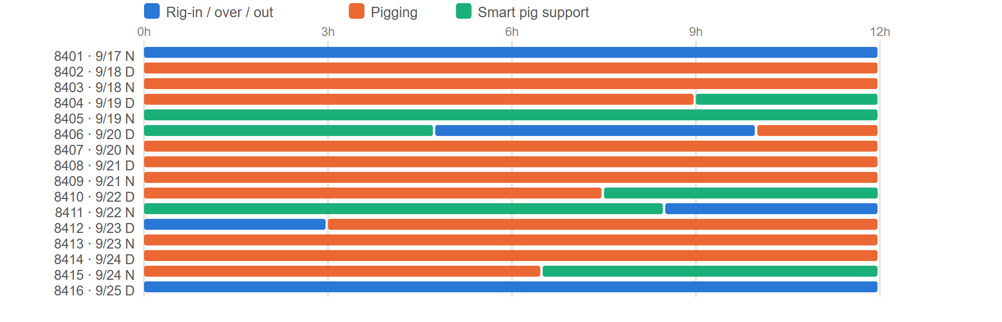
PR-170028 - task hours by shift, from the daily service receipts.
Pigs Used
SIZE — QTY | SIZE — QTY | SIZE — QTY | SIZE — QTY
6" — 30 | 6.25" — 50 | 8" — 40 | 8.5" — 12
6.125" — 12 | 7.75" — 3 | 8.25" — 54
TOTAL — 201
Flow Tests
Pass 1 | Pass 2
  GPM | BEFORE PSI | AFTER PSI | Δ PSI
  750 | 310 | 270 | 40
  700 | 285 | 255 | 30
  650 | 250 | 225 | 25
  GPM | BEFORE PSI | AFTER PSI | Δ PSI
  750 | 315 | 280 | 35
  700 | 295 | 270 | 25
  650 | 270 | 255 | 15
Pass 3 | Pass 4
  GPM | BEFORE PSI | AFTER PSI | Δ PSI
  750 | 350 | 305 | 45
  650 | 275 | 220 | 55
  550 | 220 | 165 | 55
  GPM | BEFORE PSI | AFTER PSI | Δ PSI
  750 | 324 | 295 | 29
  650 | 248 | 230 | 18
  550 | 177 | 165 | 12
Pass 5 | Pass 6
  GPM | BEFORE PSI | AFTER PSI | Δ PSI
  750 | 270 | 245 | 25
  650 | 215 | 190 | 25
  550 | 155 | 125 | 30
  GPM | BEFORE PSI | AFTER PSI | Δ PSI
  800 | 300 | 285 | 15
  700 | 280 | 255 | 25
  600 | 240 | 205 | 35
Pass 7 | Pass 8
  GPM | BEFORE PSI | AFTER PSI | Δ PSI
  800 | 290 | 265 | 25
  700 | 265 | 240 | 25
  600 | 230 | 205 | 25
  GPM | BEFORE PSI | AFTER PSI | Δ PSI
  800 | 250 | 221 | 29
  700 | 220 | 190 | 30
  600 | 200 | 165 | 35
Project Summary
USADebusk performed the mechanical decoke of the Crude Furnace (PR-170028) for Cenovus at the Lima Refinery during the 2026 turnaround, September 17 – 25, on Trimax 5 with filtration through Press 3. The eight passes were run in three sets — 8, 7 and 6; then 5, 4 and 3; then 1 and 2 — and smart-pigged by Intero after cleaning. The heater ran 192 operating hours with no stand-by, using 201 pigs.
Project Close
The Crude Furnace was cleaned, rigged out and returned to Cenovus on September 25, 2026.
USADebusk thanks the Cenovus Lima team for their coordination and support throughout the turnaround, and we look forward to continuing to serve your decoking and pigging needs.
Peter Campbell | Pigging and Decoking SME
Cell: 832-920-4253 | pcampbell@usadebusk.com

