2026 TURNAROUND MECHANICAL DECOKE
Vacuum Charge Furnace — PR-170029
Job Report | USADebusk | Cenovus Lima Refinery — Lima, OH
PROJECT NO. | FACILITY | EXECUTION | PROJECT MANAGER
USA26046 | Cenovus Lima Refinery | Sep 19 – 30, 2026 | Jesse Utsey
WORK ORDER | SCOPE | HEATER | DURATION
82036776 | TA Mechanical Decoke | PR-170029 | 12 days

195.5 | 52 | 97 | 8
OPERATING HOURS | STAND-BY HOURS | PIGS RUN | PASSES
Project Information
Customer Details
FACILITY | Cenovus Lima Refinery
ADDRESS | 1150 S Metcalf St, Lima, OH 45804
WORK ORDER | 82036776
CONTACT | Alfredo Trevino
Project Details
SCOPE | 2026 turnaround mechanical decoke of the Vacuum Charge Furnace, with filtration and smart-pig support
EXECUTION | September 19 – 30, 2026 (12 days)
HEATER | PR-170029 Vacuum Charge Furnace
EQUIPMENT | (1) Trimax Pumper (Trimax 6) · (1) Support Unit · (1) Filter Press (Press 1) · Crew Truck
Crew Details
PROJECT MANAGER | Jesse Utsey
SHIFT LEAD | Day — Jesse Utsey; Night — Sam Mixon
DAYSHIFT | Danilo Ramirez, Blake Harman, Blake Baugh, Travis Trenholm, David Charles
NIGHTSHIFT | Tyler Garza, Joel Ruiz, Mikee Green
Project Duration
SCOPE | UNIT | RIG | PIG | SMART PIG | SUBTOTAL
PR-170029 Vacuum Charge Furnace | Trimax 6 | 58.5 | 63 | 74 | 195.5
Stand-By Summary
Stand-by is on-site time during which the pumping units were not actively pigging. Cause is recorded from the daily service receipts.
DATES | HOURS | CAUSE
Sep 19 – 21 (7077–7081) | 49 | Awaiting installation of the 12" radiant-outlet launchers (Vacuum)
Sep 26 (7091) | 3 | Awaiting relocation of the 12" launchers to passes 5, 7, 8 (Vacuum)
TOTAL | 52
Heater total: 195.5 operating hours plus 52 stand-by hours — 247.5 pumping-unit hours.

PR-170029 — Vacuum Charge Furnace
Number of Passes | 8, pigged individually
Total Footage | 7,054 ft (882 ft per pass)
Convection Tube ID | 4.000"
Radiant Tube ID | 3.826" · 5.761" · 7.813" · 9.750" · 11.750" (4" to 12")
Metallurgy | A312 TP317/317L
Return Bends | 180° seamless
Smart Pigging | Yes — Intero
Decoking Analysis: Passes 4 and 5 carried the heaviest fouling, pass 5 the most. In pass 5, fouling was heavy in the 12" section, moderate in the 10" and 4" sections, and light in the 6" and 8" sections. In pass 4, it was moderate in the 12", light to moderate in the 10", and light in the 8", 6" and 4" sections. The remaining six passes showed light fouling throughout. The external 6" convection inlet piping, between the control valve and the 4" convection inlet tube, was heavily fouled on all eight passes, enough to keep 4" pigs from entering the convection section, and was cleaned first on each pass. Average pigging time was approximately 21 hours per pass.
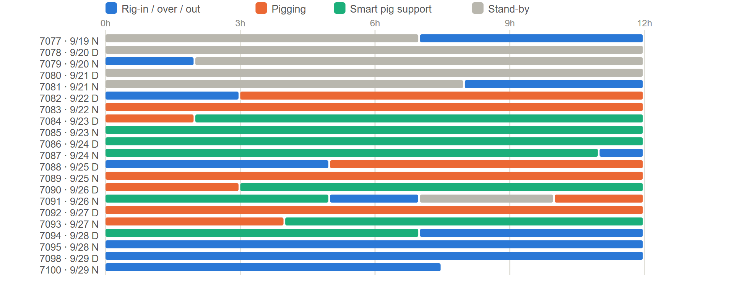
PR-170029 - task hours by shift, from the daily service receipts.
Pigs Used
SIZE — QTY | SIZE — QTY | SIZE — QTY | SIZE — QTY
3.75" — 4 | 4.125" — 15 | 6.25" — 6 | 10" — 20
3.875" — 1 | 4.25" — 4 | 8" — 7 | 12" — 6
4" — 22 | 6" — 10 | 8.25" — 2
TOTAL — 97
Flow Tests
Pass 1 | Pass 2
  GPM | BEFORE PSI | AFTER PSI | Δ PSI
  700 | 295 | 220 | 75
  650 | 260 | 185 | 75
  600 | 225 | 165 | 60
  GPM | BEFORE PSI | AFTER PSI | Δ PSI
  700 | 275 | 225 | 50
  650 | 235 | 195 | 40
  600 | 205 | 170 | 35
Pass 3 | Pass 4
  GPM | BEFORE PSI | AFTER PSI | Δ PSI
  700 | 332 | 282 | 50
  650 | 290 | 250 | 40
  600 | 255 | 220 | 35
  GPM | BEFORE PSI | AFTER PSI | Δ PSI
  700 | 280 | 210 | 70
  650 | 235 | 188 | 47
  600 | 210 | 160 | 50
Pass 5 | Pass 6
  GPM | BEFORE PSI | AFTER PSI | Δ PSI
  700 | 270 | 220 | 50
  650 | 235 | 190 | 45
  600 | 202 | 160 | 42
  GPM | BEFORE PSI | AFTER PSI | Δ PSI
  700 | 285 | 225 | 60
  650 | 235 | 195 | 40
  600 | 210 | 165 | 45
Pass 7 | Pass 8
  GPM | BEFORE PSI | AFTER PSI | Δ PSI
  700 | 260 | 220 | 40
  650 | 225 | 185 | 40
  600 | 195 | 160 | 35
  GPM | BEFORE PSI | AFTER PSI | Δ PSI
  700 | 320 | 280 | 40
  650 | 280 | 250 | 30
  600 | 240 | 220 | 20
Images
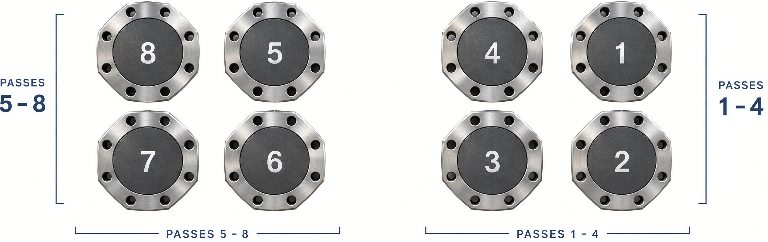 | 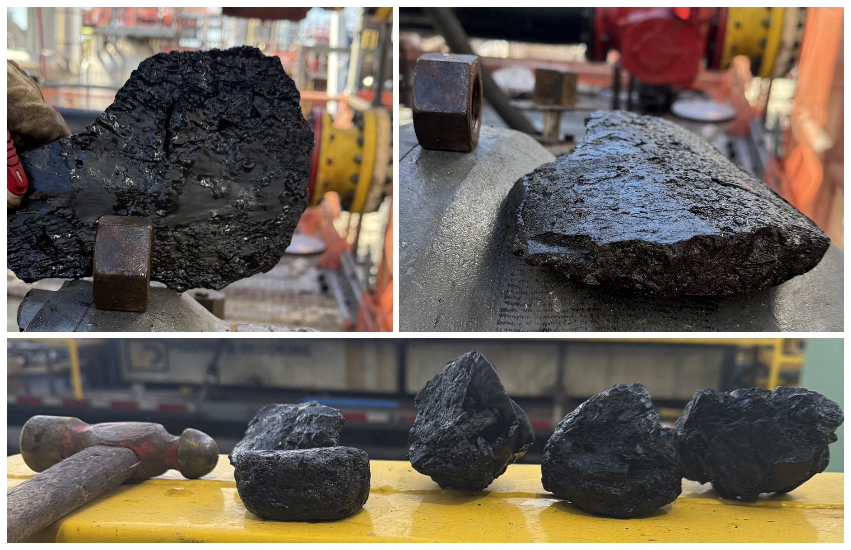
Radiant outlet labels and orientation, viewed facing the outlets. Each outlet connects to the convection inlet of the same pass number. | Top: coke removed from the 12" tube, pass 5. Bottom: deposits removed from the external 6" convection inlet piping, collected from all eight passes.
Project Summary
USADebusk performed the mechanical decoke of the Vacuum Charge Furnace (PR-170029) for Cenovus at the Lima Refinery during the 2026 turnaround, September 19 – 30, on Trimax 6 with filtration. The external 6" convection inlet piping was heavily fouled on all eight passes and was cleaned first on each pass, before pigging inside the heater. All eight passes were smart-pigged by Intero after cleaning. Of the heater's 247.5 pumping-unit hours, 52 were stand-by, waiting on the 12" radiant-outlet launchers to be installed and later relocated.
Project Close
The Vacuum Charge Furnace was cleaned and returned to Cenovus, and all equipment was demobilized from the unit on September 30, 2026.
USADebusk thanks the Cenovus Lima team for their coordination and support throughout the turnaround, and we look forward to continuing to serve your decoking and pigging needs.
Jesse Utsey | Project Manager, USADebusk
713-252-8516 | JUtsey@USADebusk.com

