Matteo Guerrini

**Kevin Rausch M.A.**

**International Office**

**Deputy Head of International Office**

Blechhammer 4-9  
D - 98574 Schmalkalden

+49 (0) 3683 688-1014



+49 (0) 3683 688- 981014



k.rausch@hs-sm.de



Matriculation Number: 12321

30 September 2021

**Proof of participation in online classes**

To whom it may concern,

Schmalkalden University of Applied Sciences is an attendance university. As a rule, our courses take place on the university campus and are not generally offered digitally.

Against this background, we hereby confirm the following for you to present to foreign authorities and when entering the country:

Mr Matteo Guerrini has done 13123123 online courses in the Winter Semester 2021. In general he took part in the offered online classes in the Winter semester 2021 from his home country.

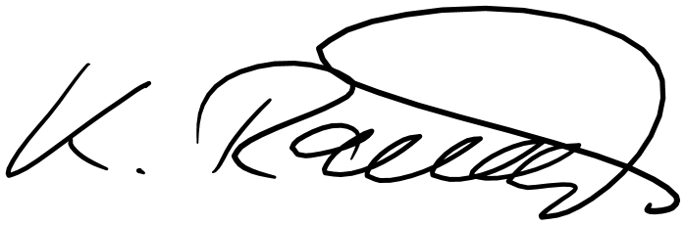

Sincerely,