MATTEO GUERRINI

Via Ugo Bassi 12

62027 San Severino Marche

ITALY

22 September 2021

**Confirmation of unconditional admission to Schmalkalden University of Applied Sciences**

**Kevin Rausch M.A.**

**International Office**

**Deputy Head of International Office**

Blechhammer 4-9  
D - 98574 Schmalkalden

+49 (0) 3683 688-1014



+49 (0) 3683 688- 981014



k.rausch@hs-sm.de



To whom it may concern

This is to confirm that the admission letter for Mr MATTEO GUERRINI received separately constitutes unconditional admission for the study programme B.Sc. Informatik in the Winter 2020/2021.

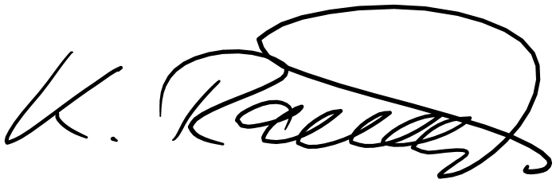

Sincerely,