To all students admitted for a study programme

at Schmalkalden University of Applied Sciences

in the semesterattr semester yearsattr

**Your entry to Germany for your studies at Schmalkalden University of Applied Sciences**

**Kevin Rausch M.A.**

**International Office**

**Deputy Head of International Office**

Blechhammer 4-9  
D - 98574 Schmalkalden

+49 (0) 3683 688-1014



+49 (0) 3683 688- 981014



k.rausch@hs-sm.de



dateattribute

Dear student,

You have been admitted for a study programme at Schmalkalden University of Applied Scien-ces (SUAS) in Germany in the semesterattr semester yearsattr, starting startingdate.

All study programmes at SUAS are conducted in presence; hence, your presence in Schmalkalden is required. If you come from a non-EU country, you may need a visa in order to enter Germany. In this case you will need to apply for a visa and fulfil all requirements for the same, possibly incl. a blocked bank account.

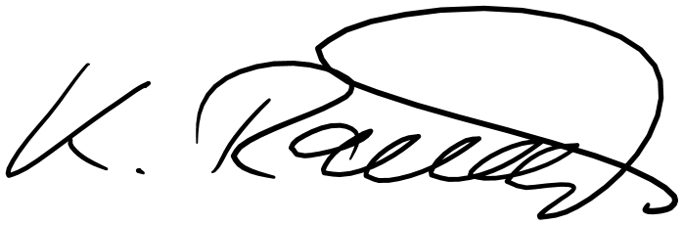

Sincerely,