**Confirmation of unconditional admission to Schmalkalden University of Applied Sciences**

nameattr

address1attribute

numberaddress address2attribute

zipcode cityattribute

countryattribute

**Kevin Rausch M.A.**

**International Office**

**Deputy Head of International Office**

Blechhammer 4-9  
D - 98574 Schmalkalden

+49 (0) 3683 688-1014



+49 (0) 3683 688- 981014



k.rausch@hs-sm.de



dateattribute

To whom it may concern

This is to confirm that the admission letter for genderattr nameattr received separately constitutes unconditional admission for the study programme degreetype degreefield in the semestera yearsattribute.

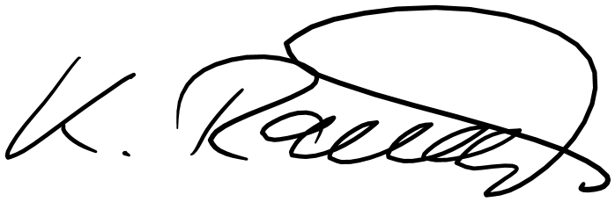

Sincerely,