Application no.: appnum

dateattribute

**Confirmation of valid admission to Schmalkalden University of Applied Sciences**

**Kevin Rausch M.A.**

**International Office**

**Deputy Head of International Office**

Blechhammer 4-9  
D - 98574 Schmalkalden

+49 (0) 3683 688-1014



+49 (0) 3683 688- 981014



k.rausch@hs-sm.de



To whom it may concern

This is to confirm that the admission letter for nameattr (application number: appnum) received separately continues to be valid even if the student cannot be physically present in Schmalkalden for the beginning of the semestera semester yearsattr due to an ongoing visa procedure. The student may enrol himself remotely for the semestera semester yearsattr and travel to Schmalkalden anytime during the semester.

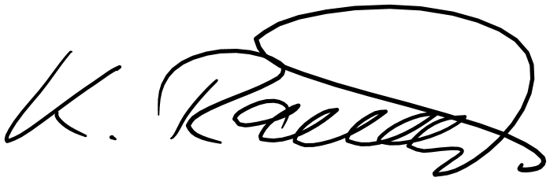

Sincerely,