nameattribute

**Proof of the required entry for presence teaching**

**Kevin Rausch M.A.**

**International Office**

**Deputy Head of International Office**

Blechhammer 4-9  
D - 98574 Schmalkalden

+49 (0) 3683 688-1014



+49 (0) 3683 688- 981014



k.rausch@hs-sm.de



dateattribute

To whom it may concern

You have received admission for a full study programme at Schmalkalden University of Applied Sciences Schmalkalden in Thuringia. Due to the worldwide Corona pandemic, there are dynam-ically changing travel restrictions. Whether or not you can enter the country might depend on whether your university offers teaching and examinations in class or virtually. Against this back-ground, we hereby confirm the following for you to present to foreign authorities and when en-tering the country:

Schmalkalden University of Applied Sciences is an attendance university. As a rule, our courses take place on the university campus and are not generally offered digitally. Examinations also regularly take place on site. In order to start studying, it is necessary to physically enter our campus in the semesterattr semester yearsattr.

This proof is only valid in connection with the admission or invitation letter. If you are arriving from abroad, please also note any applicable isolation and registration requirements. Further information is currently available on our website www.hs-sm.de/en..

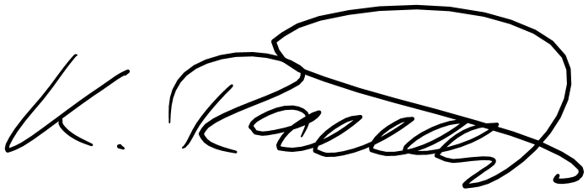

Sincerely,