nameattribute

Student ID: idstudentattribute

**Proof of participation in english courses during the exchange semester**

**Kevin Rausch M.A.**

**International Office**

**Deputy Head of International Office**

Blechhammer 4-9  
D - 98574 Schmalkalden

+49 (0) 3683 688-1014



+49 (0) 3683 688- 981014



k.rausch@hs-sm.de



dateattribute

To whom it may concern

This is to certify that genderattribute nameattribute was an Exchange Student of Schmalkalden University of Applied Sciences. He was studying in an exchange Program in Schmalkalden in the semesterattribute semester yearsattribute. During his exchange Program he took courses which were taught in English and performed good in these courses.

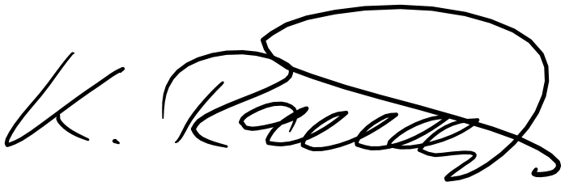

Sincerely,