**TRON**

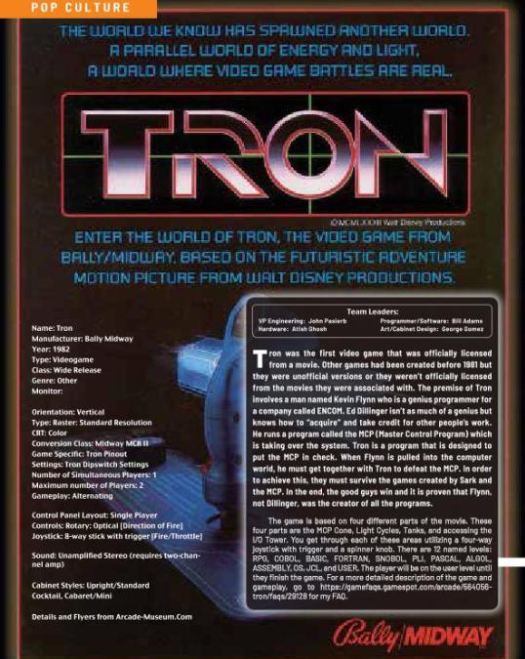

Tron was the first video game that was officially licensed from a movie. Other games had been created before 1981 but they were unofficial versions or they weren’t officially licensed from the movies they were associated with. The premise of Tron involves a man named Kevin Flynn who is a genius programmer for a company called ENCOM. Ed Dillinger isn’t as much of a genius but knows how to “acquire” and take credit for other people’s work. He runs a program called the MCP (Master Control Program) which is taking over the system. Tron is a program that is designed to put the MCP in check. When Flynn is pulled into the computer world, he must get together with Tron to defeat the MCP. In order to achieve this, they must survive the games created by Sark and the MCP. In the end, the good guys win and it is proven that Flynn, not Dillinger, was the creator of all the programs.

The game is based on four different parts of the movie. These four parts are the MCP Cone, Light Cycles, Tanks, and accessing the I/O Tower. You get through each of these areas utilizing a four-way joystick with trigger and a spinner knob. There are 12 named levels: RPG, COBOL, BASIC, FORTRAN, SNOBOL, PLI, PASCAL, ALGOL, ASSEMBLY, OS, JCL, and USER. The player will be on the user level until they finish the game.

In order to capitalize on Tron, the original movie, Disney con- tracted with Bally-Midway to create an arcade game to compli- ment the movie (and to also encourage people to see it). Bally- Midway was given a very narrow window in which they were told to design, program, and test this game. I managed to catch up with Bill Adams, the programmer, to gain some insight and to get to know him a little better.

