**THE HOUSE OF THE DEAD**

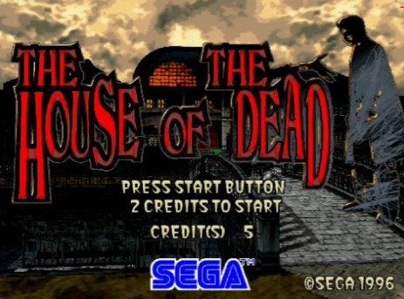

The game was released in Japan in 1996, appearing in the United States a year later. It immediately became a staple at arcades. As I recall, it sat in the arcade section of every movie theater around my home, and it was almost always occupied. If you wanted to play, you had to be prepared to stand and wait. Walk away, and someone else would get there ahead of you.

In the game, you played as agent Thomas Rogan or “G.” The story took place at Curien Mansion, home of the mad scientist Roy Curien, whose experiments in life and death created a horde of unholy monsters. Your goal was to fight your way through the mansion, rescue Sophie (Rogan’s fiancée),and defeat Curien. Along the way, you fought off wave after wave of zombies, a giant spider crab, a mutant named the Chariot who came armed with a bardiche (a giant axe on a pole), and The Magician, who could control fire with his mind.

House of the Dead was designed using the game engine for Virtua Cop, which had come out in 1994. Like Virtua Cop, the game took place in a first person view and you fought through the game using a light gun (a technology which actually traces back to the 1930s. In 1936, Seeburg Ray-O-Light was released, which was essentially an early version of Nintendo’s duck hunt. You aimed your gun at a light sensing tube on the back of ducks. If your ray of light hit, the duck fell.) In House of the Dead, your gun could fire six rounds before you had to reload. You did this by aiming away from the screen and pulling the trigger. As much of the game was simply shooting frantically at everything that moved, you had to reload a lot.

You had a set amount of health, which could be lost by taking damage or by accidentally shooting a hostage that the monsters were holding. Health could be regained through first aid kits, which could be found by defeating enemies or breaking certain objects.

As you would expect from an arcade game, things moved quickly and it seemed like you burned through life at an unbelievable rate. This, of course, would require you to feed more quarters into the cabinet. As with most shooter games of this sort, the game was always easier when you had another player with you. With multiple players, you could divide the screen up into quadrants to wipe out the onslaught of enemies. The plot was really secondary to the action in the game, a loose sort of thing designed to get you from one wave of monsters to the next. It was fun, and bloody, but not particularly terrifying.

Perhaps the best review of the game came from U.S. Appeals Court Judge Richard Possner, when he was forced to consider an attempted ban on the game in the state of Indianapolis, “The most violent game in the record, “The House of the Dead,” depicts zombies being killed flamboyantly, with much severing of limbs and effusion of blood; but so stylized and patently fictitious is the cartoon-like depiction that no one would suppose it “obscene” in the sense in which a photograph of a person being decapitated might be described as “obscene.” It will not turn anyone’s stomach.”