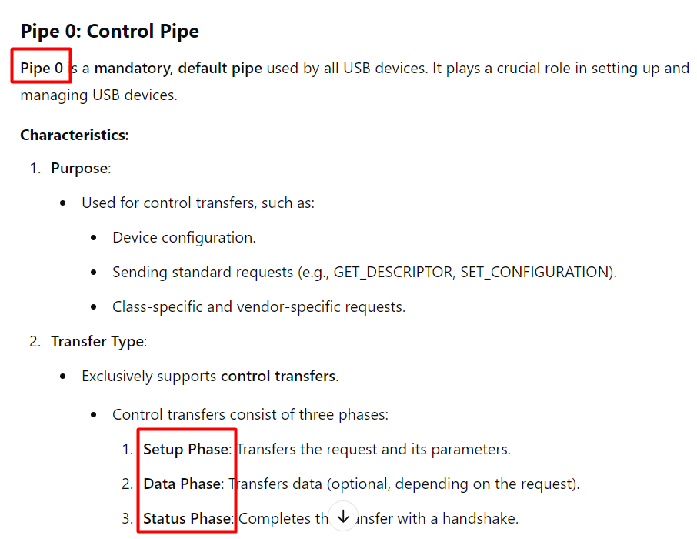

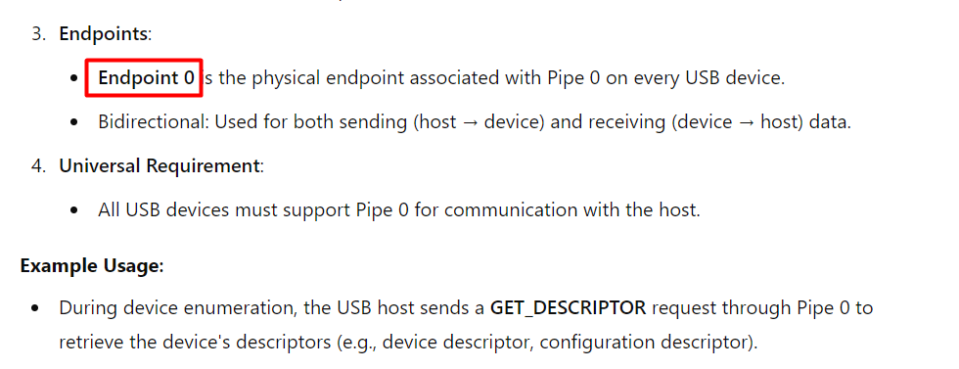

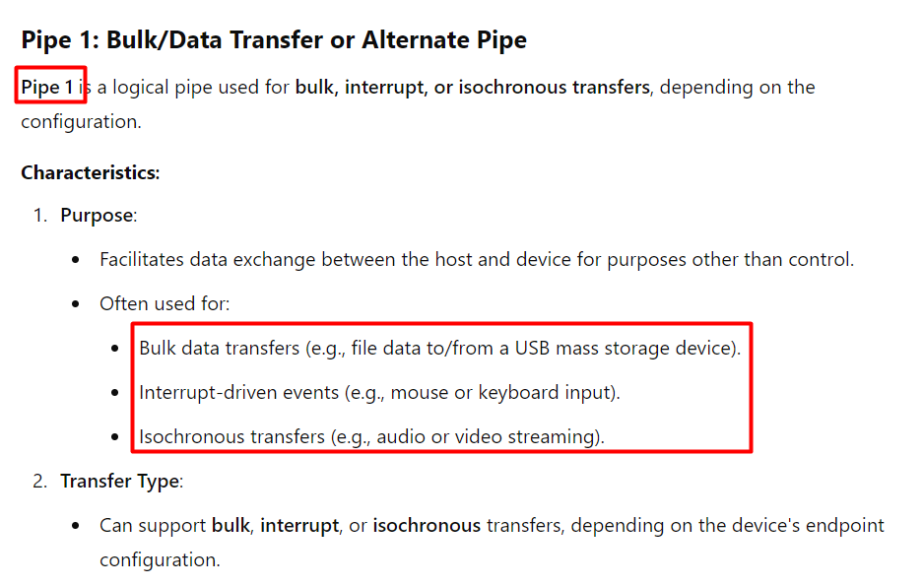

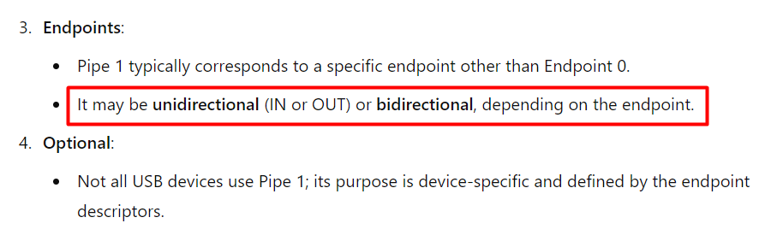

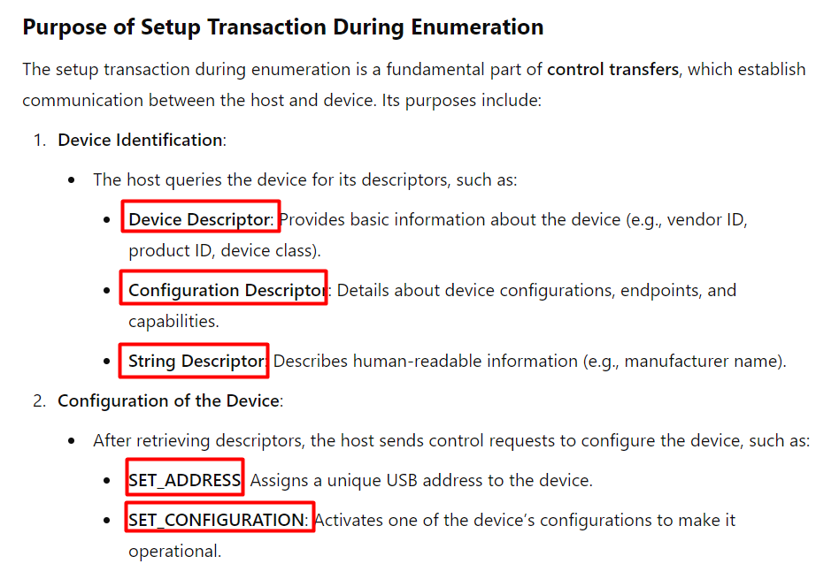

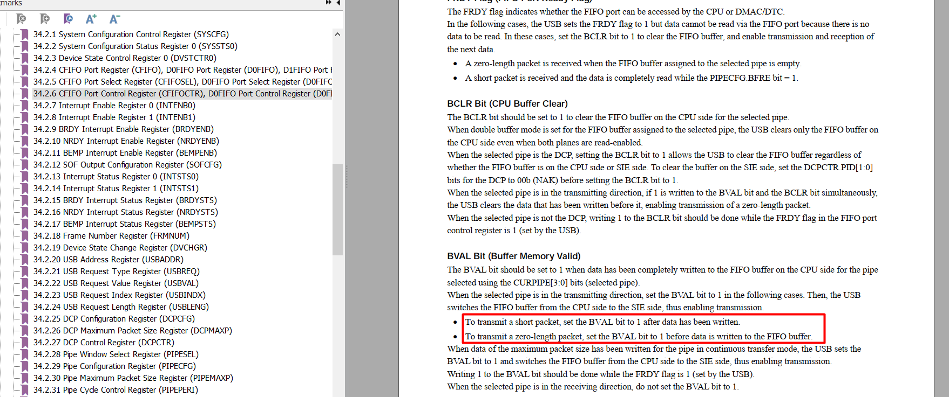🡺 Transmit zero-length packet for Handshake transaction

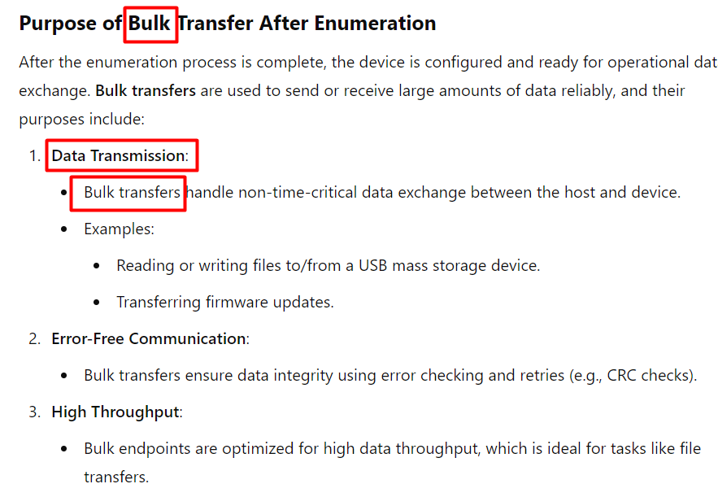

| **Byte** | **Field Name** | **Value (Hex)** | **Interpretation** |
| --- | --- | --- | --- |

|  |  |  |  |
| --- | --- | --- | --- |
| 0 | bLength | 0x12 | Descriptor length is **18 bytes** (standard size for device descriptors). |

|  |  |  |  |
| --- | --- | --- | --- |
| 1 | bDescriptorType | 0x01 | Descriptor type is **Device Descriptor**. |

|  |  |  |  |
| --- | --- | --- | --- |
| 2–3 | bcdUSB | 0x0110 | USB version is **1.10** (USB 1.1). |

|  |  |  |  |
| --- | --- | --- | --- |
| 4 | bDeviceClass | 0x00 | Class is defined at the interface level. |

|  |  |  |  |
| --- | --- | --- | --- |
| 5 | bDeviceSubClass | 0x02 | Subclass code, typically depends on the device. |

|  |  |  |  |
| --- | --- | --- | --- |
| 6 | bDeviceProtocol | 0xFF | Protocol is vendor-specific. |

|  |  |  |  |
| --- | --- | --- | --- |
| 7 | bMaxPacketSize0 | 0x40 | Maximum packet size for Endpoint 0 is **64 bytes**. |

|  |  |  |  |
| --- | --- | --- | --- |
| 8–9 | idVendor | 0x5E40 | Vendor ID: Manufacturer-specific identifier (e.g., assigned by USB-IF). |

|  |  |  |  |
| --- | --- | --- | --- |
| 10–11 | idProduct | 0x0012 | Product ID: Unique identifier for the product (assigned by the vendor). |

|  |  |  |  |
| --- | --- | --- | --- |
| 12–13 | bcdDevice | 0x0201 | Device release number **2.01**. |

|  |  |  |  |
| --- | --- | --- | --- |
| 14 | iManufacturer | 0x03 | Index of string descriptor for the manufacturer. |

|  |  |  |  |
| --- | --- | --- | --- |
| 15 | iProduct | 0x01 | Index of string descriptor for the product. |

|  |  |  |  |
| --- | --- | --- | --- |
| 16 | iSerialNumber | 0x01 | Index of string descriptor for the serial number. |

|  |  |  |  |
| --- | --- | --- | --- |
| 17 | bNumConfigurations | 0x01 | Device supports **1 configuration**. |

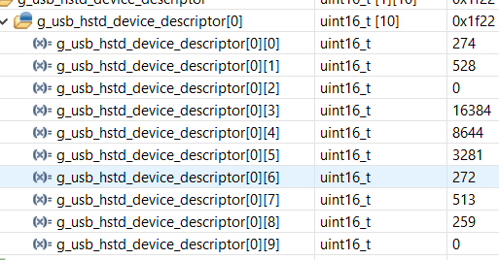

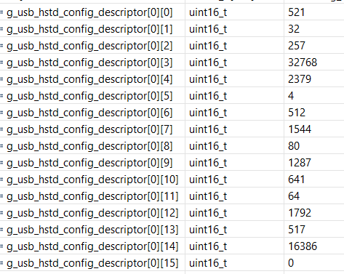

First 9 bytes:



        
        
        