/* Load the boot sector */

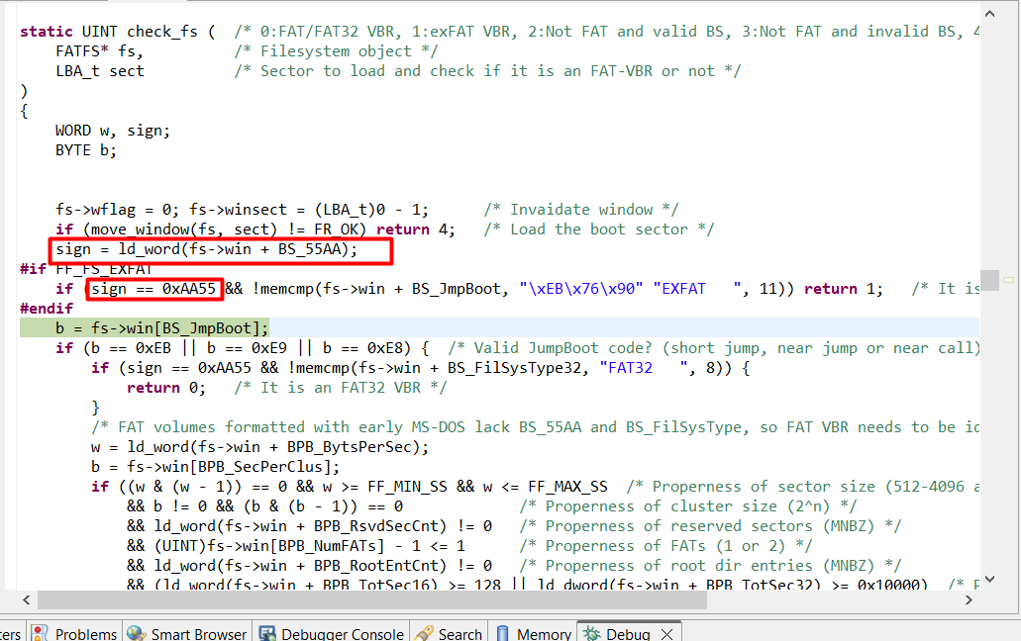

Check sign at the end of sector

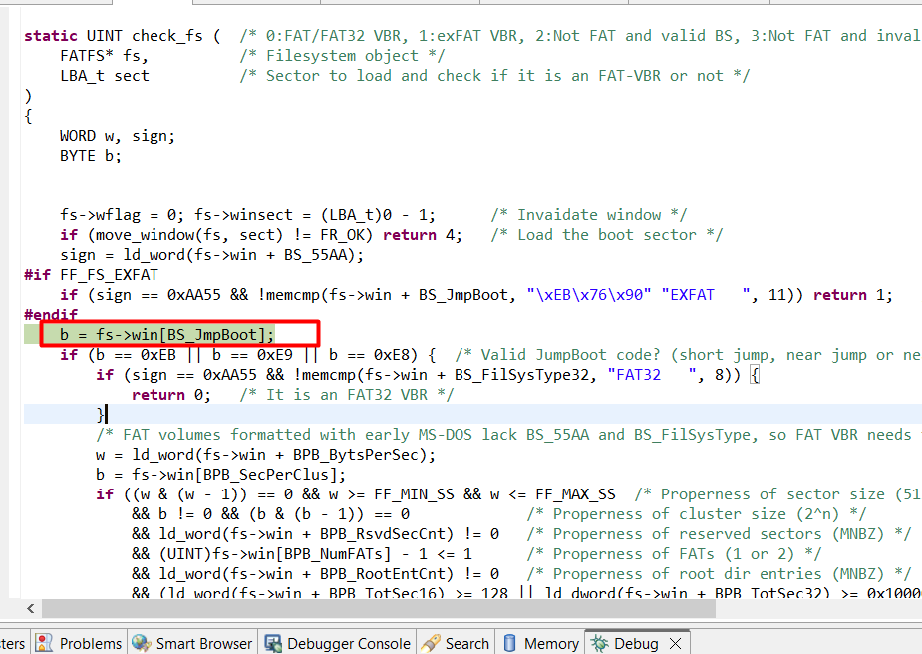

Check JmpBoot (short jump, near jump, near call) => fail => return

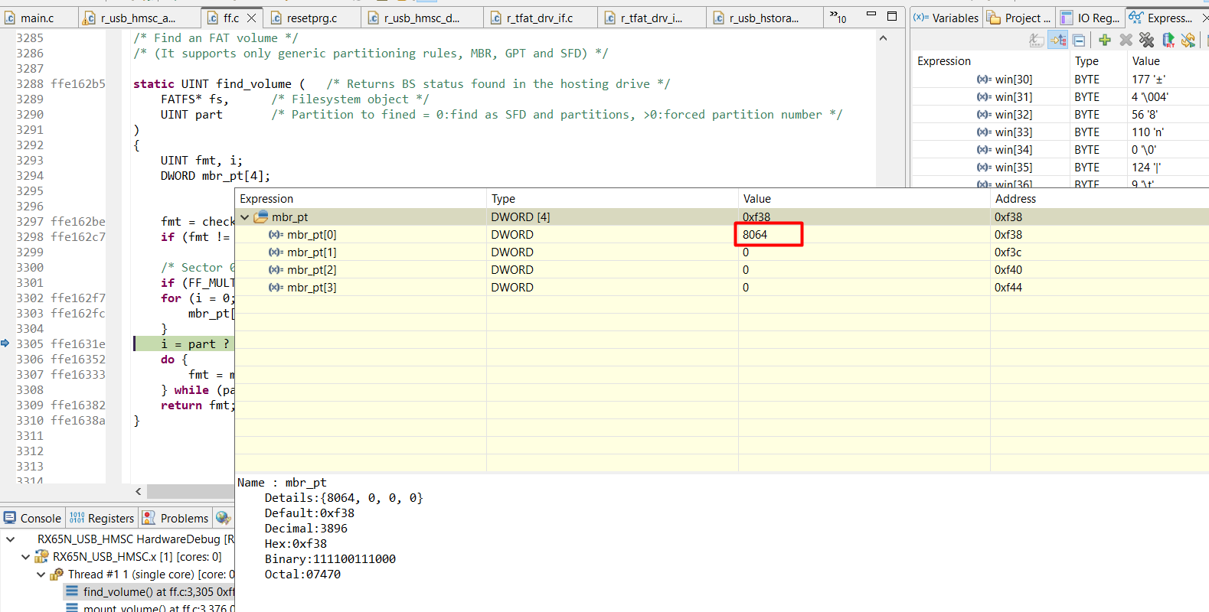

Find sector at the index at 8064 and load that sector (512 bytes) from device to host

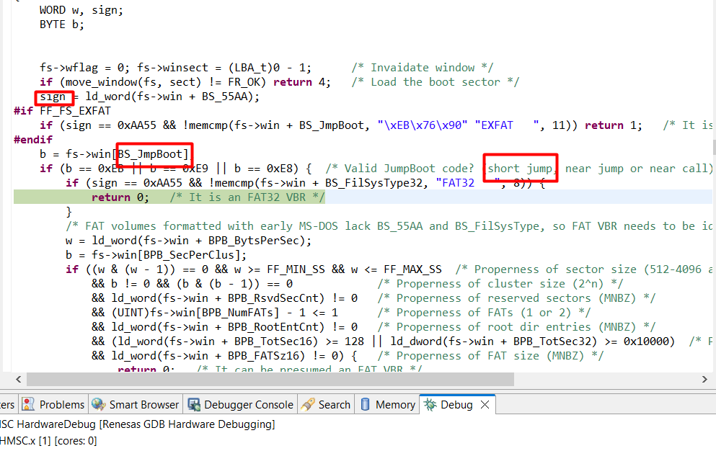

Sign and BS_JmpBoot are validated => DONE of fmt = find_volume(fs, LD2PT(vol));

After loading the sector at the index of 8064

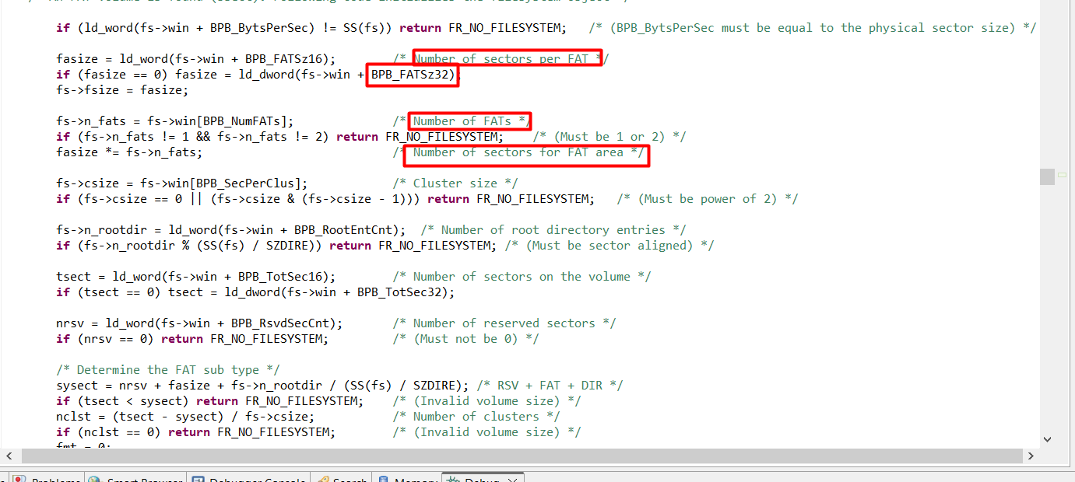

Get the number of sectors per FAT, number of FATs => number of sectors for FAT area

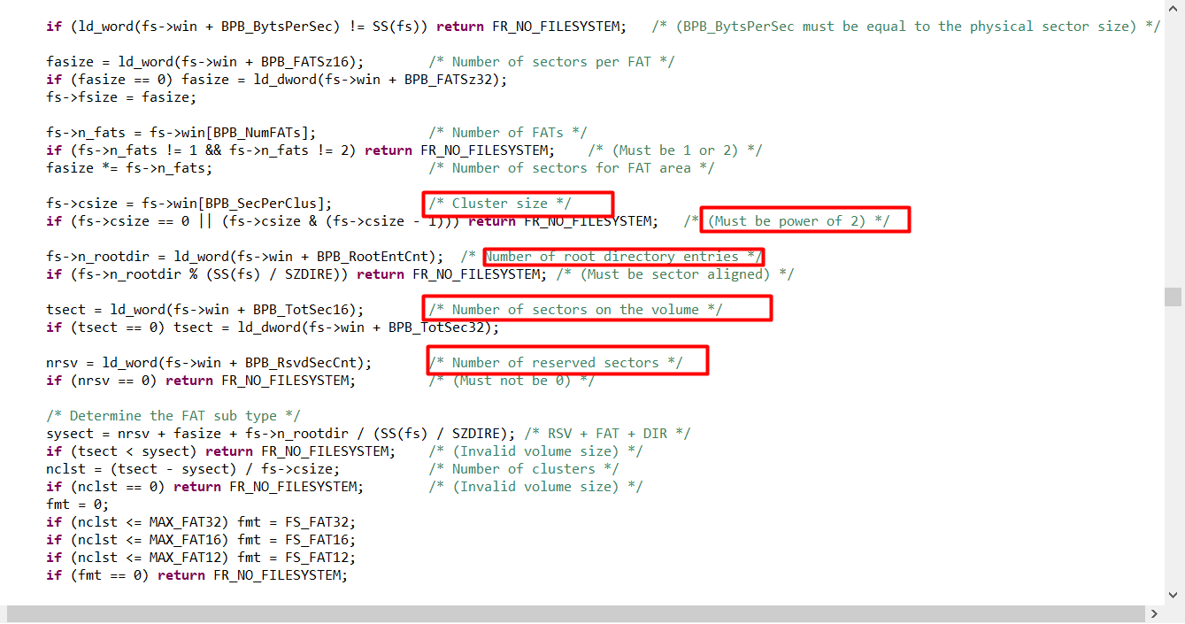

Get the cluster size, root directory, num of sectors on the volume and reserved area

* Because the total num of sectors is larger than 65,535 => use BPB_TotSec32

* FAT (File Allocation Table) = track cluster allocation for files on the volume

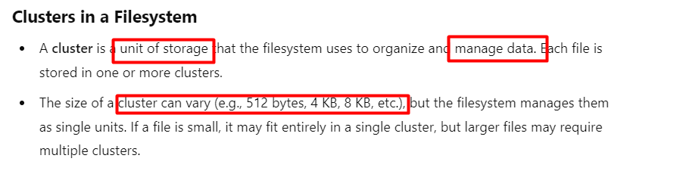

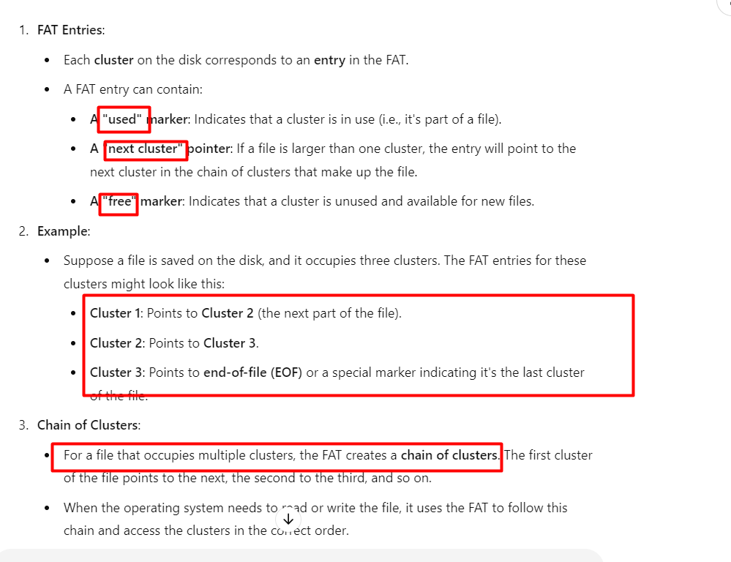

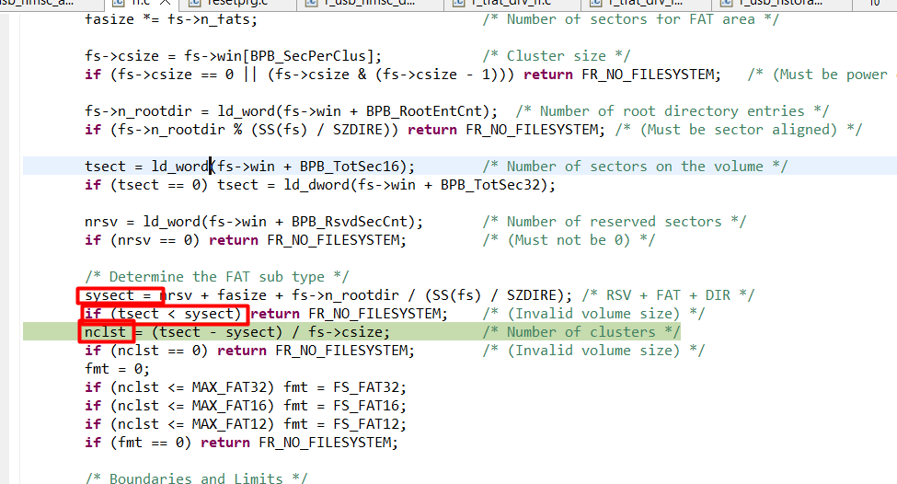

Make sure sysect (system size) is smaller than tsect (total size): sectors

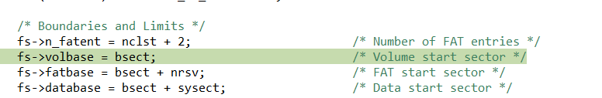

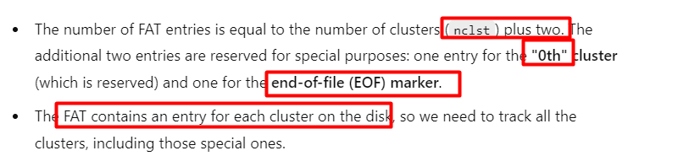

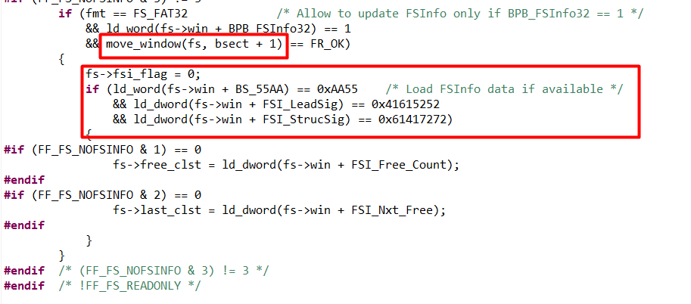

Load FSInfo sector after Boot sector (index 8064)

* Identify num of free clusters and last cluster