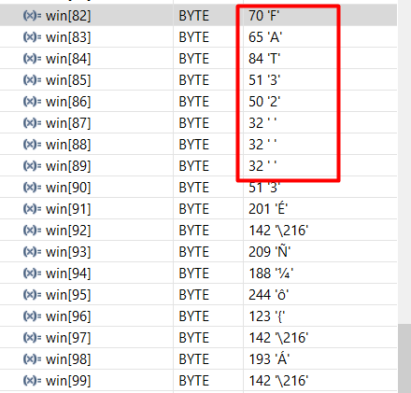

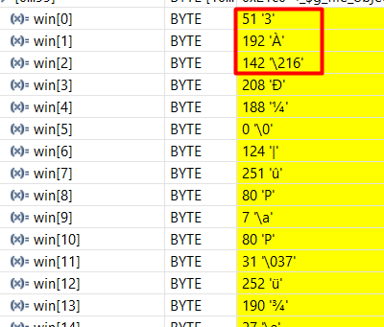

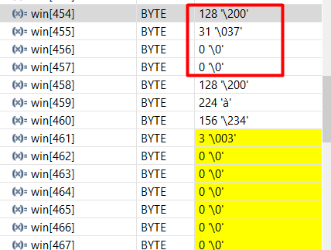

128 = 0x80

31 = 1F

8064 = 0x1F80 🡺 load the sector index 8064 from device to host

======================= Check_fs_8064 ========================



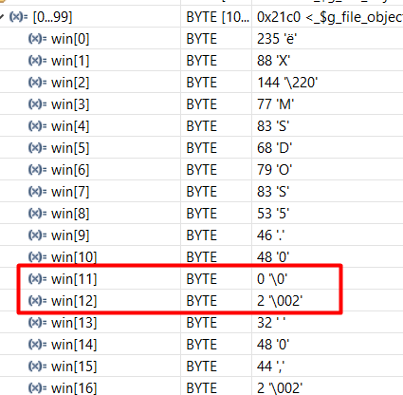

BPB_BytsPerSec = 512 bytes

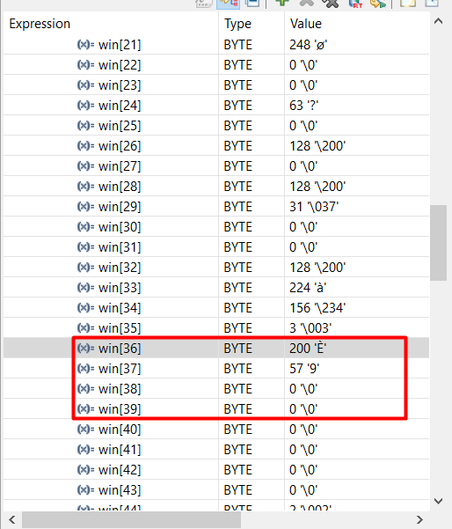

Number of sector per FAT (Fat32) = 14792

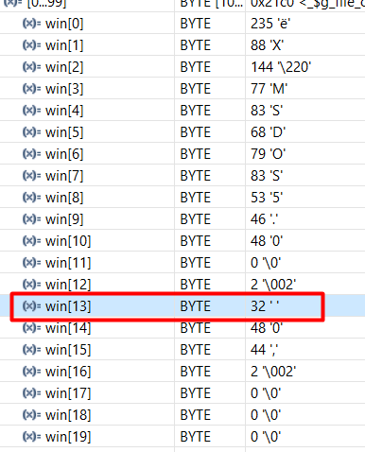

BPB_SecPerClus = 32 sectors per cluster

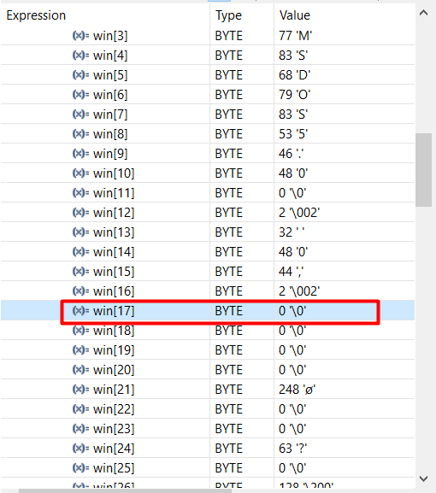

Root directory entries are fixed-size structures that store metadata for files and subdirectories in the root directory.

Num of root .. = 0 ⬄ FAT32

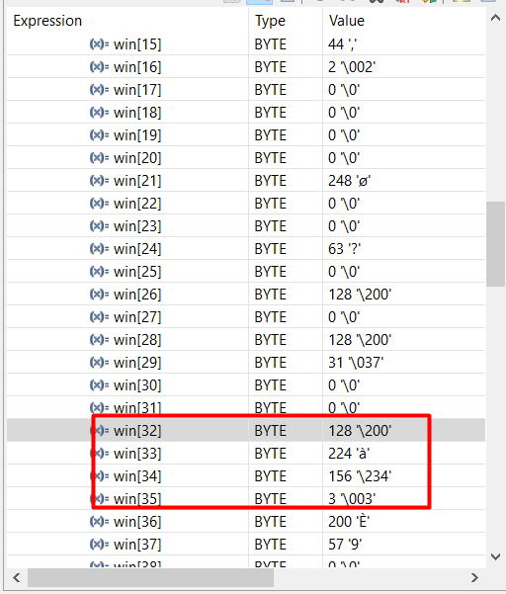

Number of sectors on the volume = 60612736

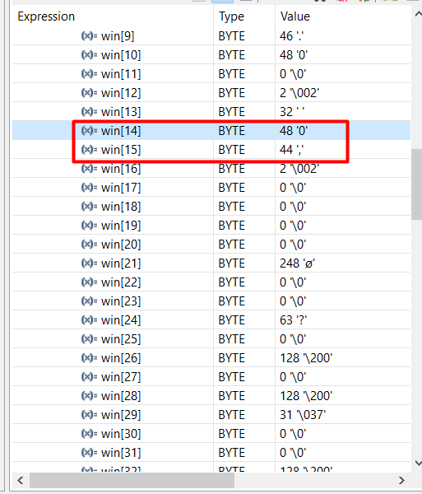

Number of reserved sectors =