Having 2 types:
with BOOT_protocol – no need to get report descriptor
with REPORT_protocol – need to get report descriptor
STEPs:
- Polling to perform to IN transaction (polling interval – defined at endpoint descriptor)
- No key – empty report >< Detected key – 8-byte report

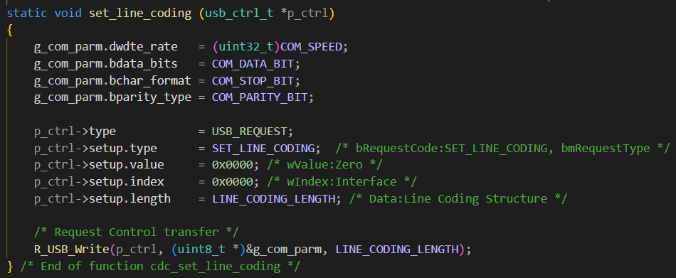
Set common parameters: baundrate, databit, stopbit, paritybit

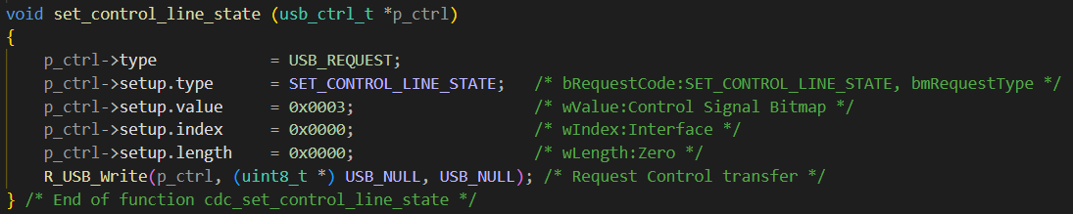
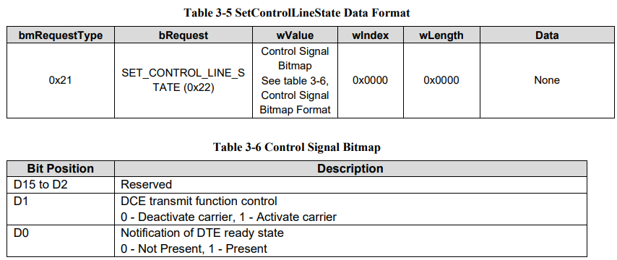 (more detail below)

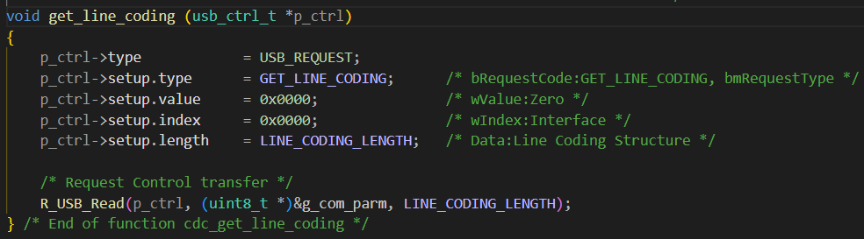
Get common parameters: to check device has the configuration parameters set by host before
==============
This stage should be placed at the end of transfer
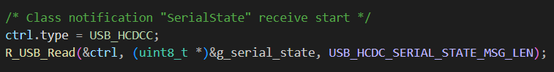
Get the serial state
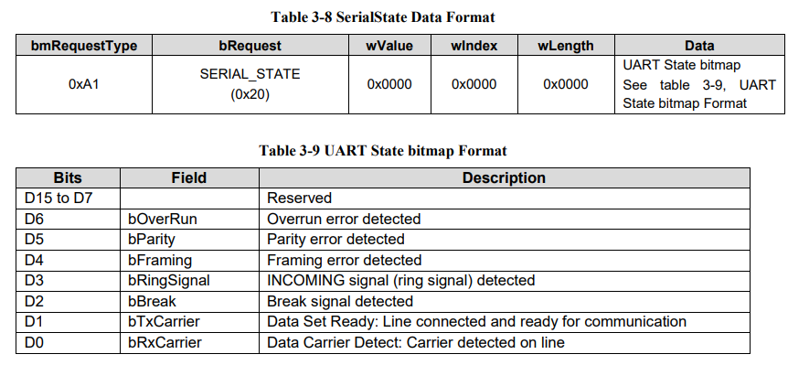
- If g_serial_state.bitmap = 0 => no error occurs

