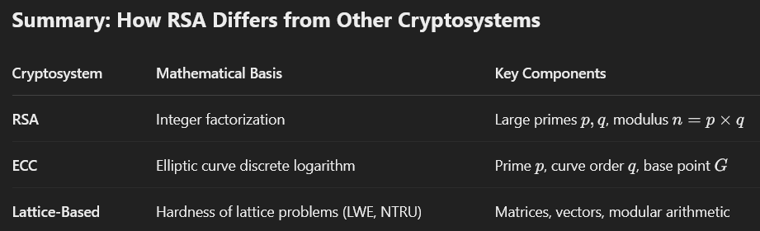
========================= Note ===========
+ ECC – base point G (use scalar multiplication)
+ Latticed-Based – high-dimensional vectors (matrix)

