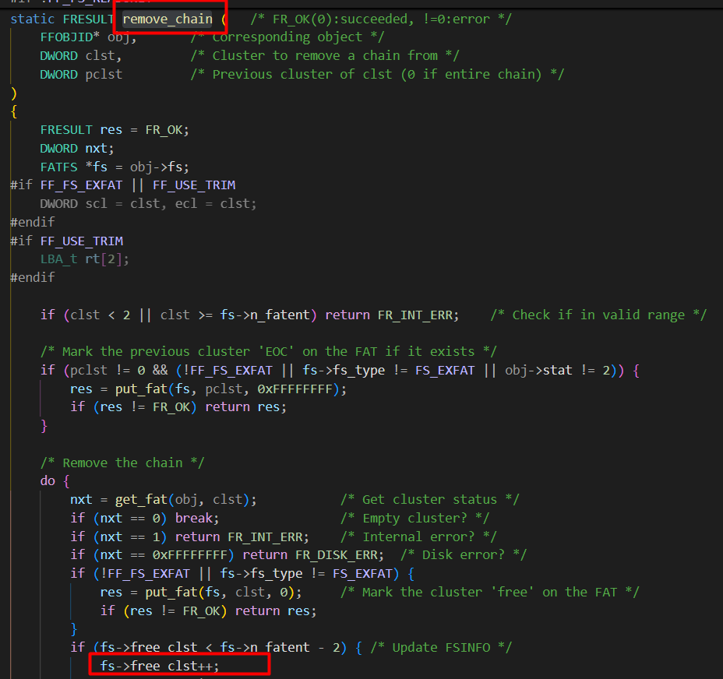
Add “fs->free_clst--” in updating FSInfo
- When creating cluster chain, last cluster can be updated correctly

