Cluster chain
- Happens when creating a dir or writing data into a file
- Need to download sector of FAT (fatbase) to update cluster chain
  - Need to write 0xFFFFFFFF (FAT32) at the cluster to mark the end of cluster (EOC)
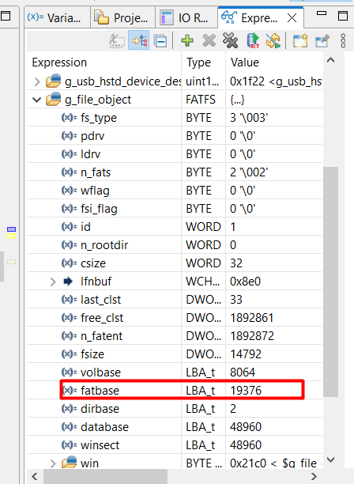
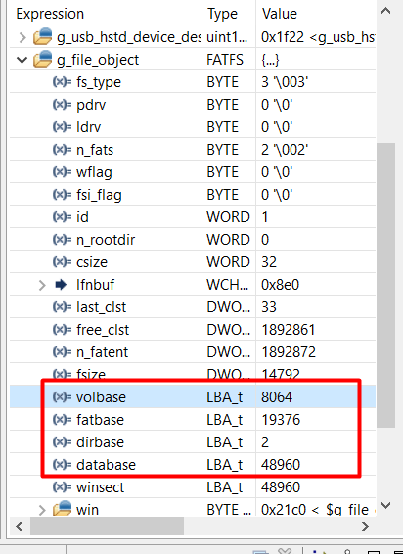
Volbase - holds the starting LBA (Logical Block Address) of the volume.
Fatbase – holds and manage clusters (FAT32)
Dirbase – ?????
Database – data (name of dir, file and data)
Load sector 0 – f_mount
/* Load partition offset in the MBR */ => mbr_pt[i] = ld_dword(fs->win + MBR_Table + i * SZ_PTE + PTE_StLba);
(Reach the partition table in MBR and read at PTE_StLba) => get the starting sector (8064) + (MBR has max 4 patrition tables)

Load sector volbase + 0 – f_mount
Load sector 0 to:
/* Number of sectors per FAT */ (14792 sectors)
/* Number of FATs */ (2)
/* Cluster size */ (32 sectors)
/* Number of root directory entries */ (0 = FAT32)
/* Number of sectors on the volume */ (60612736 sectors)
/* Number of reserved sectors */ (11312 sectors)

sysect = nrsv + fasize + fs->n_rootdir / (SS(fs) / SZDIRE); /* RSV + FAT + DIR */

/* Number of clusters */ = (tsect - sysect) / fs->csize; (1892870 sectors)
/* Number of FAT entries */ fs->n_fatent = nclst + 2; (1892872 sectors)

/* Volume start sector */ => fs->volbase = bsect (8064 )
/* FAT start sector */ => bsect + nrsv; (19376)
/* Data start sector */ => fs->database = bsect + sysect (48960)

/* Root directory start cluster */ (2)
Load sector volbase + 1 – f_mount update FSInfo
Check FSI_LeadSig, FSI_StrucSig and BS_55AA (at the end of sector for FSInfo)
- Read the last cluster and free clusters

