READ CONTROL TRANSFER
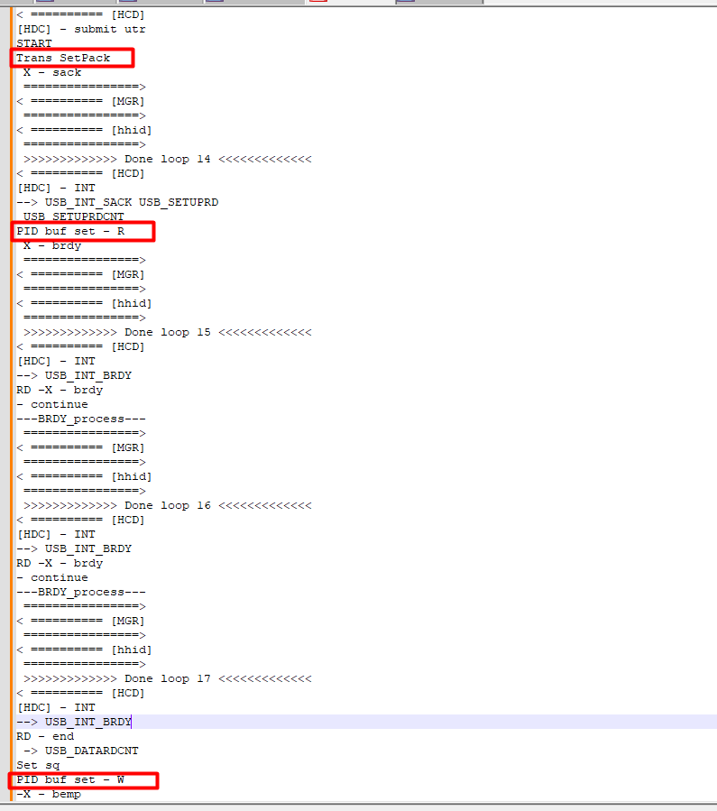
1 -> Setup transaction (request to read data)
2 -> Data transaction (R – read data)
3 -> Status transaction (W – send ACK back to device)
WRITE CONTROL TRANSFER
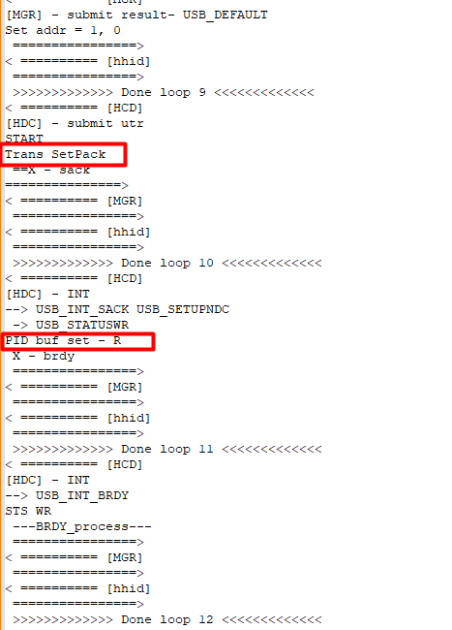
1 -> Setup transaction (request to sen data)
2 -> Data transaction (No data transfer)
3 -> Status transaction (R – read ACK from device)

