Pipe 0 (default) – setting up and configuring the USB device
Pipe (1, 2, …) – bulk, interrupt or isochronous transfers
Pipe (host) = channel to communicate with device
Endpoint (device) = logical buffer on device
- Only 1 pipe does IN or OUT operation
- 1 Endpoint can interact with multiple pipes (pipe 1 (IN) and pipe 2(OUT))
STEPS to CONFIGURE USB DEVICE:
- Get descriptor (18 bytes)
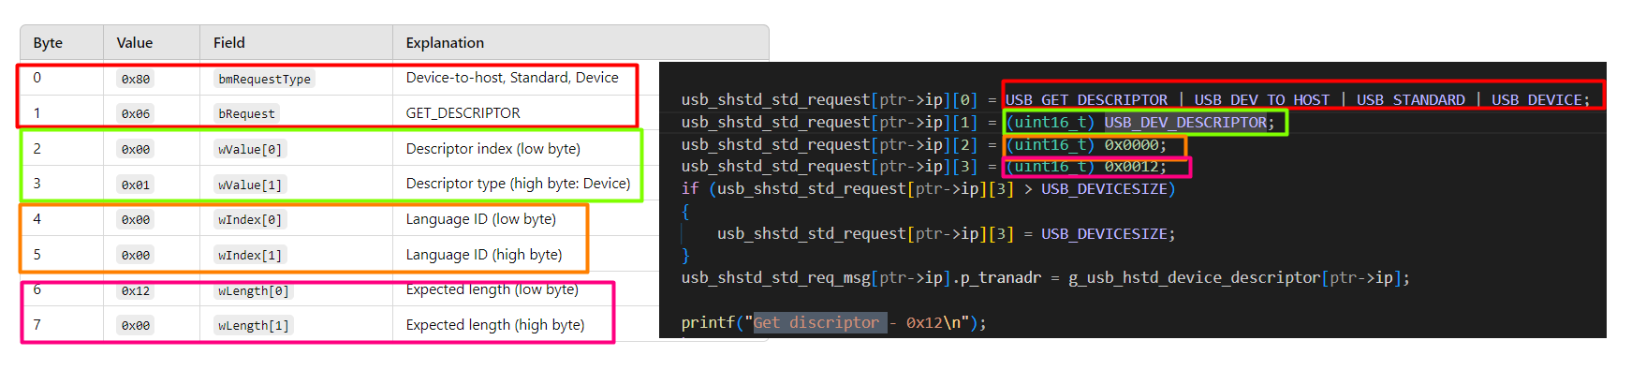
  - Result:
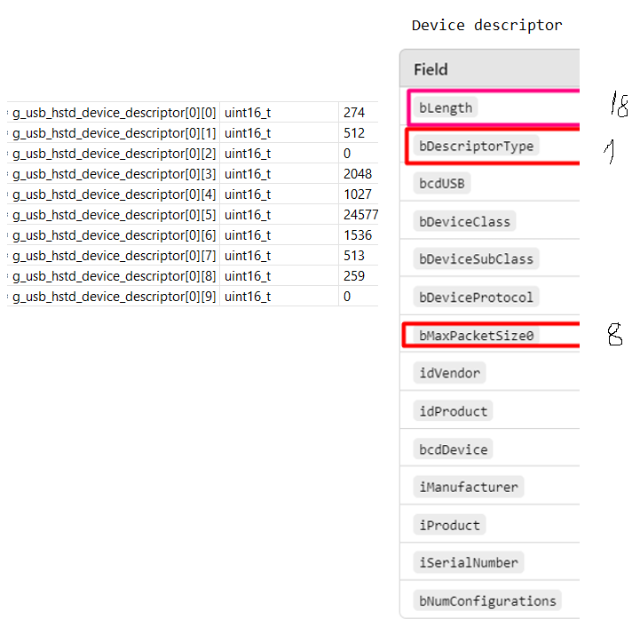

- Set address from 0 to 1
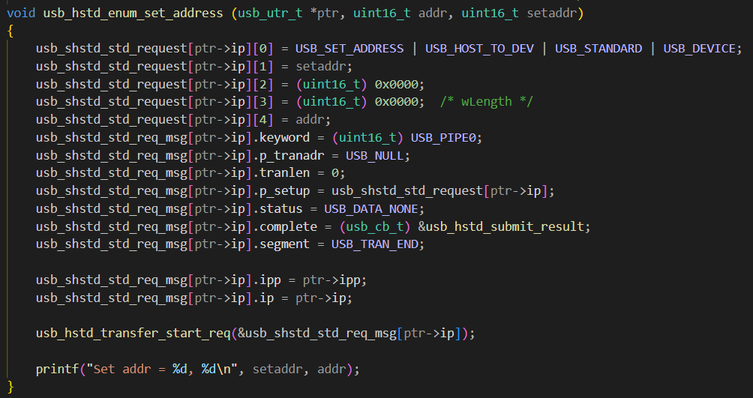
- Get config descriptor (9 bytes)
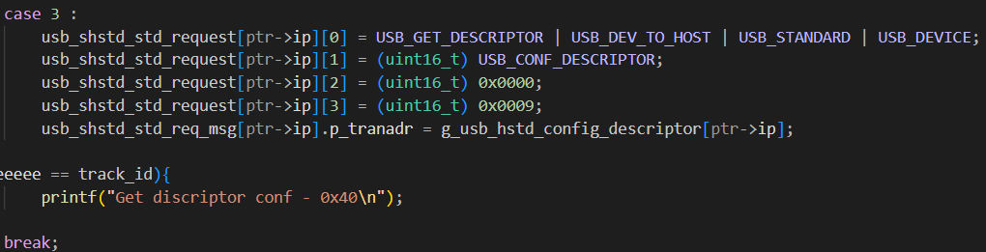
  - Result
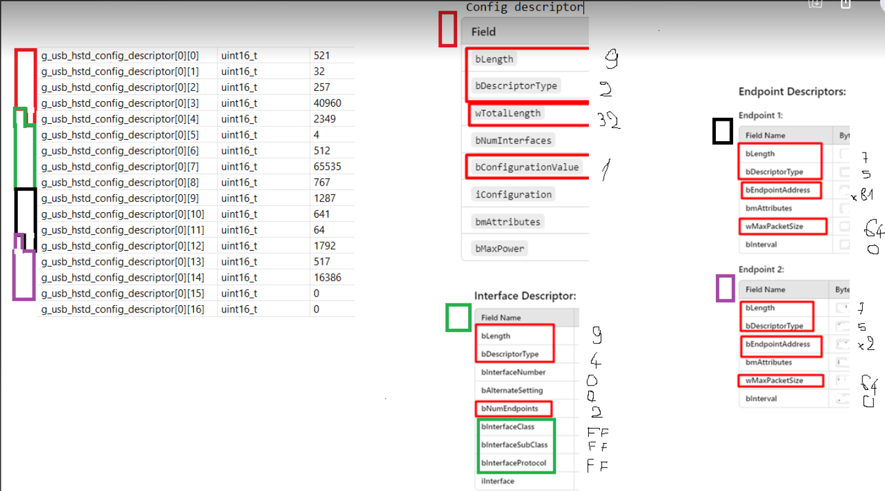
- Get config descriptor (next 57 bytes)
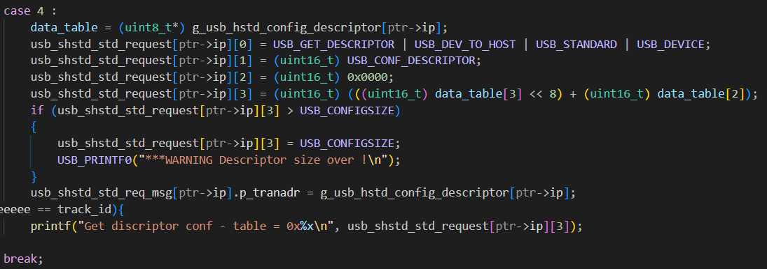
  - Result:

- Set the configuration (setting confnum = bConfigurationValue (=1))
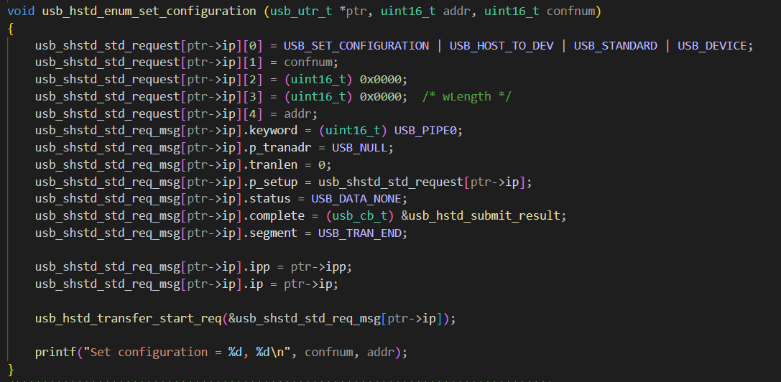

- Device, config - descriptior
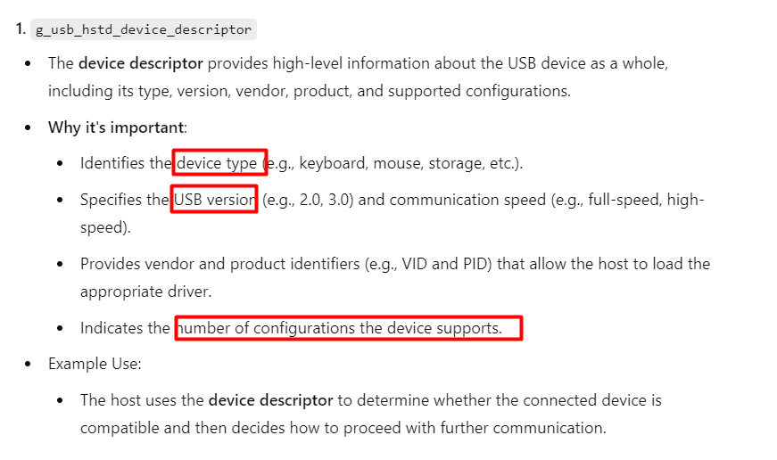
- Confirm the max package size on default endpoint (pipe 0)
