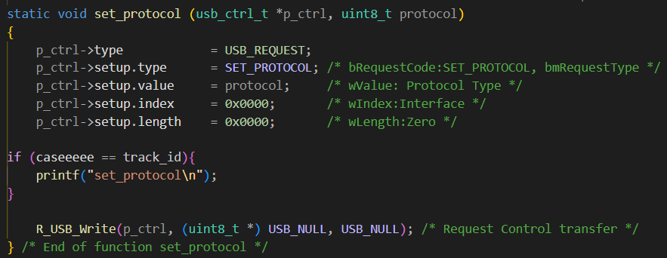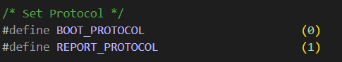
Having 2 types:
with BOOT_protocol – no need to get report descriptor
with REPORT_protocol – need to get report descriptor
STEPs:
- Polling to perform to IN transaction (polling interval – defined at endpoint descriptor)
- No key – empty report >< Detected key – 8-byte report

