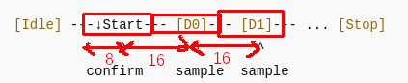

Sample data at the center bit (at -><-)

