- INIT:
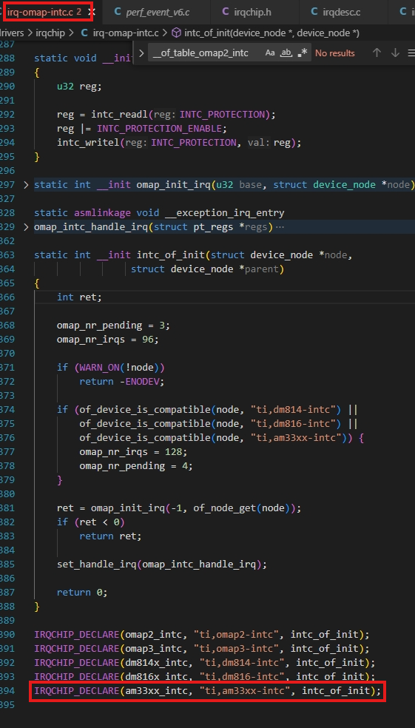
- Expand:
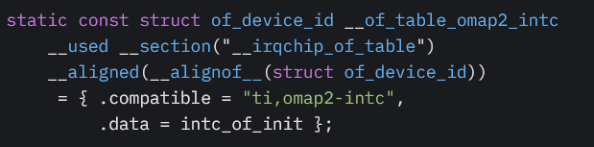
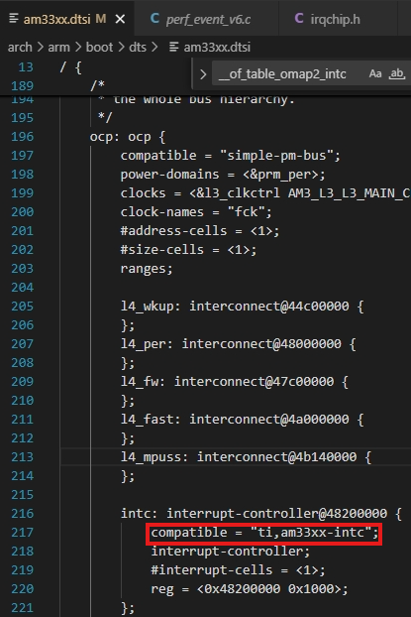
The irq-omap-intc.c compatible <-> interrupt-controller compatible => intc_of_init:
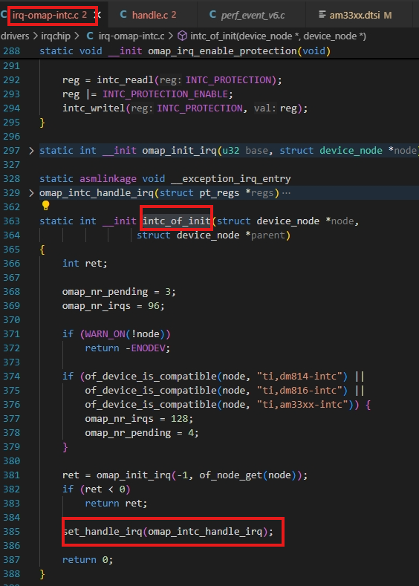
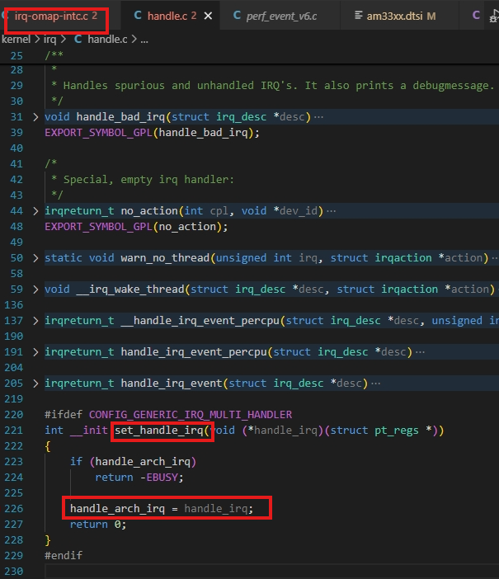
Handle_arch_irq ➔ omap_intc_handle_irq
- RUNNING:
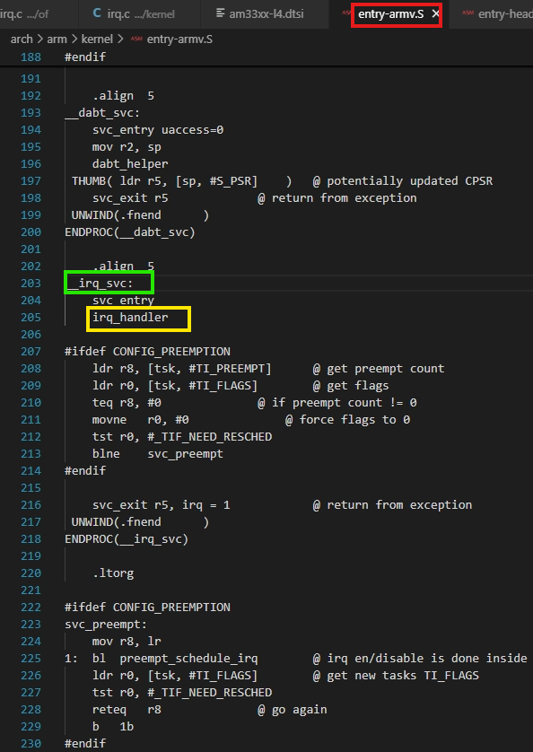
Irq_handler is a macro in assembly -> call handle_arch_irq:
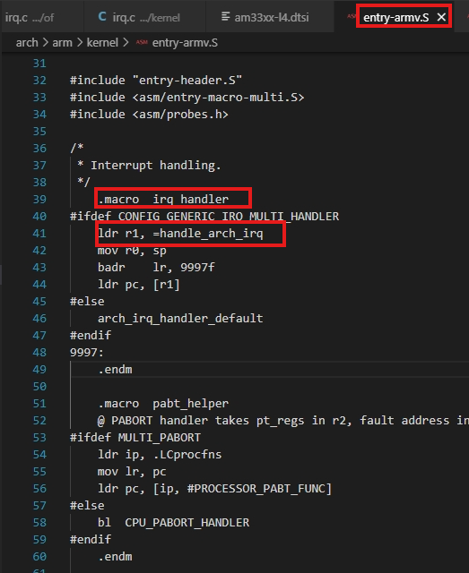
Handle_arch_irq -> r1 = omap_intc_handle_irq -> r1

Then the sequence below:

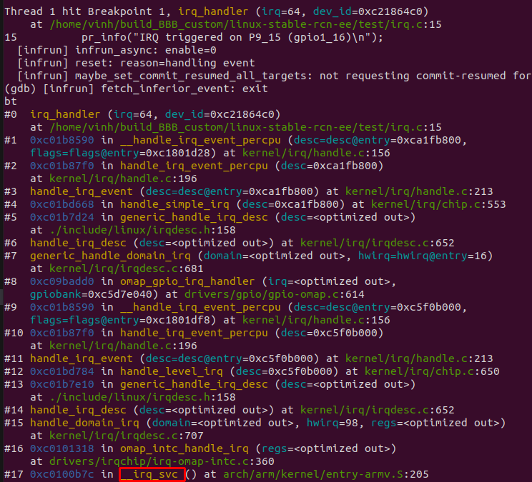
with the assembly of __irq_svc:
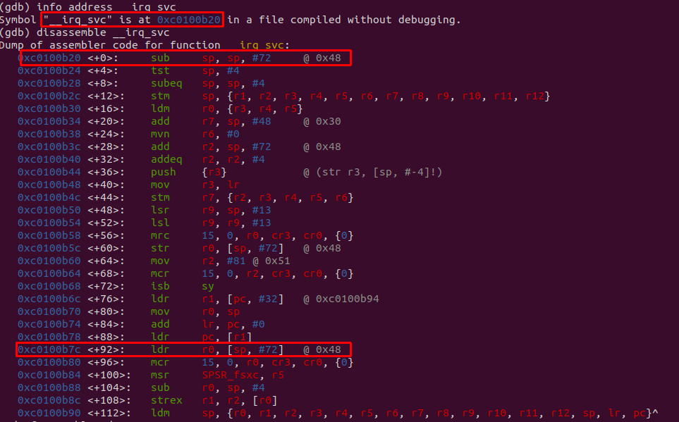
==
** when The processor identifies the external interrupt and jumps to the IRQ vector entry in the interrupt vector table.
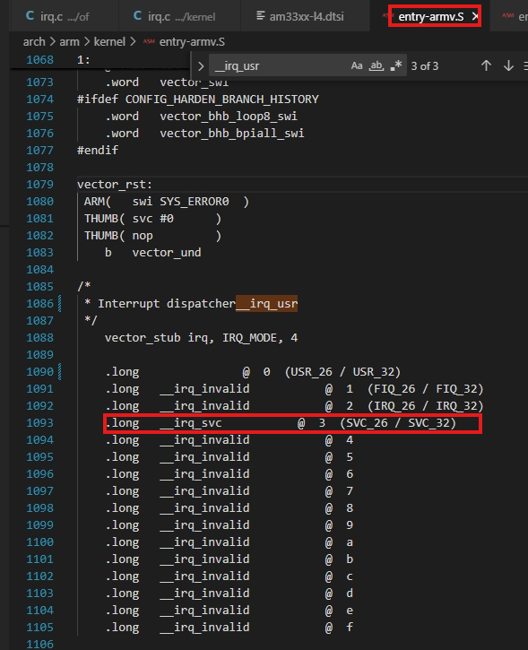
- Enter IRQ mode as below:
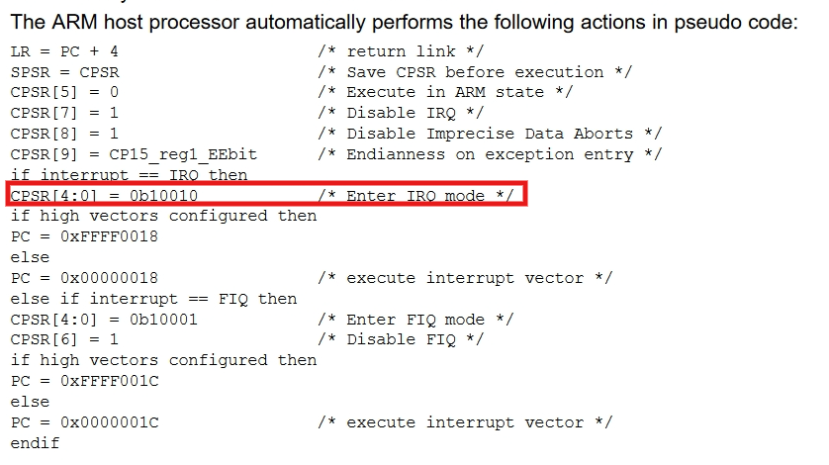
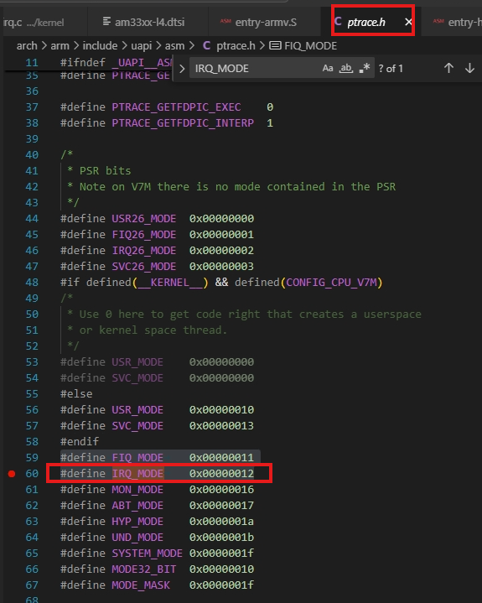

How CPU identify the interrupt (request from interrupt controller) -> check irq_sequence.docx

