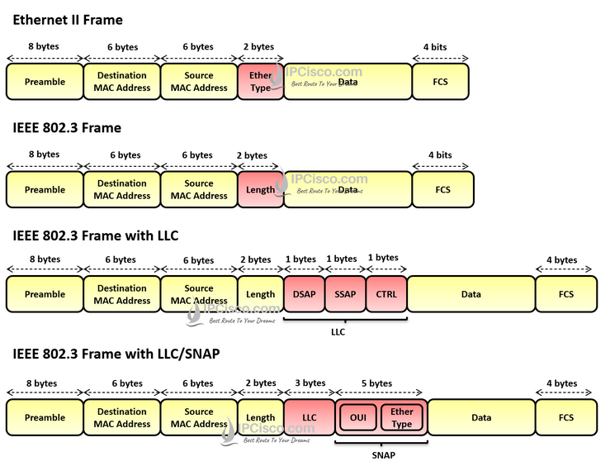
1. Preamble – sync pattern: 7bytes alter + 1byte SFD (1)
2. FCS – frame check sequence (4)
3. Data – 46-1500 bytes

4. Ethertype:
+ 0x0800 = IPv4
+ 0x08DD = IPv6
+ 0x0806 = ARP (addr resolu protocol)
+ 0x8100 = VLAN tag
5. LLC – Logical link control – sublayer between layer 2 and 3
+ DSAP – D service addr point
+ SSAP
+ CTRL - info
6. OUI – organizationally uni id – 3 bytes => vendor of a network

