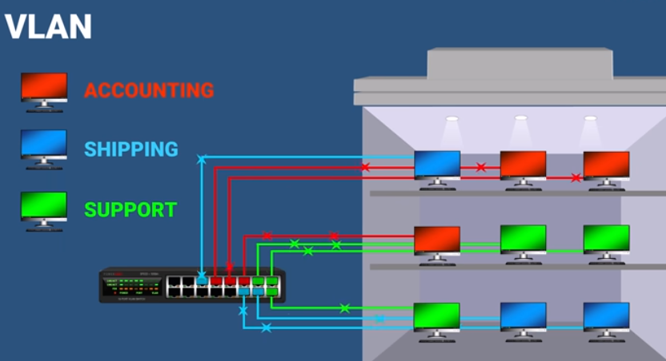
Each group of ports are connected to each VLANs

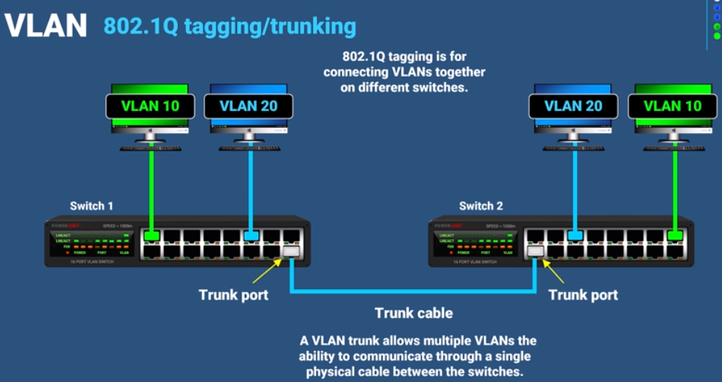

Trunk cable = a single cable – carry - 802.1Q tag frame (to VLANs)
- Untagged frame (to native VLAN)
IEE 802.1Q tag (4 bytes) = TPID (0x8100) + TCI (PCP-3 + DEI-1 + VID-12)
→ upto 4094 VLANs

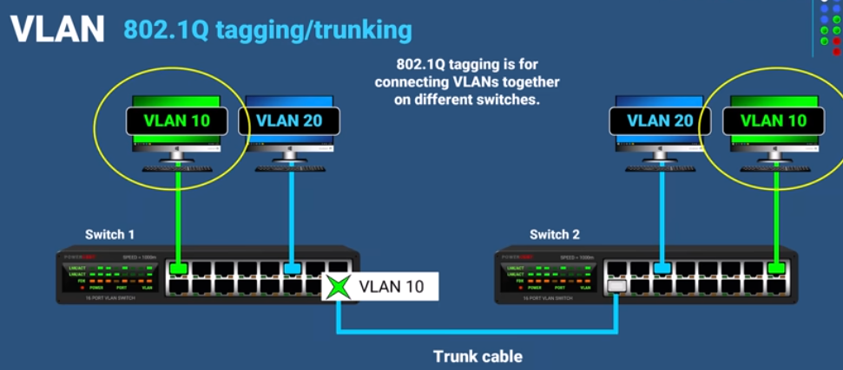
Tag:
to VLANs
(10 or 20)

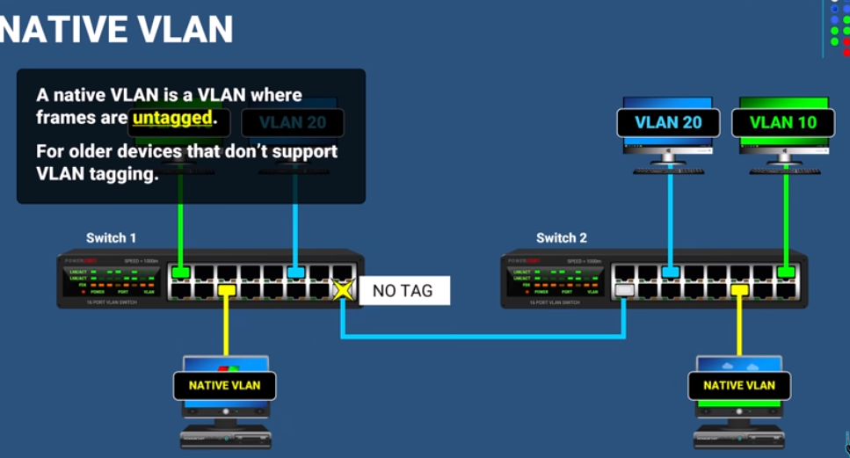
Untag:
to native VLAN

** Note **
TPID = Tag protocol ID
TCI = Tag ctrl info
PCP = Priority code point – 8 level (0-7)
DEI = Drop eligible indicator

