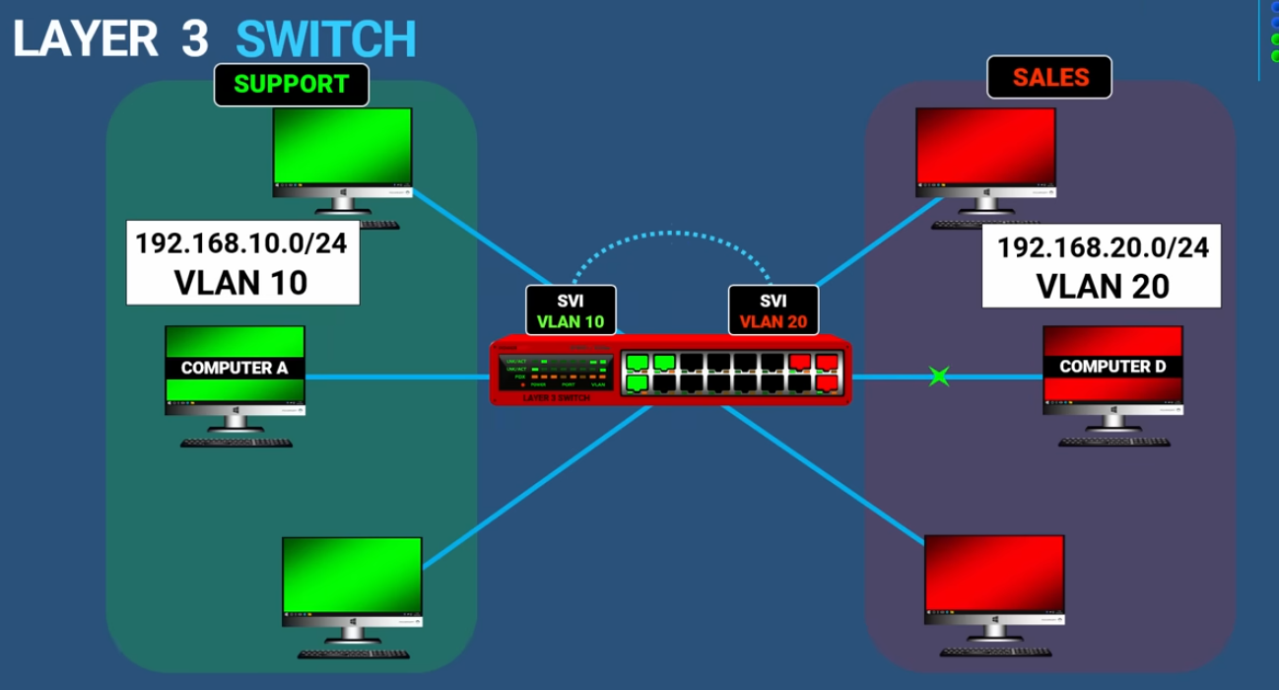

Layer 3 SW
- Route packet - IP addr
- Forward packet - MAC

=> Router / L3 sw deal with device communication – DIFFERENT Vlan or DIFFERENT subnet

** Note **
SVI = switch virtual if

