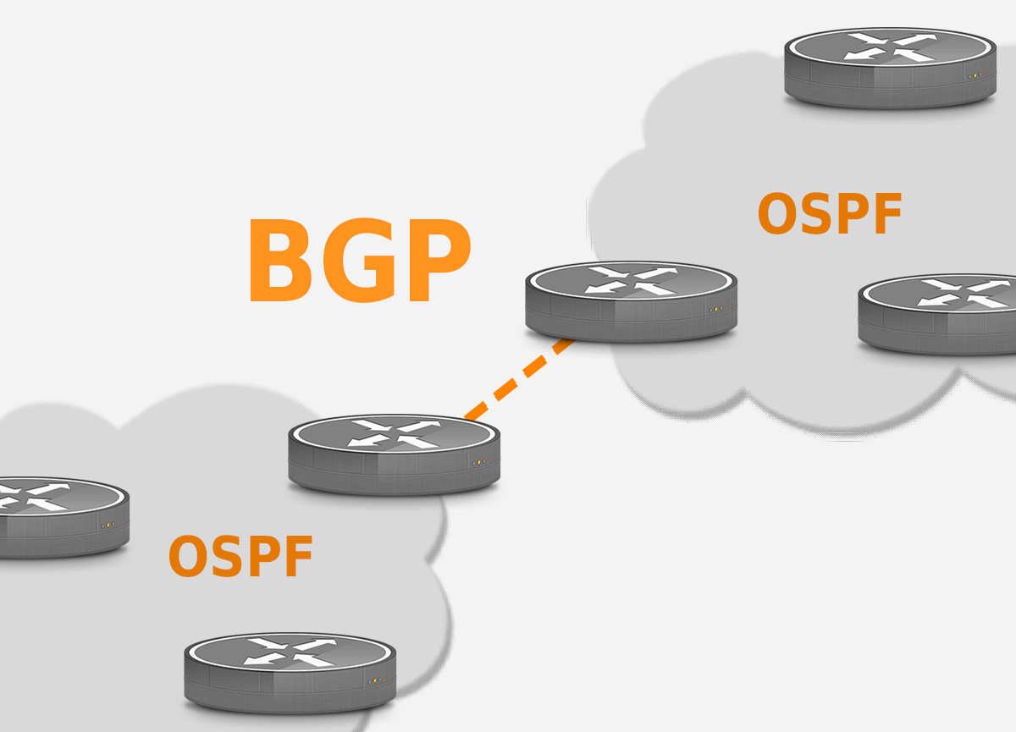
BGP = Border Gate Protocol → external gateway protocol
OSPF = Open Shortest Path First → internal gateway protocol

BGP → Find the best path between networks – vector state routing (small traffic)
OSPF → Find the best path within the network – link state routing (large traffic)

