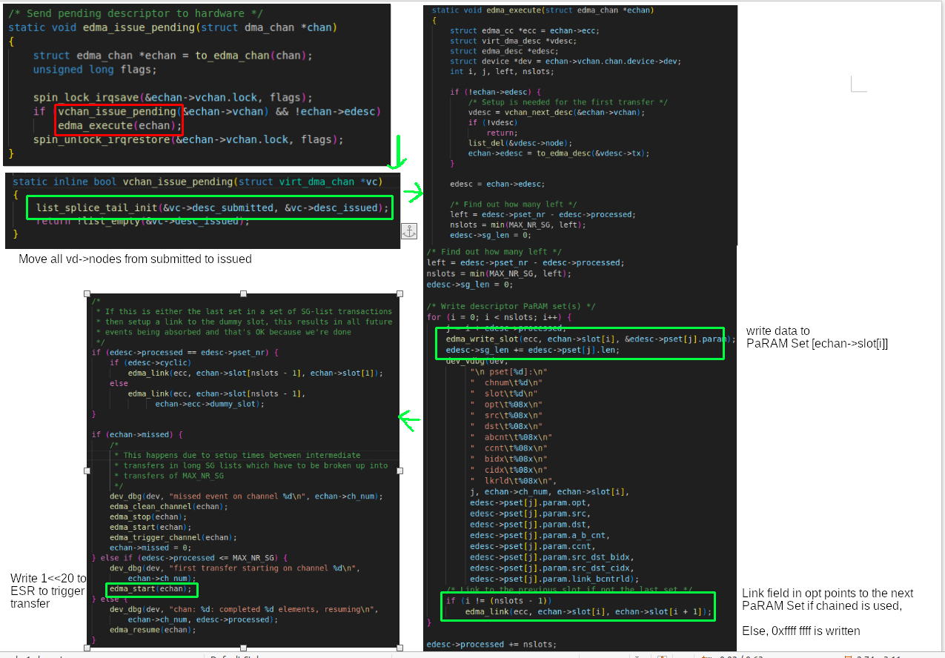
But edma_execute is called here to start the transfer of the first vdesc. After edma_completion_handler is called, it will iterate over vdesc = vchan_next_desc(&echan→vchan); to perform transfer of the next vdesc :
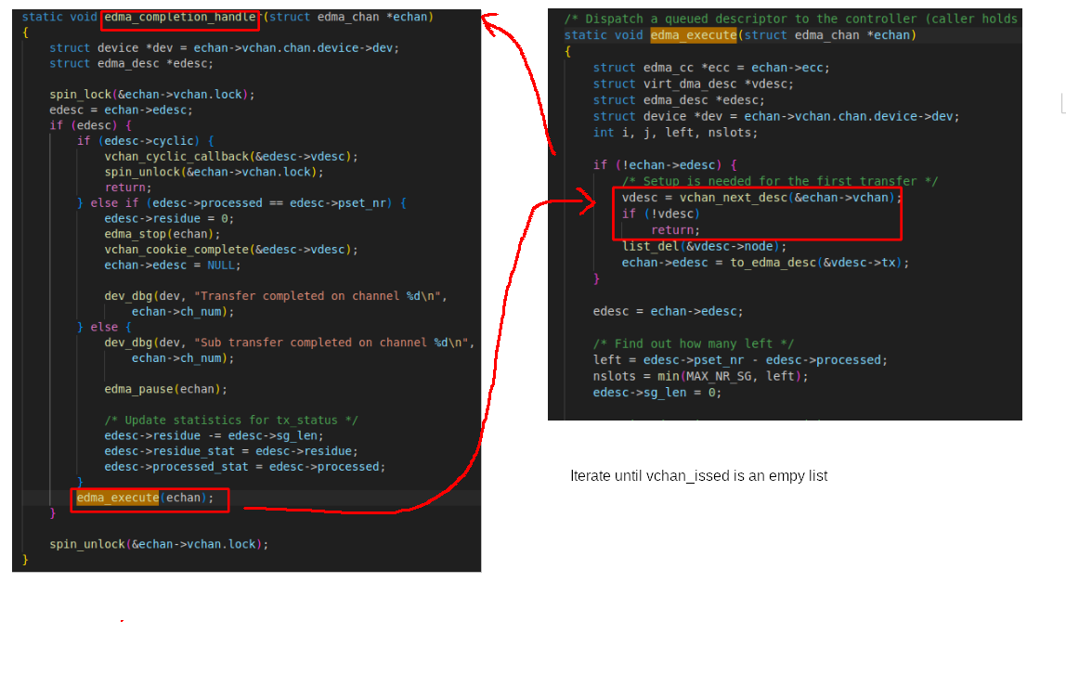
vchan_cookie_complete
– update completed_cookie = current cookie to mark the finish of the current descriptor
- move vd→node from desc_issued to desc_completed:
