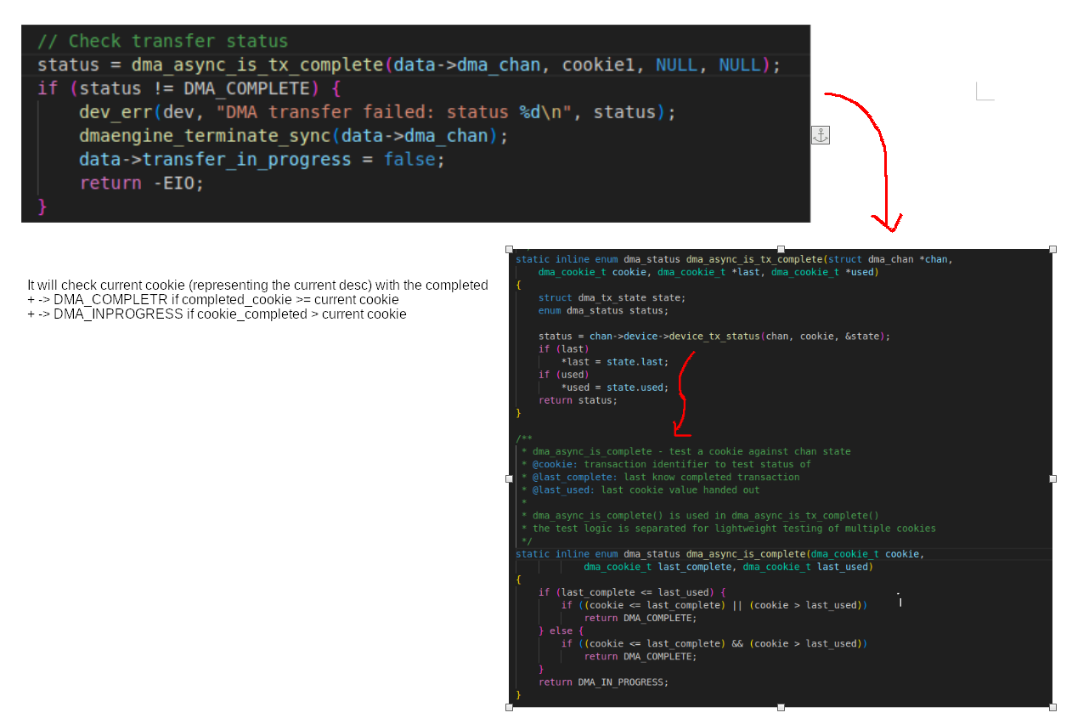
The current cookie is received from cookie1 = dmaengine_submit(tx1);

