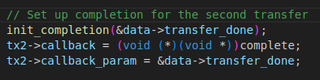

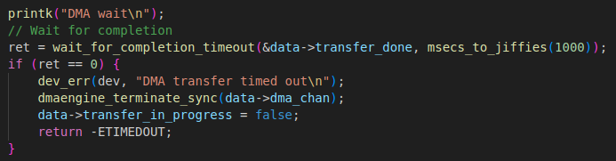
+ complete → data→transfer_done→done ++
+ wait_for_completion_timeout → pass (done = 1) + done – - → data→transfer_done→done = 0 again
