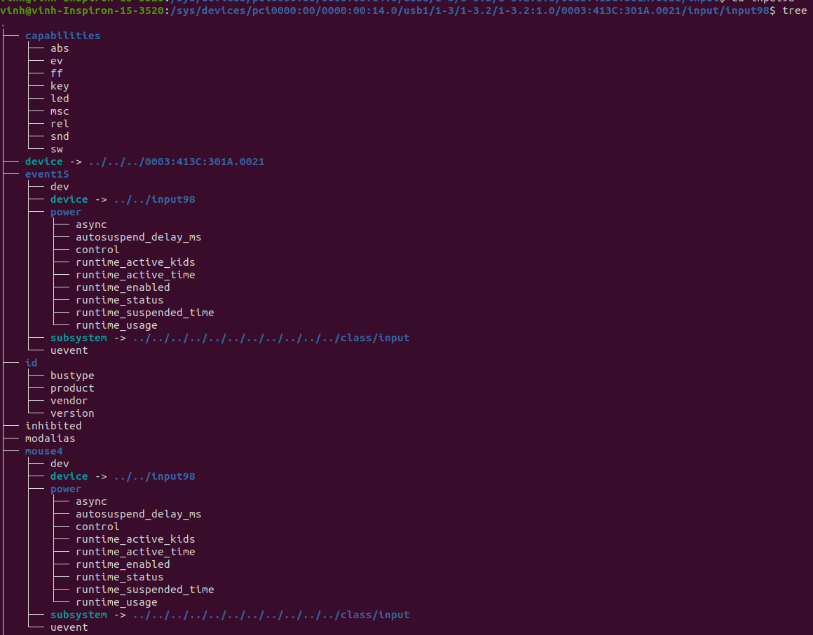
=========================
+ 1-3: bus 1, port 3 (port here is the port number on PCs)
+ 1-3.1 : bus 1, port 3 on PC, port 1 on the hub
+ 1-3.1:1.1 : bus 1, port 3 on PC, port 1 on the hub and the interface 1 (for phys …/input 1)

+ Input: hiddev0 and hidraw2 – read from phys: usb-0000:00:14.0-3.1/input1
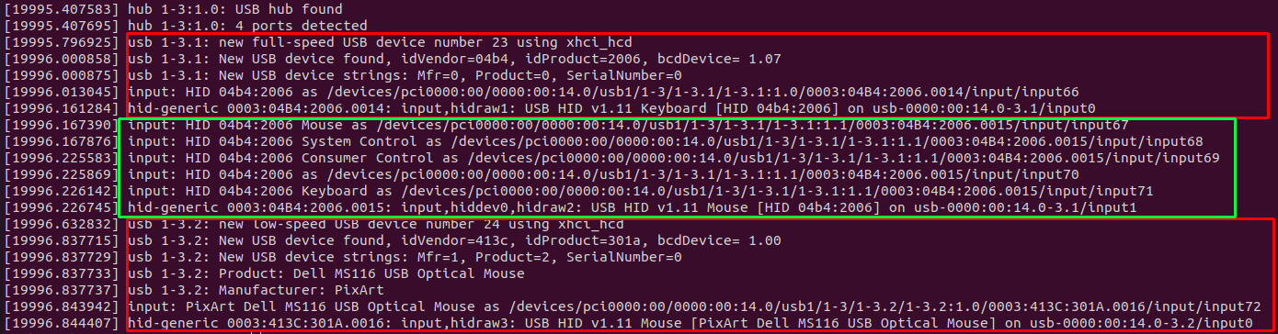
=============================
Every ../input/inputX respond to /dev/input/eventY -> use evtest to check event

has phys, name, uevent, …
===============================
PRODUCT=3/4b4/2006/111
NAME="HID 04b4:2006"
PHYS="usb-0000:00:14.0-3.1/input0"
UNIQ=""
PROP=0
EV=120013
KEY=e080ffdf01cfffff fffffffffffffffe
MSC=10
LED=1f
MODALIAS=input:b0003v04B4p2006e0111-e0,1,4,11,14,k77,7D,7E,7F,ram4,l0,1,2,3,4,sfw

This is uevent of keyboard

PRODUCT=3/413c/301a/111
NAME="PixArt Dell MS116 USB Optical Mouse"
PHYS="usb-0000:00:14.0-3.2/input0"
UNIQ=""
PROP=0
EV=17
KEY=70000 0 0 0 0
REL=903
MSC=10
MODALIAS=input:b0003v413Cp301Ae0111-e0,1,2,4,k110,111,112,r0,1,8,B,am4,lsfw

This is uevent of mouse

==========================================
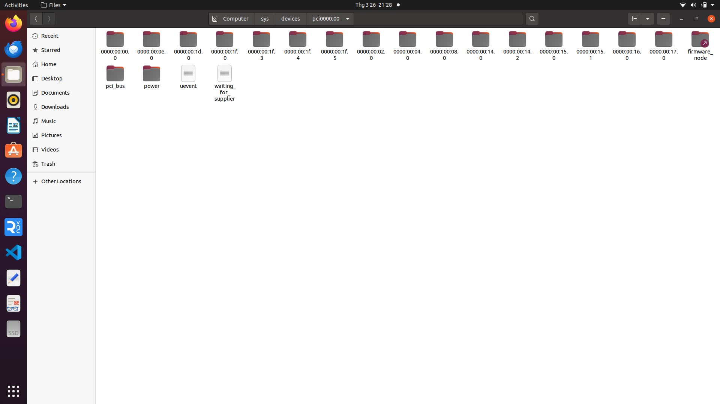
PCI with domain 0000 and bus 0

