sudo evtest /dev/input/event7 -> see the event of keyboard/mouse
:
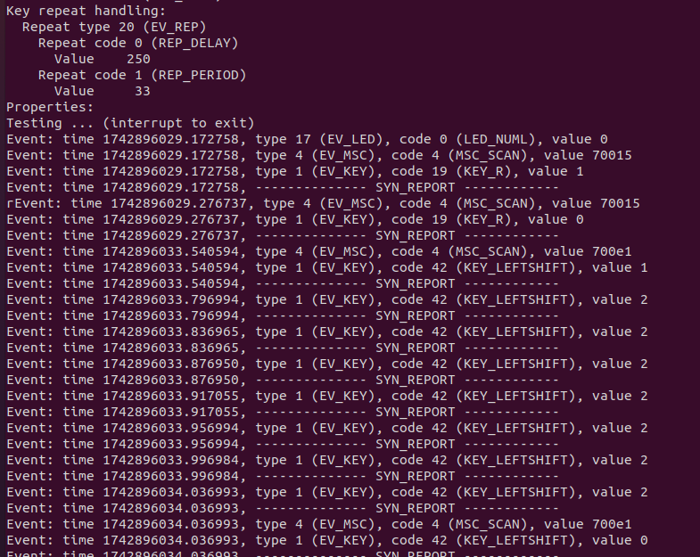
:
Each /dev/input/eventX node supports different event types:
EV_KEY → Handles keyboard key presses (/dev/input/event7)
EV_REL → Handles relative mouse movements (/dev/input/event10)
EV_ABS → Handles absolute input (used in touchscreens)
EV_MSC → Miscellaneous events (e.g., function keys, media buttons)

=======================================================================
sudo hexdump -C /dev/input/event7
sudo hexdump -C /dev/hidraw0
→ see raw data
:
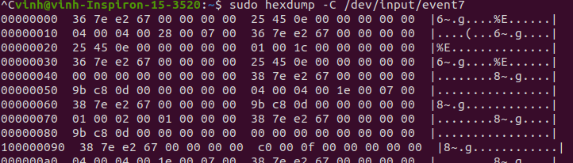
:
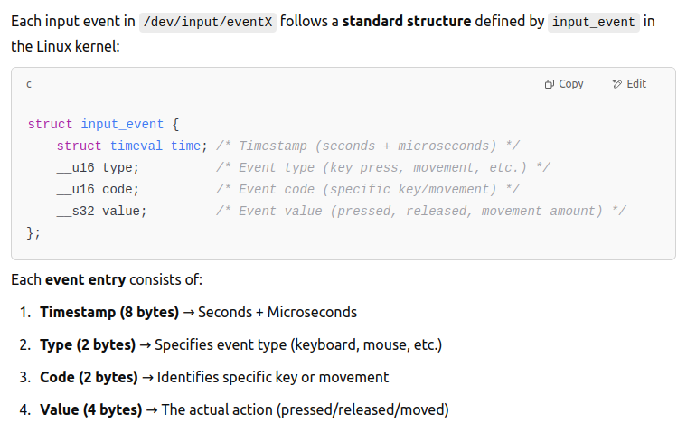
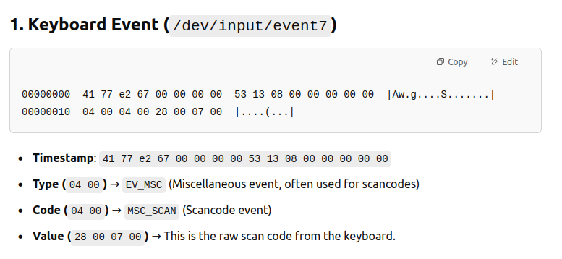
=======================================================================

lsinput → ist all input devices and their corresponding /dev/input/eventX
:

