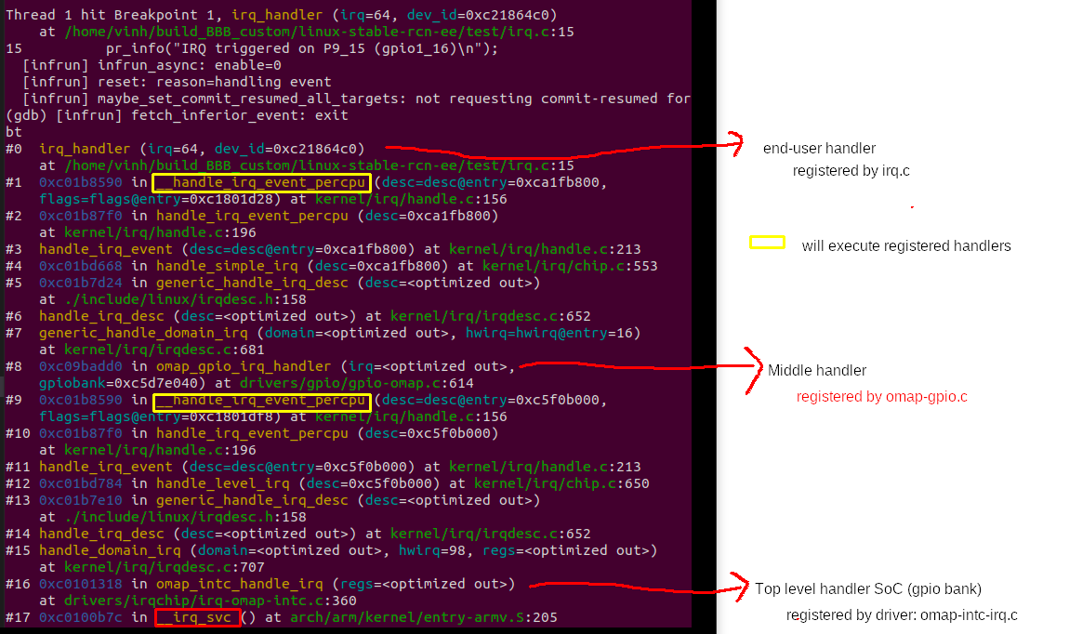
hwirq 98 and hwirq 16 is a parent-child IRQ relationship
omap_intc_handle_irq will trace IRQ 98, then → omap_gpio_irq_handler will trace IRQ 16:
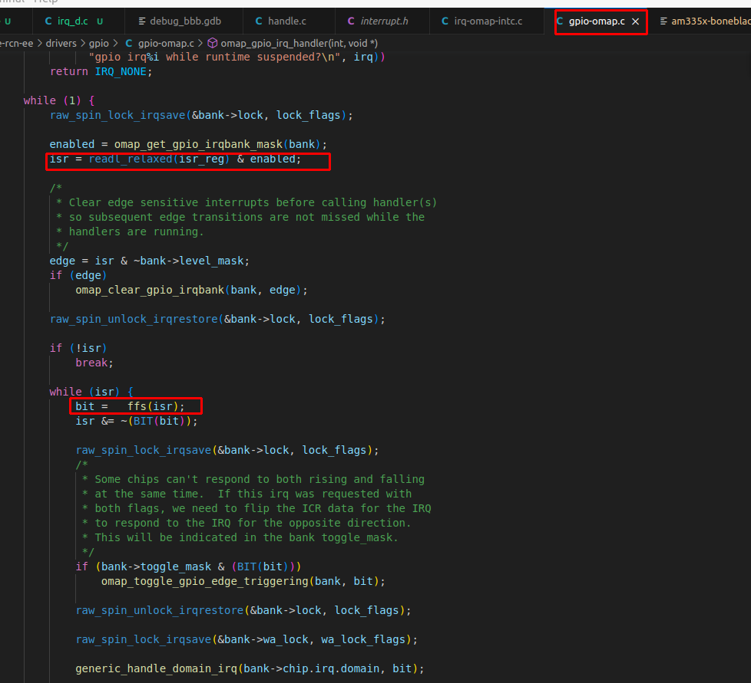

isr is the raw value of register, then through __ffs() to get the first index from the least
Ex. If isr = 65536 = 0x1 0000 0000, bit = __ffs(isr) = 8

