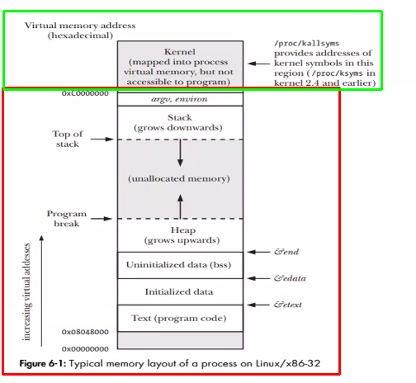
Red → user-space memory
Green → kernel memory
They are connected via system calls

A process is + allocated into every part of the user-space memory (.text, .data, .stack, .heap)
+ not accessable to kernel space without system calls

