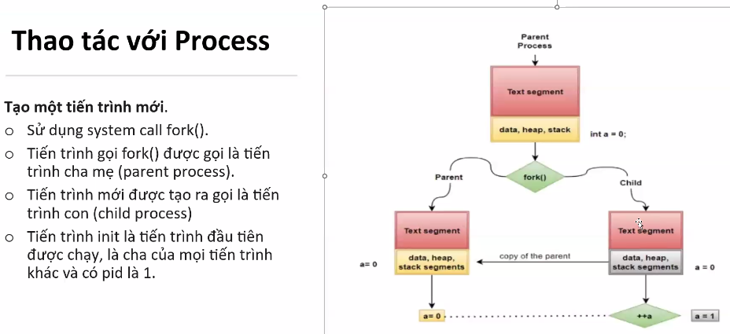
+ fork() >= 0 → create another process successfully
fork() = 0 → child process
fork() > 0 → parent process
+ < 0 → not successfully

=======================
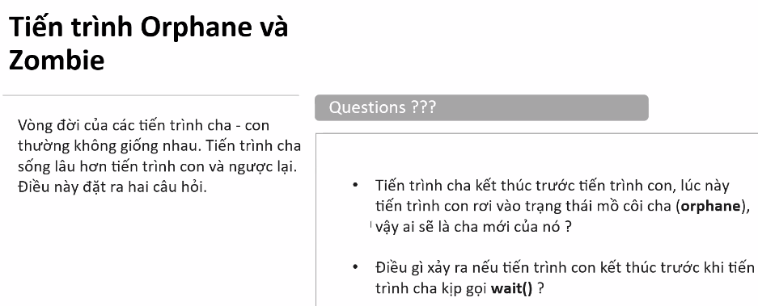
(2):
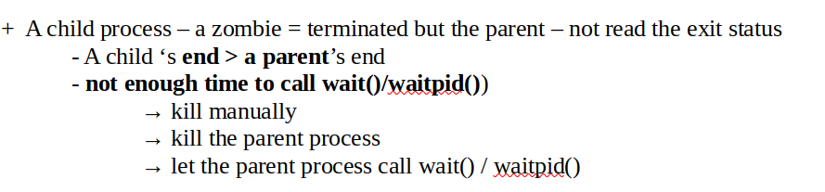
(1):
