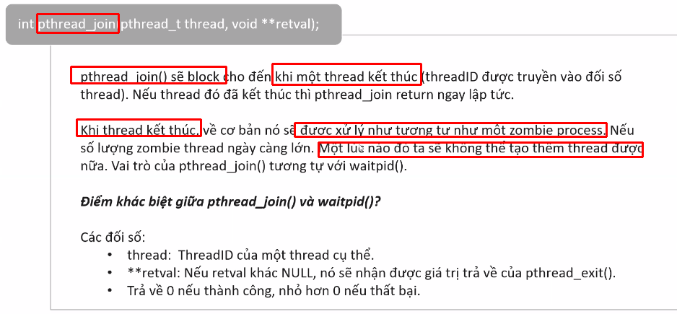
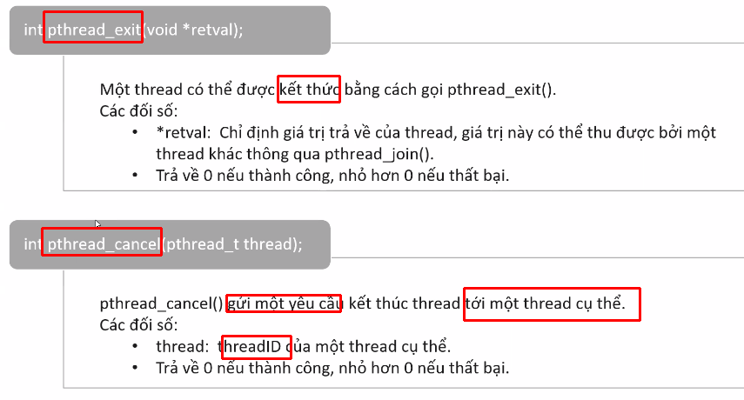
pthread_self → return the thread id of the current thread

==================================================================
pthread_equal(tid, thread_id1) → check the comparison between tid and thread_id1

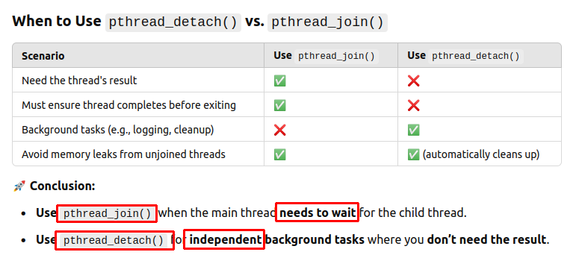
=> pthread_join >< pthread_detach = automatically free own resources (id, parameters, ...)

=======================================================================

pthread_mutex_t lock = PTHREAD_MUTEX_INITIALIZER;
pthread_mutex_lock(&lock);
pthread_mutex_unlock(&lock);

pthread_cond_t cond = PTHREAD_COND_INITIALIZER;
pthread_cond_signal(&cond);
pthread_cond_wait(&cond);
→ the code waits until condition signals

