BLOCKING SIGNAL → prevent unnecessary signal interrupt important processes

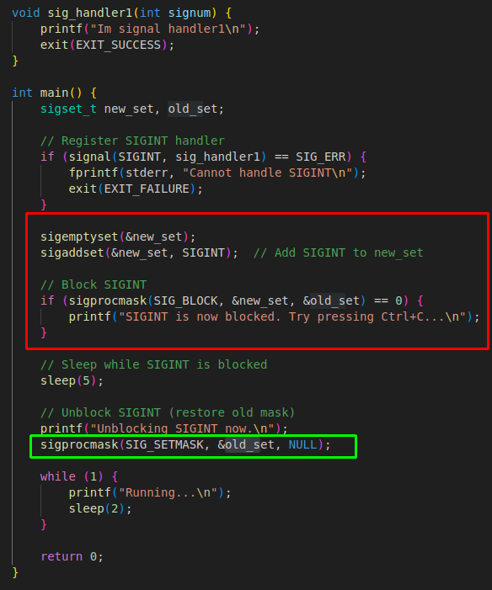
Red → blocking the processes
Green → unblocking the process

============================== OVERVIEW ============================
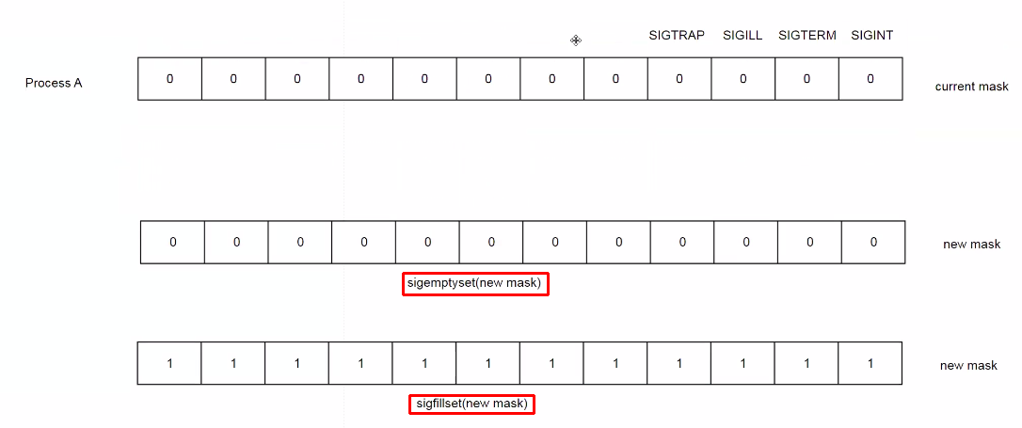
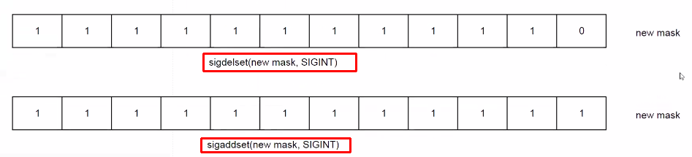
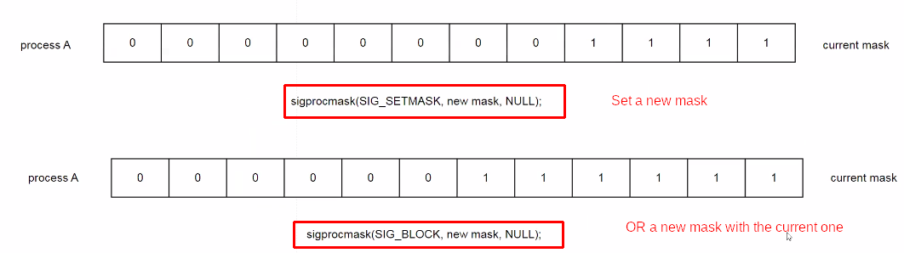
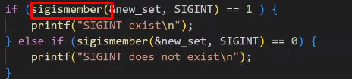

→ Check the member of signal in a new mask

