Signal → handle a process, not thread

By default, ‘Ctrl + C’ = SIGINT >< in the code, SIGINT can be programmed to change the function of “Ctrl + C”
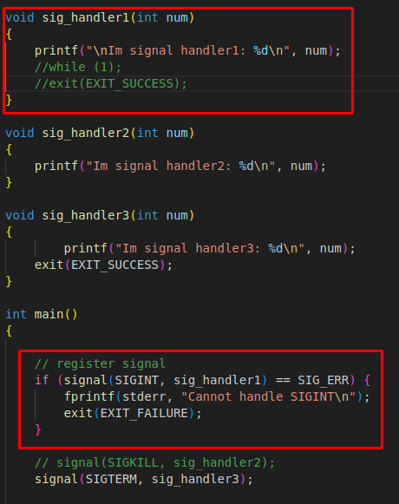

→ when we press ‘Ctrl + C’ → It jumps to sig_handler1(), not terminate the process as usual

==============================

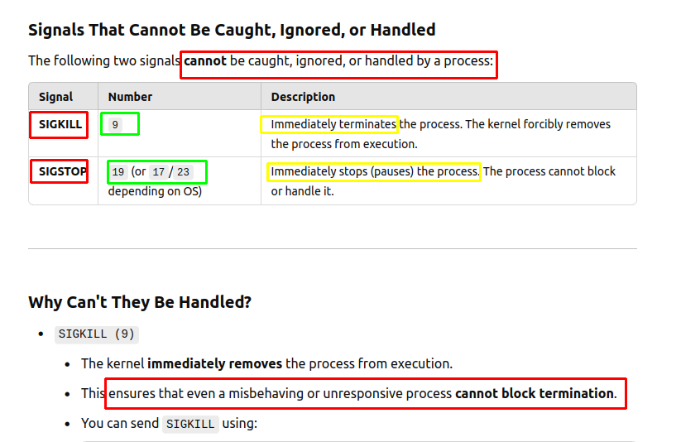
==========================

SIGTERM = SIGKILL → all terminate a process
SIGTERM >< SIGKILL → catch >< ignored

============================



