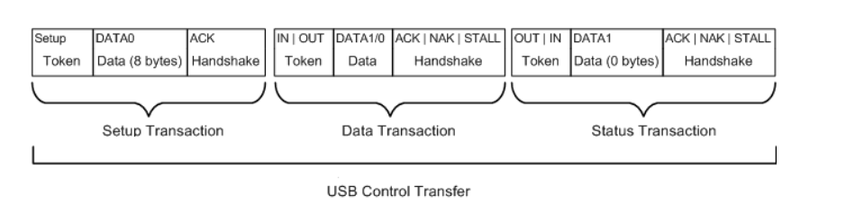

Each transaction has 3 packets: TOKEN, DATA, HANSHAKE:
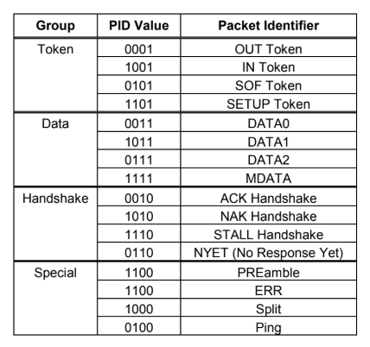
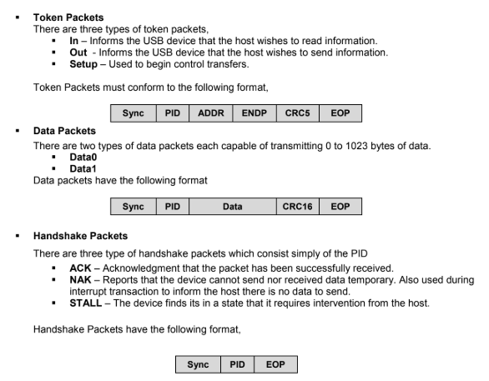
===== Summary ========
