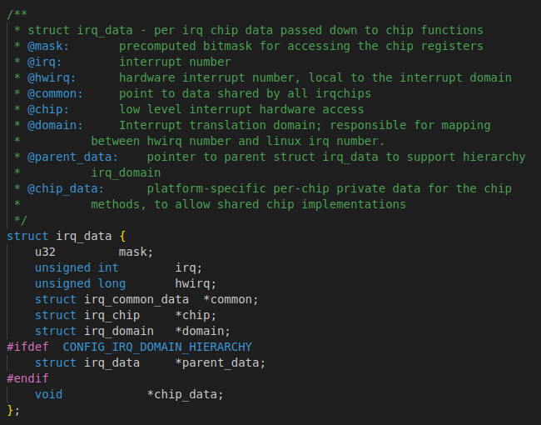
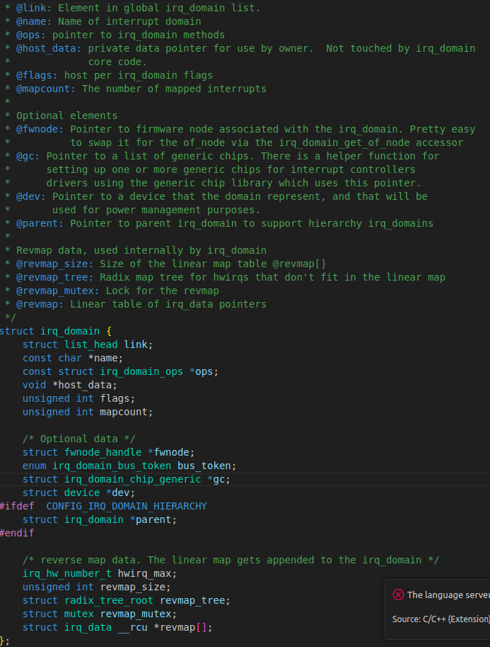

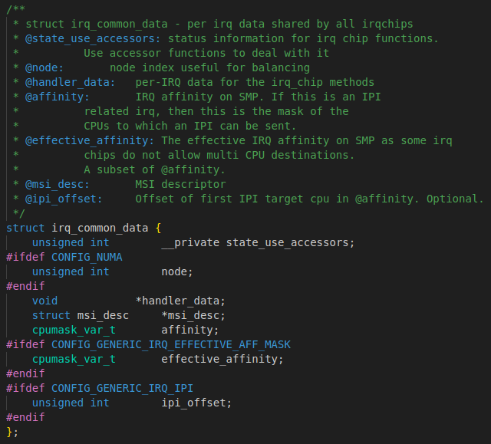

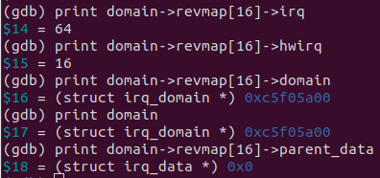
revmap[16] → irq_data[16]:
revmap[15] = 0x0 as no irq_data at hwirq 15

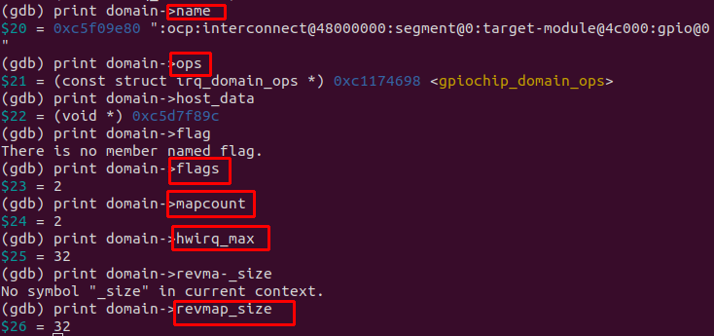
irq_domain member:

Due to mapcount = 2 → there is another revmap other than revmap[16]
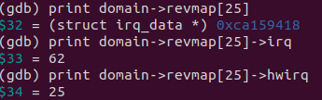

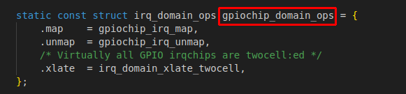

this will provide .map and .unmap to map or unmap hwirq (local offset on gpio bank 1) to irq (global offset)

============================ irq_desc ====================================
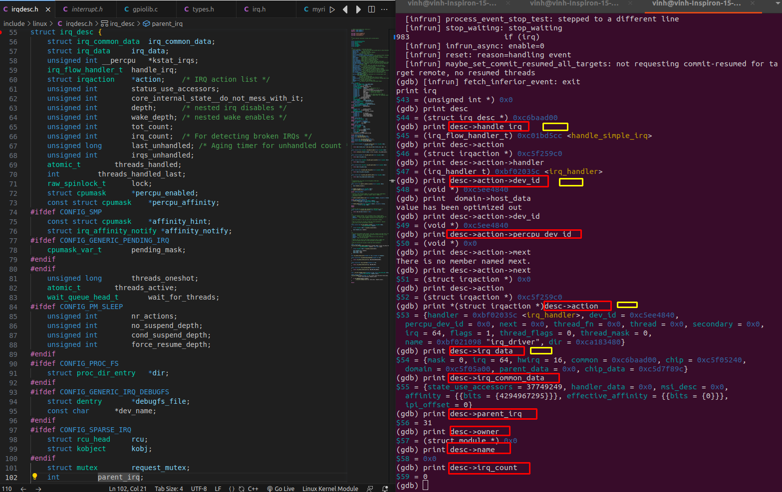

(gdb) print desc->parent_irq
$77 = 31 (from hwirq 98)
(gdb) print desc->irq_data->irq
$78 = 64 (from hwirq 16)

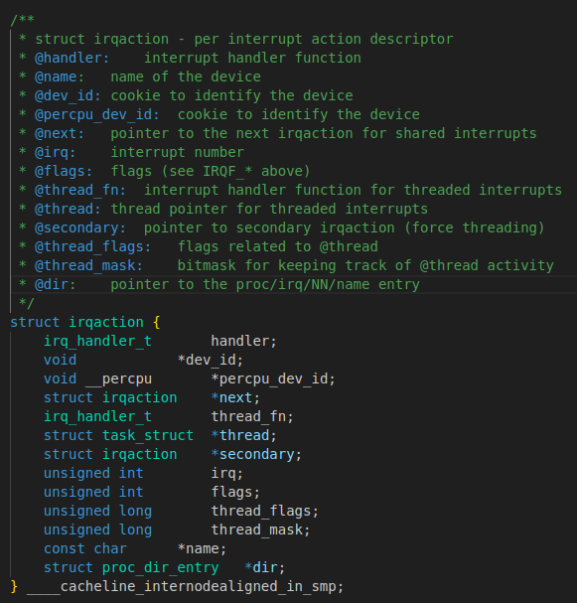

============================== perpeu_handler ===========================
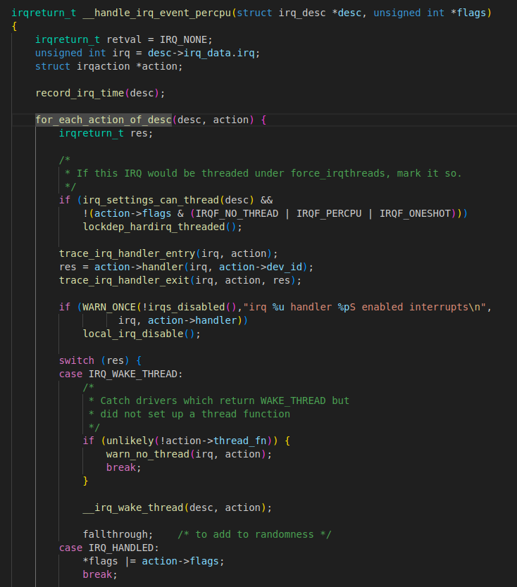
#define for_each_action_of_desc(desc, act) \
for (act = desc->action; act; act = act→next)

It will check desc→action→next NULL or not
If NULL → stop
else, another action→handler will be executed
=============================================================
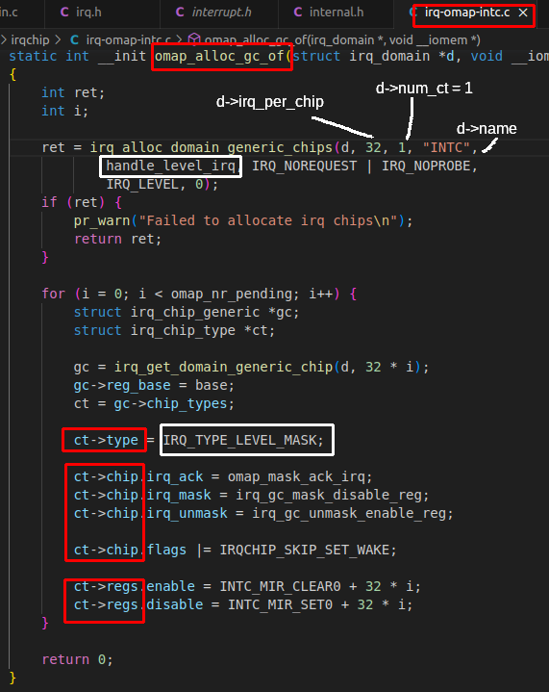
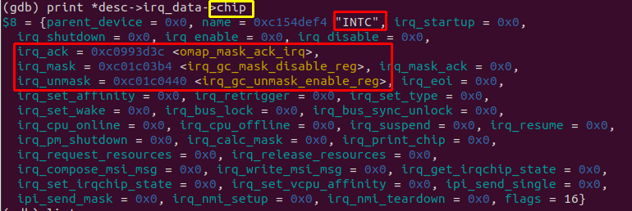

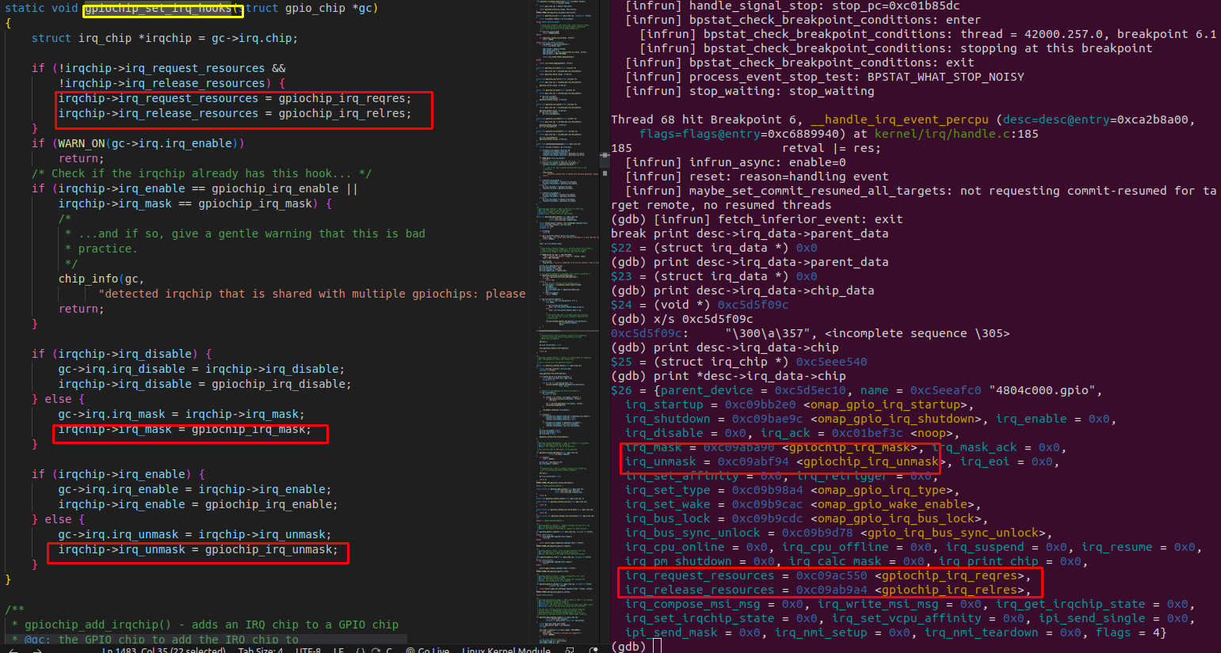

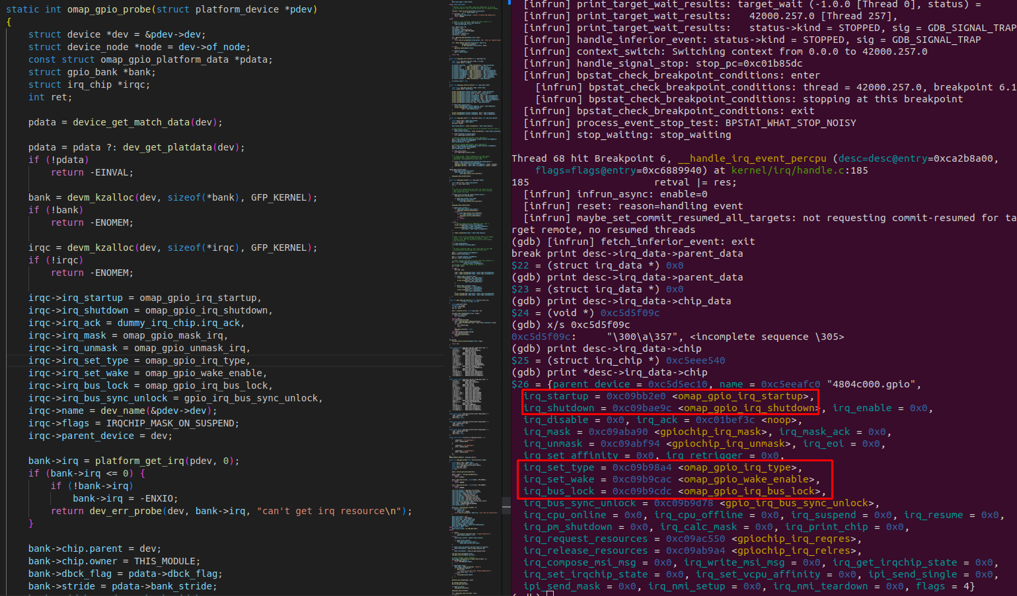

==================== Use of omap_gpio_irq_type ==========================
