===================== Diffference x86 – Arm =================================

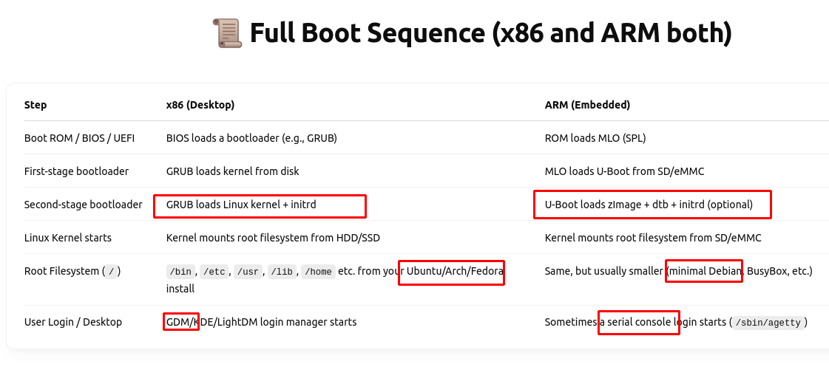
ISO – kernel + root filesystems embedded
BBB → the same (but need users to copy them into SD card manualy)
* root filesystems – OS – human use:
================

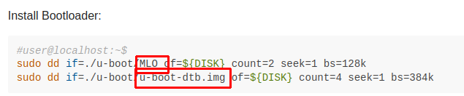
Copy MLO + u-boot-dtb.img → SD card

