(gdb) print COM_data->dev
$14 = (struct device *) 0xc22f0010
(gdb) print COM_data->dev->parent
$15 = (struct device *) 0xc193e5d8 <platform_bus>
(gdb) print COM_data->dev->parent->parent
$16 = (struct device *) 0x0

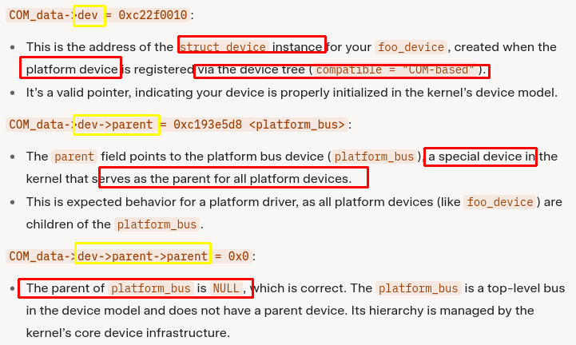
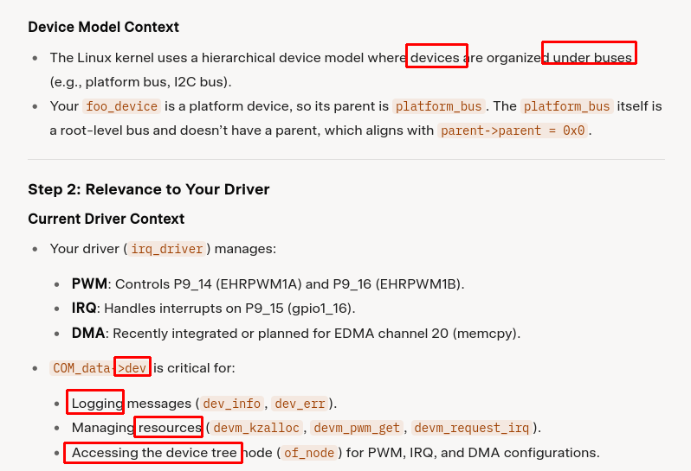
========================== Check driver ↔ device ======================
(gdb) print COM_data->dev->links->status
* @DL_DEV_NO_DRIVER: There is no driver attached to the device.
* @DL_DEV_PROBING: A driver is probing.
* @DL_DEV_DRIVER_BOUND: The driver has been bound to the device. (Ok)
* @DL_DEV_UNBINDING: The driver is unbinding from the device.

============================== Info data in a dt node ===================
(gdb) print *COM_data->dev->of_node->properties
$35 = {name = 0xff874338 "compatible", length = 10, value = 0xff86e924,
next = 0xdf95d8d0, _flags = 0, attr = {attr = {name = 0xc22c3140 "compatible",
mode = 292}, size = 10, private = 0x0, f_mapping = 0x0,
read = 0xc0dcdc40 <of_node_property_read>, write = 0x0, mmap = 0x0}}

(gdb) print *COM_data->dev->of_node->properties->next
$36 = {name = 0xff8746a5 "pinctrl-names", length = 8, value = 0xff86e93c,
next = 0xdf95d904, _flags = 0, attr = {attr = {
name = 0xc22c36c0 "pinctrl-names", mode = 292}, size = 8, private = 0x0,
f_mapping = 0x0, read = 0xc0dcdc40 <of_node_property_read>, write = 0x0,
mmap = 0x0}}

(gdb) x/s 0xff86e924
0xff86e924: "COM-based"
(gdb) x/s 0xff86e93c
0xff86e93c: "default"

=========================== Info parent, sibling node in dev ===============
(gdb) print *COM_data->dev->of_node->parent
$48 = {name = 0xdf92c59c "", phandle = 0, full_name = 0xdf92c42c "", fwnode = {
secondary = 0x0, ops = 0xc122e46c <of_fwnode_ops>, dev = 0x0, suppliers = {
next = 0xdf92c3d8, prev = 0xdf92c3d8}, consumers = {next = 0xdf92c3e0,
prev = 0xdf92c3e0}, flags = 0 '\000'}, properties = 0xdf92c430,
deadprops = 0x0, parent = 0x0, child = 0xdf92c5a0, sibling = 0x0, kobj = {
name = 0xc218ecc0 "base", entry = {next = 0xdf92c5e4, prev = 0xc218e980},
parent = 0xc218e98c, kset = 0xc218e980, ktype = 0xc1966a0c <of_node_ktype>,
sd = 0xc217af20, kref = {refcount = {refs = {counter = 19}}},
state_initialized = 1, state_in_sysfs = 1, state_add_uevent_sent = 0,
state_remove_uevent_sent = 0, uevent_suppress = 0}, _flags = 16, data = 0x0}

(gdb) print *COM_data->dev->of_node->sibling
$49 = {name = 0xdf95dbcc "dma_transfer_device", phandle = 0,
full_name = 0xdf95dab4 "dma_transfer_device", fwnode = {secondary = 0x0,
ops = 0xc122e46c <of_fwnode_ops>, dev = 0xc22f0410, suppliers = {
next = 0xdf95da60, prev = 0xdf95da60}, consumers = {next = 0xdf95da68,
prev = 0xdf95da68}, flags = 1 '\001'}, properties = 0xdf95dac8,
deadprops = 0x0, parent = 0xdf92c3c0, child = 0x0, sibling = 0xdf95dbe0, kobj = {
name = 0xc22c43c0 "dma_transfer_device", entry = {next = 0xdf95dc24,
prev = 0xdf95d868}, parent = 0xdf92c400, kset = 0xc218e980,
ktype = 0xc1966a0c <of_node_ktype>, sd = 0xc22c5d10, kref = {refcount = {
refs = {counter = 3}}}, state_initialized = 1, state_in_sysfs = 1,
state_add_uevent_sent = 0, state_remove_uevent_sent = 0, uevent_suppress = 0},
_flags = 8, data = 0x0}

========================= function to parse dt ==============================
(gdb) print COM_data->dev->of_node->properties->attr
$53 = {attr = {name = 0xc22c3140 "compatible", mode = 292}, size = 10,
private = 0x0, f_mapping = 0x0, read = 0xc0dcdc40 <of_node_property_read>,
write = 0x0, mmap = 0x0}

(gdb) print *COM_data->dev->fwnode (firmware)
$55 = {secondary = 0x0, ops = 0xc122e46c <of_fwnode_ops>, dev = 0xc22f0010,
suppliers = {next = 0xdf95d83c, prev = 0xdf95d83c}, consumers = {
next = 0xdf95d844, prev = 0xdf95d844}, flags = 1 '\001'}

=============== struct list_head devres_head; =============================
struct list_head {
struct list_head *next, *prev;
};
