WRITE:
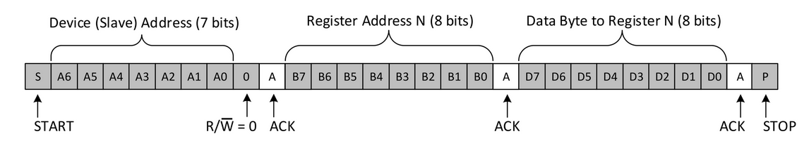
READ:
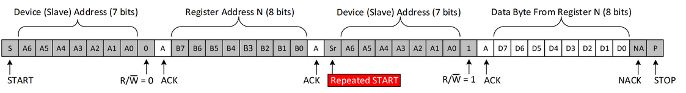
→ MSB

