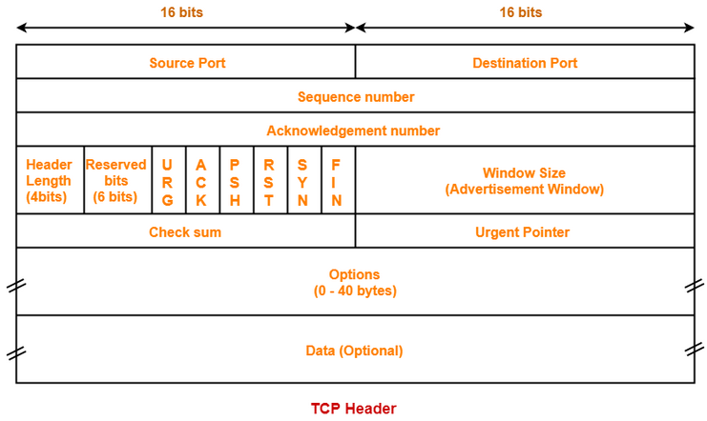
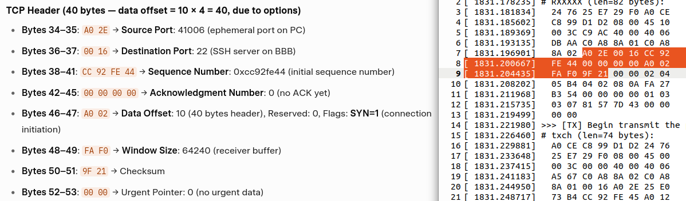
*Notes:
- Header length is ‘Header Length’ * 4 => 10*4 = 20 bytes
- URG (urgent), PSH (push), RST(reset), SYN(sync), FIN (terminate TCP connection)
- Window size → tells that the sender can get a number of bytes without ack

