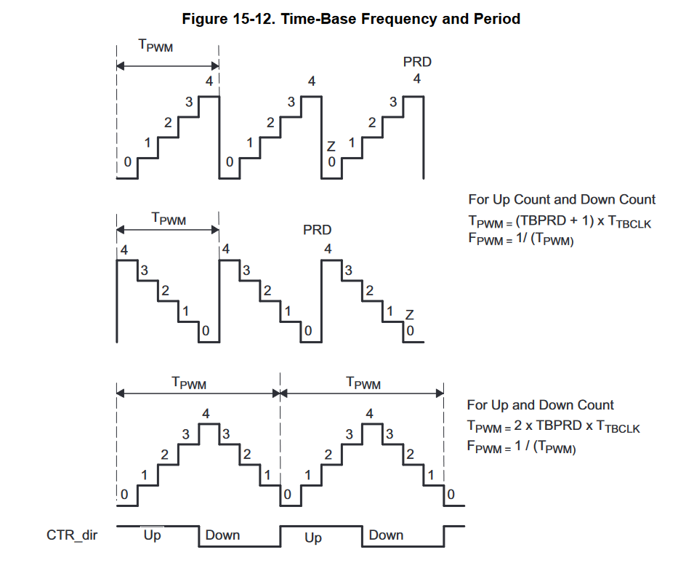

TBPRD – the number of steps
TBCLK – the amount of time in each step
- Smaller PWM_PERIOD_NS -> faster brightness changes
TBPRD ~ ARR (Stm32)
TBCNT ~ CNT (Stm32)

